Lesson 15: Design Your Own Robot
- Let’s use perimeter and area to design robots.

Warm-up: What Do You Know About Area and Perimeter?
What do you know about area and perimeter?

15.1: Create Your Own Robot
- Create your own robot with these specifications. Explain or show your work so it is clear your robot meets the required specifications.
  - Each body part must be a rectangle.
  - Head: perimeter of 36 units
  - Neck: perimeter of 8 units
  - Body: perimeter of 64 units
  - Each arm: perimeter of 24 units
  - Each leg: perimeter of 32 units
  - Include one more rectangular feature of your choice on your robot.
- Find the area of each of your robot’s body parts.
- Find the total area of your robot.
- Gallery Walk: As you visit the robots with your partner, discuss the different areas that can be created with rectangles that have the same perimeter.

Section Summary
Section Summary
In this section we reasoned about shapes to design wax prints, a park, and a robot.
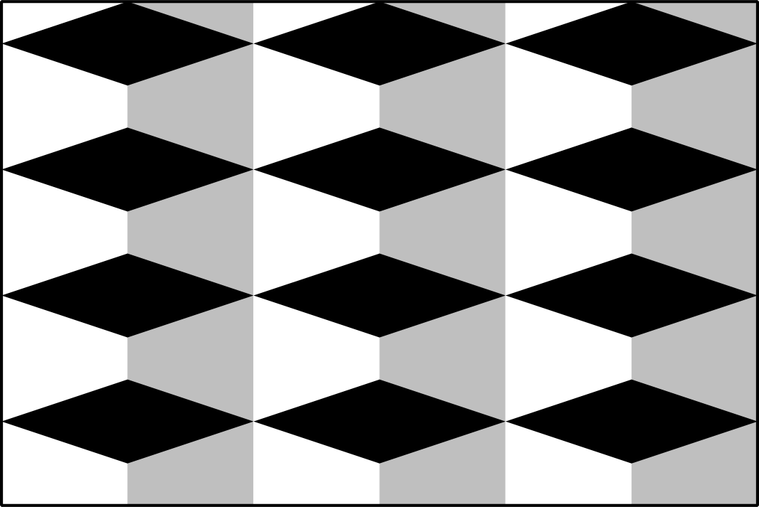
Also, we solved problems involving area and perimeter.
© CC BY 2021 Illustrative Mathematics®

