Unit 4 Lesson 10: Compare Drawings

WU Questions About Us: Pets? (Warm up)

Student Task Statement

1 Apple Slices for a Picnic

Student Task Statement

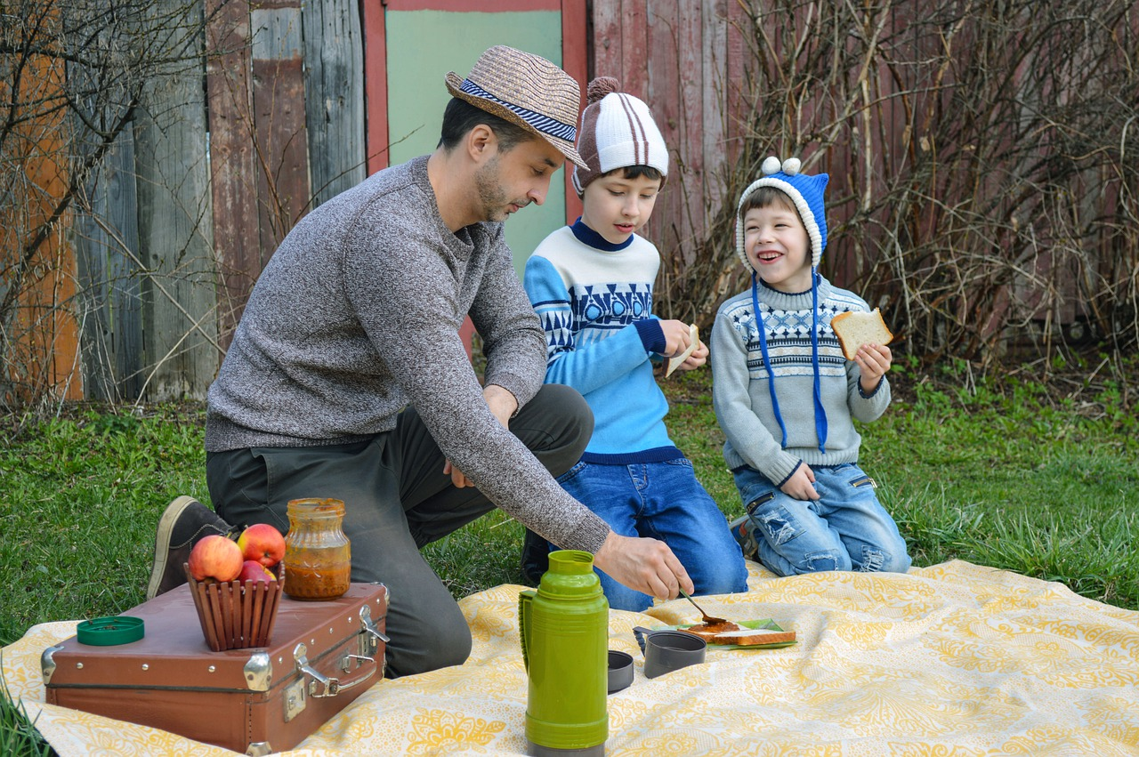
There were 3 apple slices at the picnic.
Tyler's dad brought 5 more apple slices to the picnic.
How many apples slices are there now?

Activity Synthesis
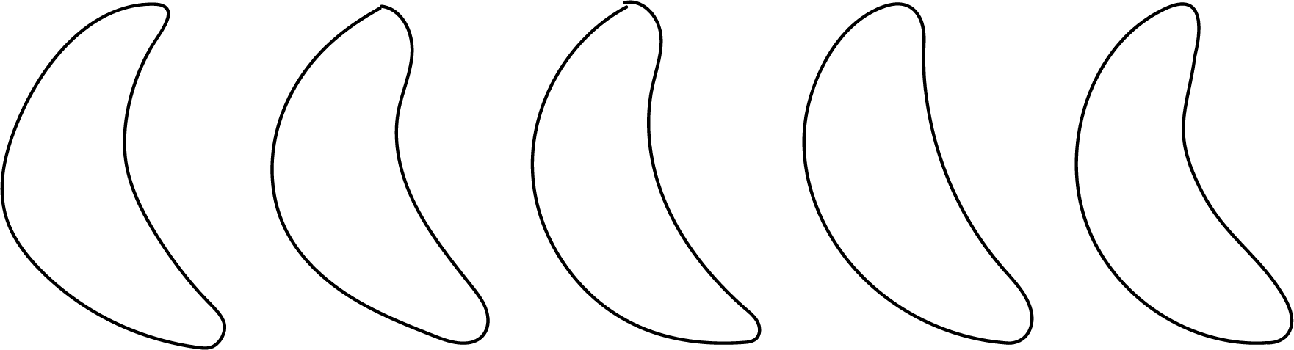
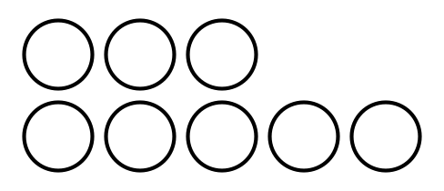

2 Compare Drawings

Student Task Statement
Andre and Noah both drew pictures to show what happened in the story problem.
Andre
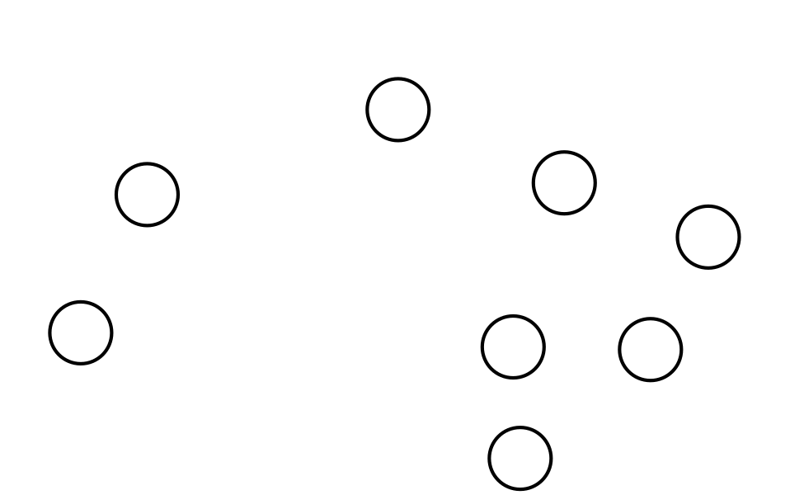
Noah

3 Introduce Bingo, Add and Cover

Student Task Statement
Choose a center.
Bingo
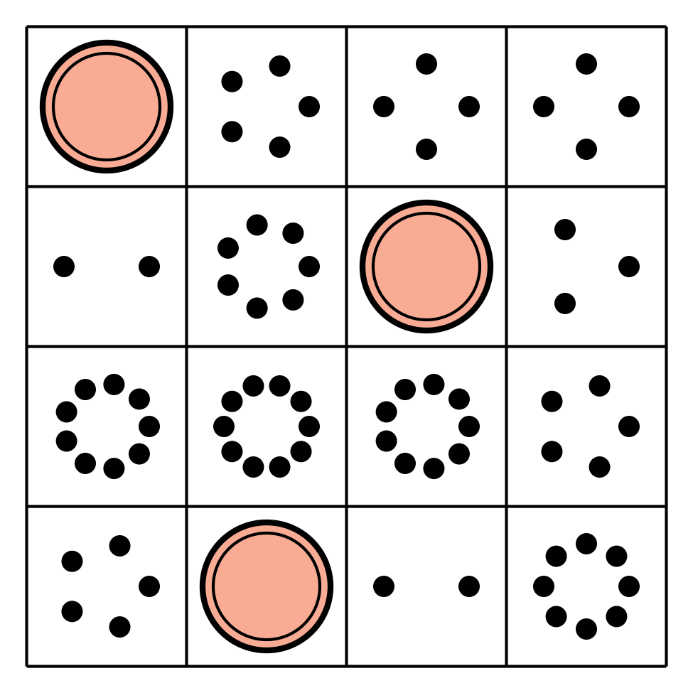
Math Fingers
Subtraction Towers
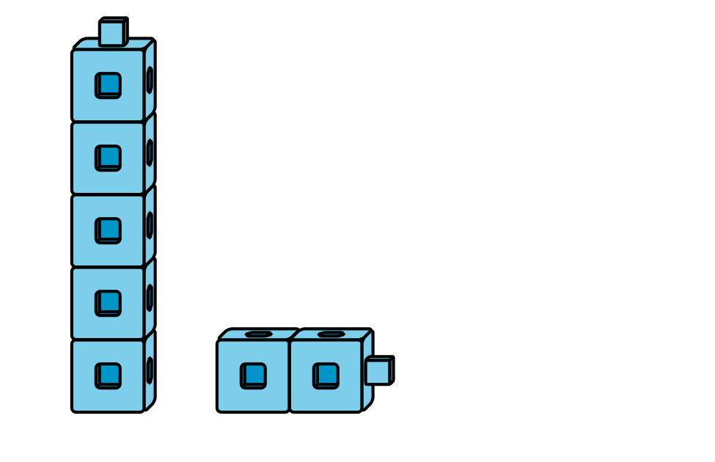
5-frames
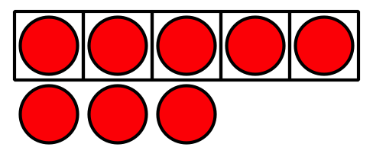
Math Stories
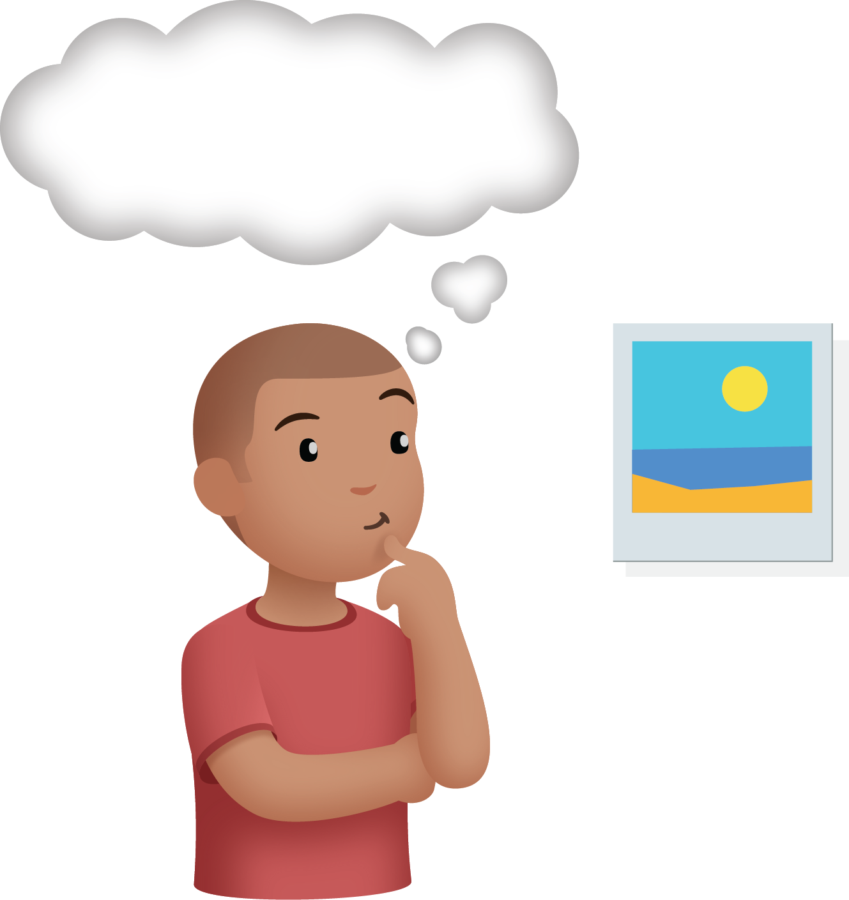
Counting Collections
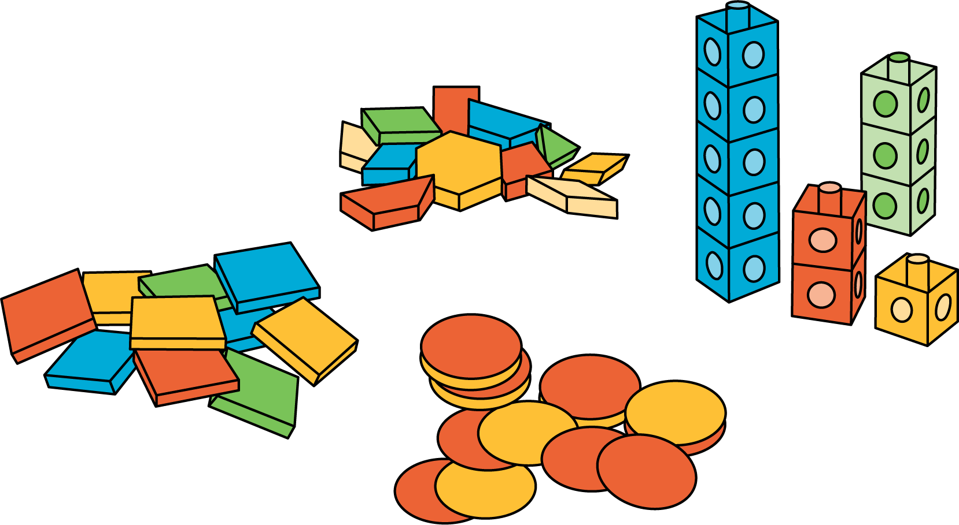

Images for Activity Synthesis
© CC BY 2021 Illustrative Mathematics®

