Lesson 4: Add and Subtract Three-digit Numbers in Different Ways
- Let’s add and subtract three-digit numbers.

Warm-up: Number Talk: Count Back by Place
Find the value of each expression mentally.
- $586−100$
- $486−20$
- $457−200$
- $257−30$

4.1: Zero Tens and Zero Ones
Mai and Lin were asked to find the value of $500−387$.
Here is their work.
Mai's Work
$387+?=500$
$387+100=487$
$487+10=497$
$497+3=500$
$100+10+3=113$
Lin's Work
$387=300+80+7$
$500−300=200$
$200−80=120$
$120−7=113$
Find the value of each expression.
Show your thinking.
- Try Mai’s way to find the value of $600−476$.
- Try Lin’s way to find the value of $400−134$.

4.2: Add or Subtract with Expanded Form
- Andre and Diego showed their thinking with equations to find the value of $427+351$.
- Andre's Work
- 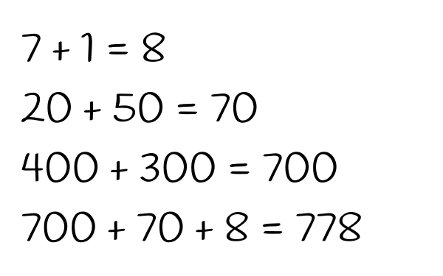
- Diego's Work
- 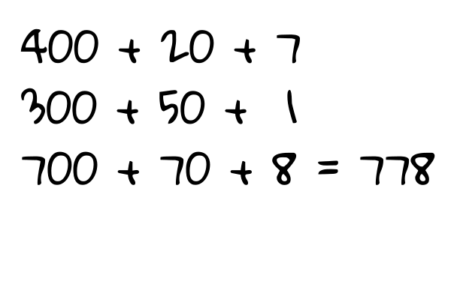
- What is the same or different about their work?
- Discuss with your partner.
- Try Andre’s way to find the value of $725+243$.
- Try Diego’s way to find the value of $863−432$.
- Choose your own way to find the value of $163+326$. Show your thinking.
- Choose your own way to find the value of $692−571$. Show your thinking.

Section Summary
Section Summary
In this section of the unit, we compared three-digit numbers and looked at how addition can be used to find the difference, especially when numbers are close together. We added and subtracted by counting on or back by place and used expanded form to think about adding or subtracting using place value based strategies.
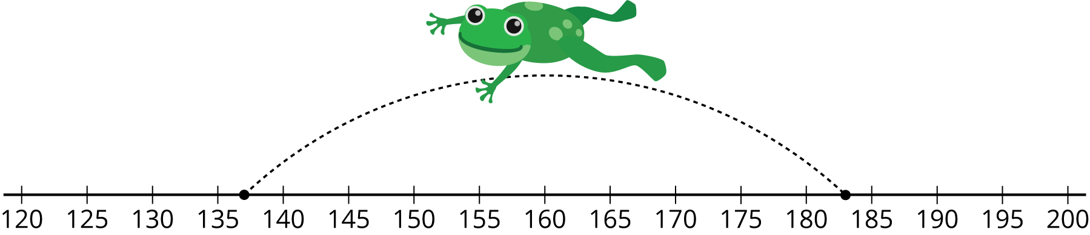
© CC BY 2021 Illustrative Mathematics®

