Unit 7 Lesson 5 Cumulative Practice Problems
- Write with a single exponent: (ex: $\frac{1}{10}⋅\frac{1}{10}={10}^{\text{-}2}$)
  - $\frac{1}{10}⋅\frac{1}{10}⋅\frac{1}{10}$
  - $\frac{1}{10}⋅\frac{1}{10}⋅\frac{1}{10}⋅\frac{1}{10}⋅\frac{1}{10}⋅\frac{1}{10}⋅\frac{1}{10}$
  - $(\frac{1}{10}⋅\frac{1}{10}⋅\frac{1}{10}⋅\frac{1}{10})^{2}$
  - $(\frac{1}{10}⋅\frac{1}{10}⋅\frac{1}{10})^{3}$
  - $(10⋅10⋅10)^{\text{-}2}$
- Write each expression as a single power of 10.
  - ${10}^{\text{-}3}⋅{10}^{\text{-}2}$
  - ${10}^{4}⋅{10}^{\text{-}1}$
  - $\frac{{10}^{5}}{{10}^{7}}$
  - $({10}^{\text{-}4})^{5}$
  - ${10}^{\text{-}3}⋅{10}^{\text{2}}$
  - $\frac{{10}^{\text{-}9}}{{10}^{5}}$
- Select all of the following that are equivalent to $\frac{1}{10,000}$:
  - $(10,​000)^{\text{-}1}$
  - $(\text{-}10,​000)$
  - $(100)^{\text{-}2}$
  - $(10)^{\text{-}4}$
  - $(\text{-}10)^{2}$
- Match each equation to the situation it describes. Explain what the constant of proportionality means in each equation.
- Equations:
  - $y=3x$
  - $\frac{1}{2}x=y$
  - $y=3.5x$
  - $y=\frac{5}{2}x$
- Situations:
  - A dump truck is hauling loads of dirt to a construction site. After 20 loads, there are 70 square feet of dirt.
  - I am making a water and salt mixture that has 2 cups of salt for every 6 cups of water.
  - A store has a “4 for $10” sale on hats.
  - For every 48 cookies I bake, my students get 24.
- (From Unit 5, Lesson 2.)
  - Explain why triangle $ABC$ is similar to $EDC$.
  - 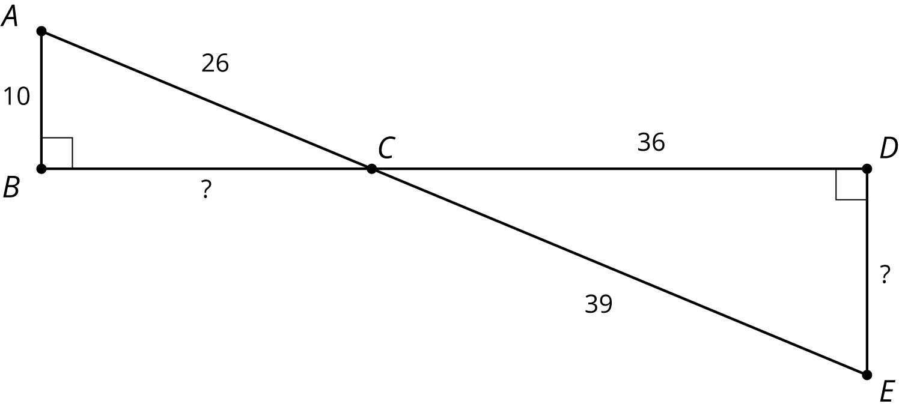
  - Find the missing side lengths.
- (From Unit 2, Lesson 13.)
© CC BY Open Up Resources. Adaptations CC BY IM.

