Unit 8 Lesson 6 Cumulative Practice Problems
  - Find the lengths of the unlabeled sides.
  - 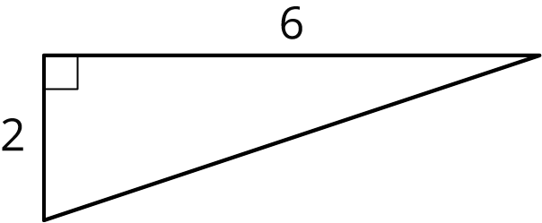
  - 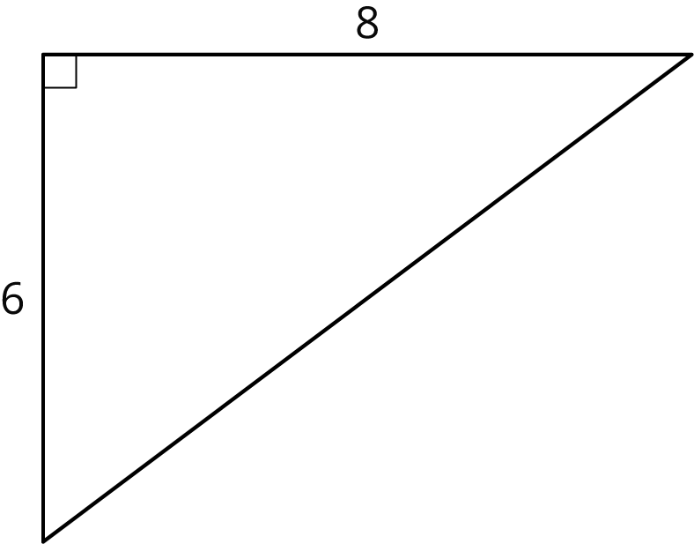
  - One segment is $n$ units long and the other is $p$ units long. Find the value of $n$ and $p$. (Each small grid square is 1 square unit.)
  - 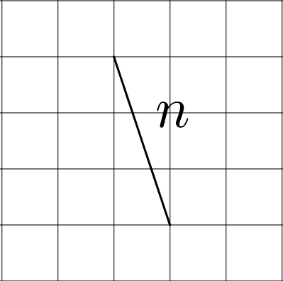
  - 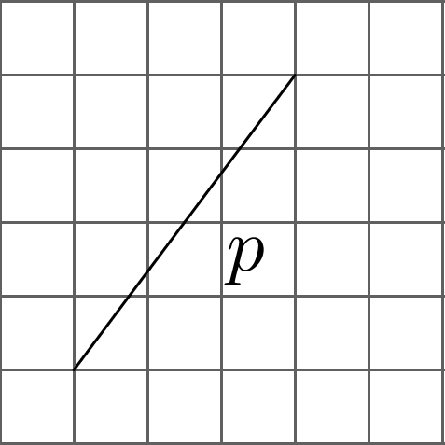
- Use the areas of the two identical squares to explain why $5^{2}+{12}^{2}={13}^{2}$ without doing any calculations.
- 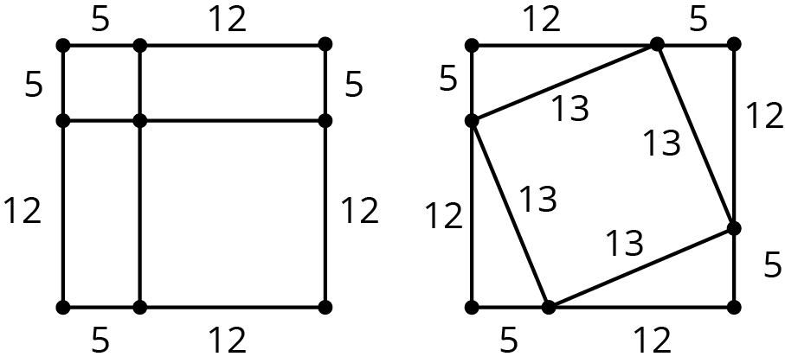

- Find the exact value of each variable that represents a side length in a right triangle.
- 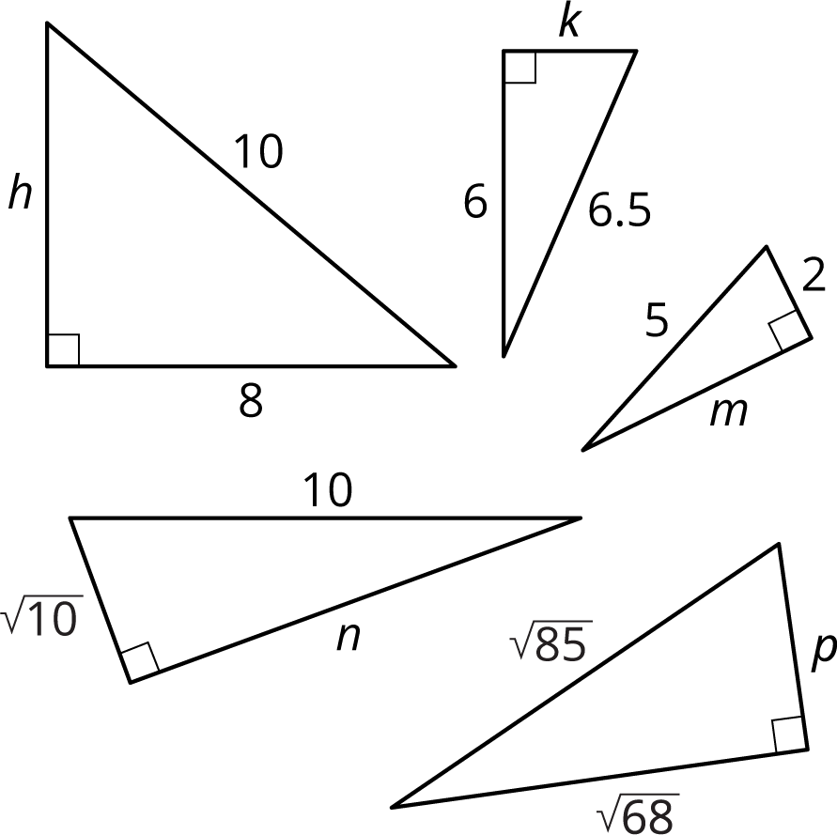

- Write each expression as a single power of 10.
  - ${10}^{5}⋅{10}^{0}$
  - $\frac{{10}^{9}}{{10}^{0}}$
- (From Unit 7, Lesson 4.)
- Here is a scatter plot of weight vs. age for different Dobermans. The model, represented by $y=2.45x+1.22$, is graphed with the scatter plot. Here, $x$ represents age in weeks, and $y$ represents weight in pounds.
- 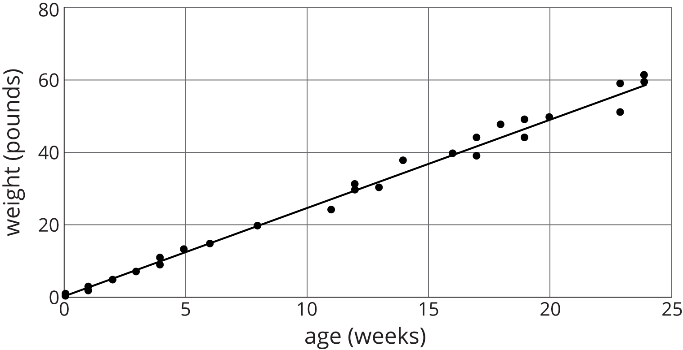
  - What does the slope mean in this situation?
  - Based on this model, how heavy would you expect a newborn Doberman to be?
- (From Unit 5, Lesson 21.)
© CC BY Open Up Resources. Adaptations CC BY IM.

