Unit 1 Lesson 5: Explore Math Tools

WU Notice and Wonder: Using Different Tools (Warm up)

Student Task Statement
What do you notice?
What do you wonder?
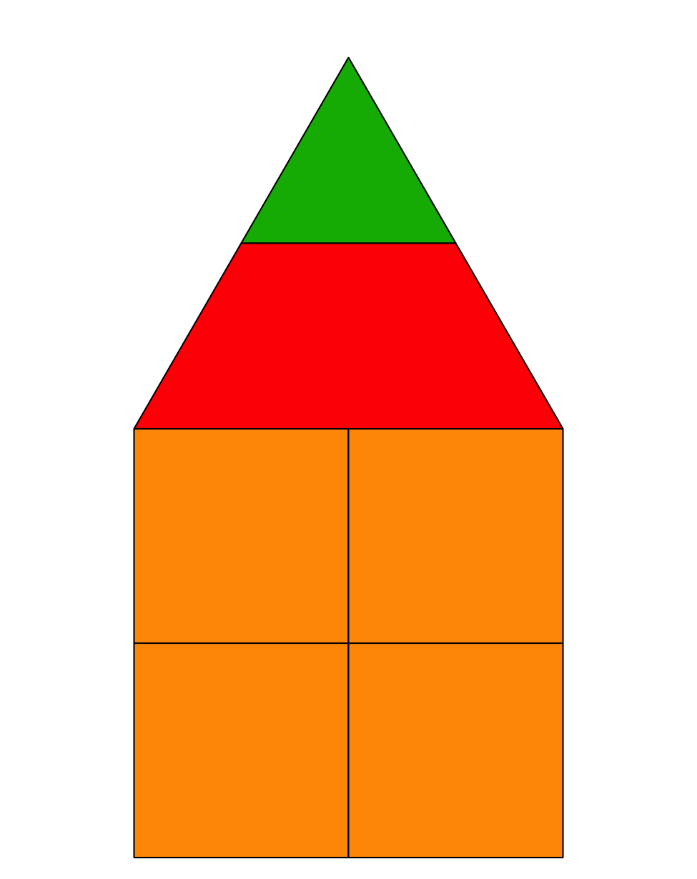
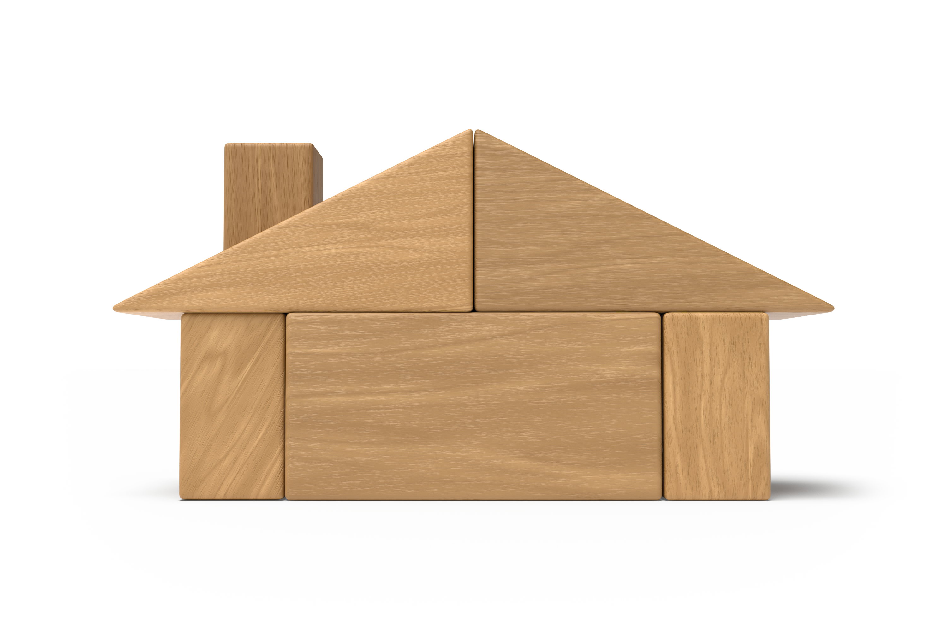
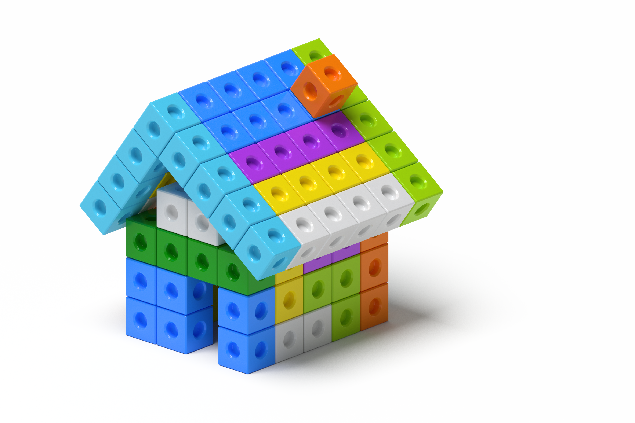

1 Introduce Connecting Cubes, Build to Match

Student Task Statement
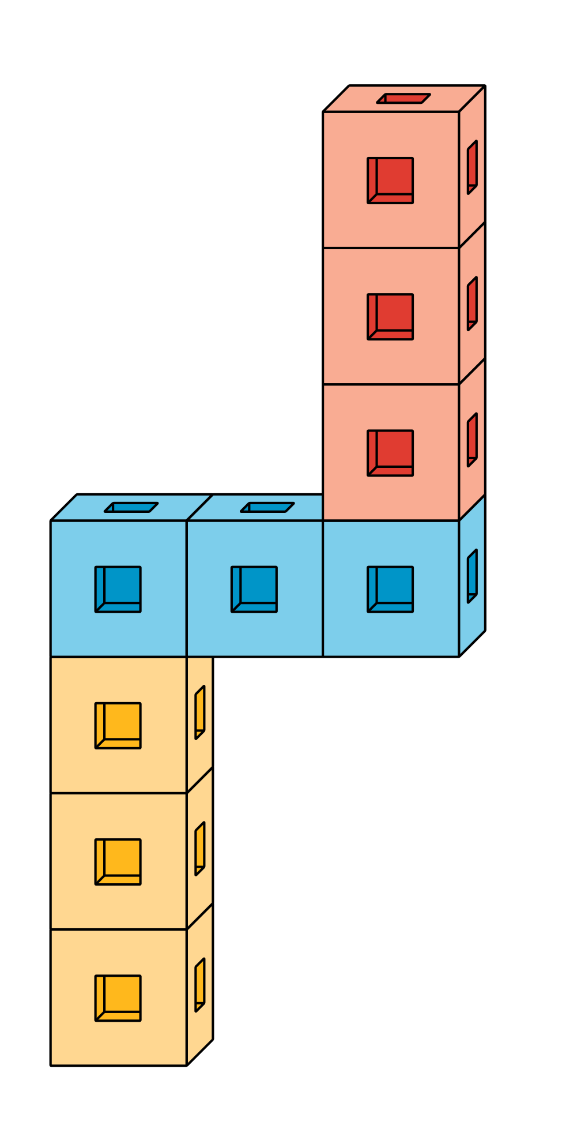

2 Introduce Pattern Blocks, Puzzles

Student Task Statement
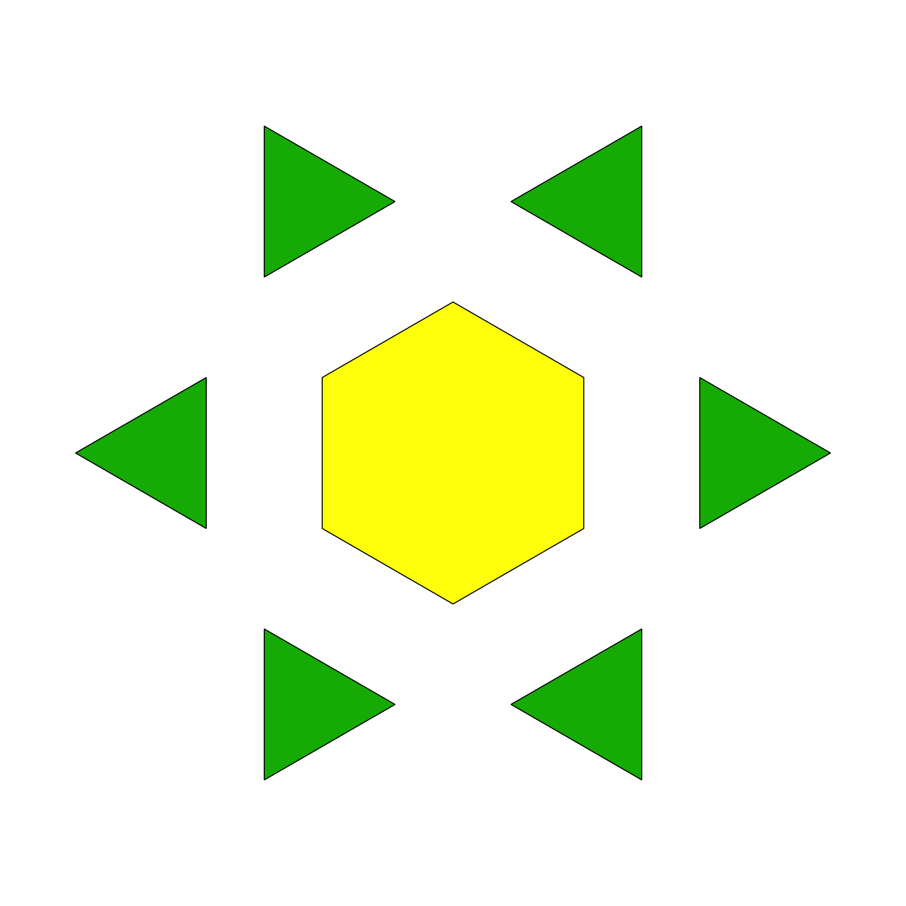

3 Centers: Choice Time

Student Task Statement
Choose a center.
Geoblocks
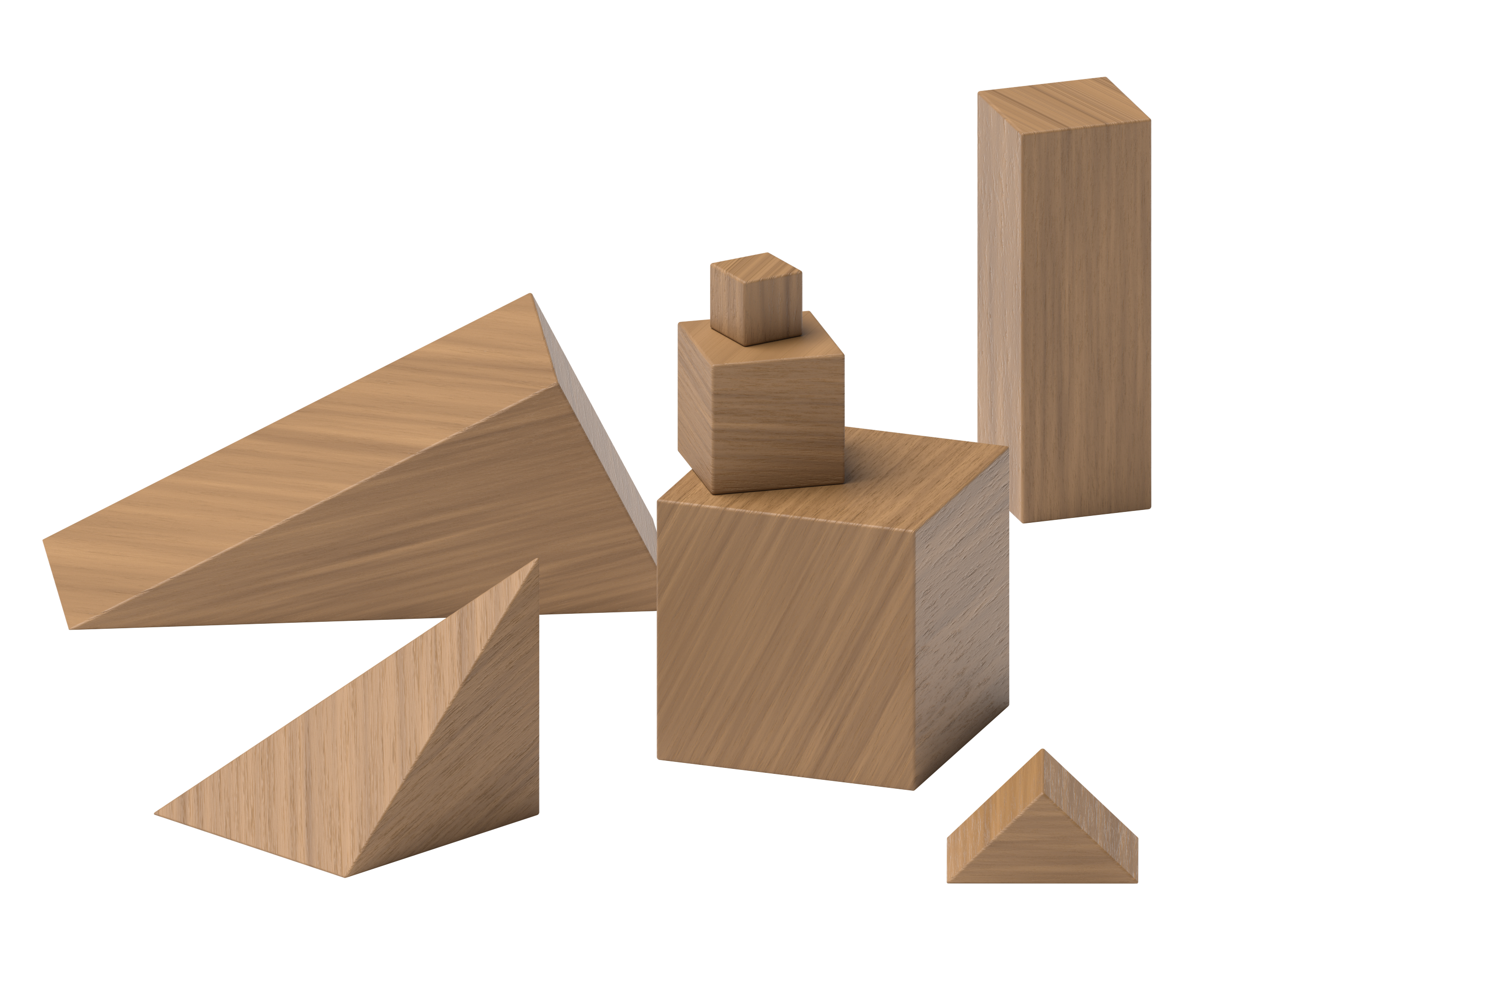
Connecting Cubes
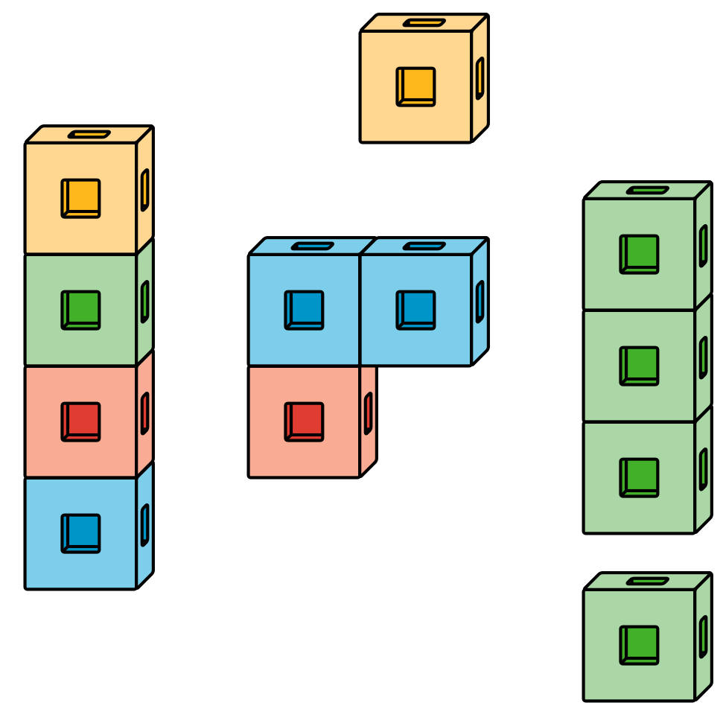
Pattern Blocks
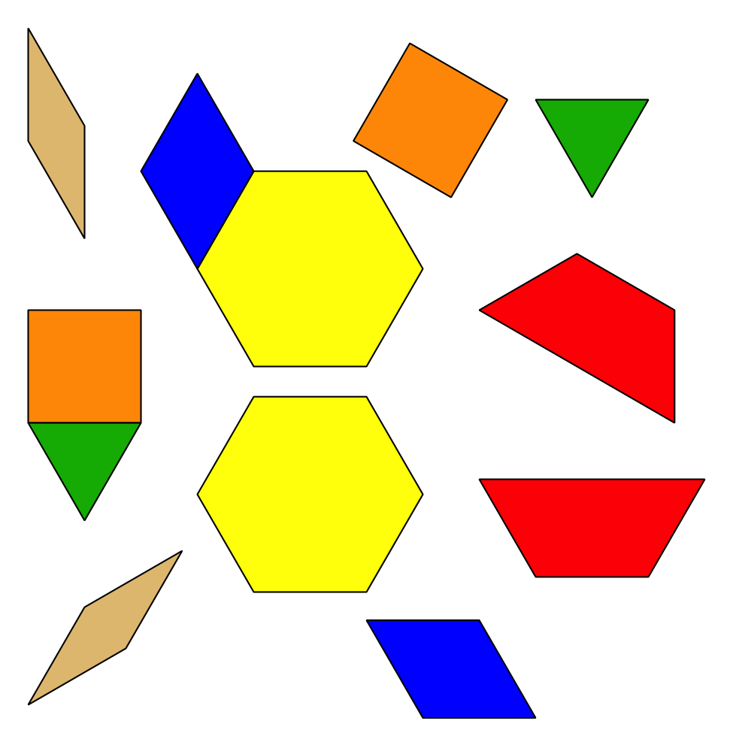
© CC BY 2021 Illustrative Mathematics®

