Lesson 3: Count Carefully
- Let’s see if we get the same number as our partner when we count the same group of objects.

Warm-up: Notice and Wonder: Pile of Connecting Cubes
What do you notice?
What do you wonder?
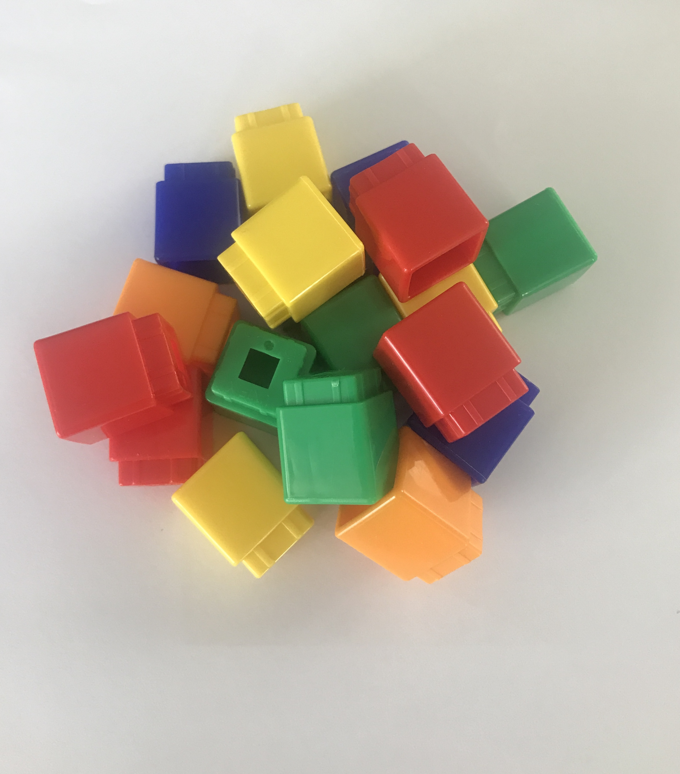

3.2: Count Carefully with Friends
Clare, Andre, and Noah all counted these cubes.
Clare says there are 15 cubes.
Andre says there are 16 cubes.
Noah says there are 17 cubes.
Can they all be right?

3.3: Introduce Find the Pair, Make 5
Choose a center.
Find the Pair
Number Race
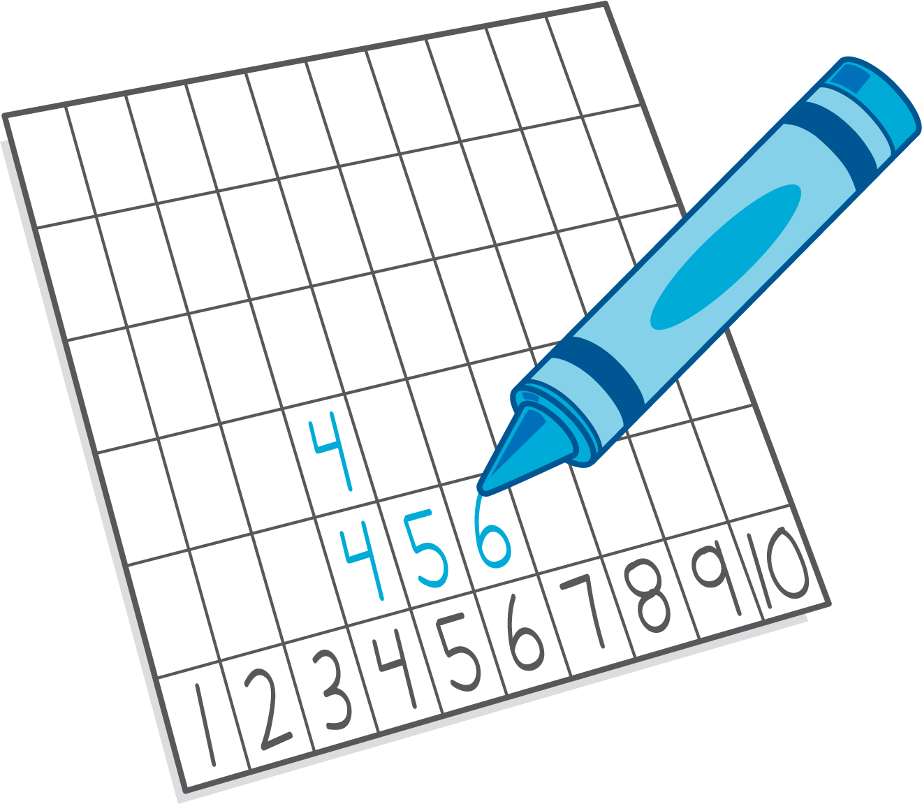
Subtraction Towers
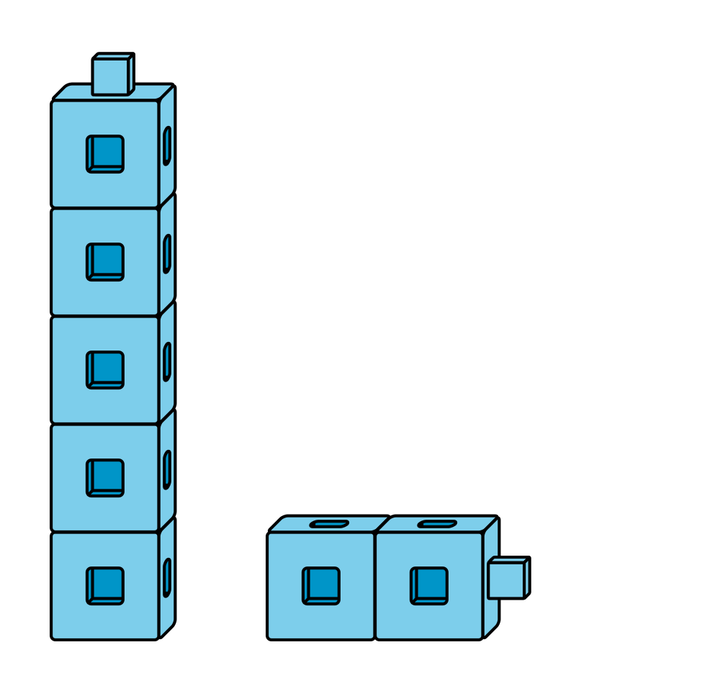
5-frames
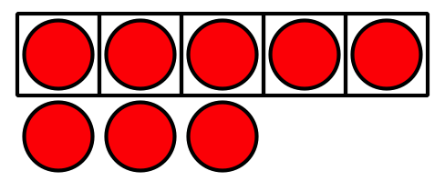
© CC BY 2021 Illustrative Mathematics®

