Lesson 8: Find Someone Who, Find Something That
- Let’s learn more about our classmates and our classroom.

Warm-up: Which One Doesn’t Belong: Representations of 6
Which one doesn’t belong?
A
B
C
D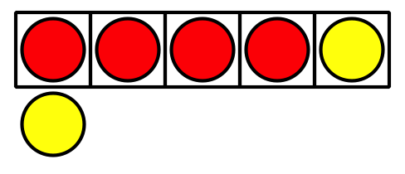

8.2: Find Something That
- Find something that you can count.
- Find 2 objects that you can compare the weight of.
- Find something that you know how many there are without counting.
- Find something that there are 5 of.
- Find 2 groups of objects that make 10 objects altogether.
- Find a group of objects that you could use to fill in a 10-frame.
- Find something that you could make using solid shapes.
- Find 2 groups of objects that you can compare the number of.
- Find something that has a number on it.
- Find 2 objects that you can compare the length of.
© CC BY 2021 Illustrative Mathematics®

