Lesson 5: Representing Exponential Decay
Let’s think about how to show and talk about exponential decay.

5.1: Two Other Tables
Use the patterns you notice to complete the tables. Show your reasoning.
Table A
$x$ | 0 | 1 | 2 | 3 | 4 | 25
$y$ | 2.5 | 10 | 17.5 | 25

Table B
$x$ | 0 | 1 | 2 | 3 | 4 | 25
$y$ | 2.5 | 10 | 40 | 160

5.2: The Algae Bloom
In order to control an algae bloom in a lake, scientists introduce some treatment products.
Once the treatment begins, the area covered by algae $A$, in square yards, is given by the equation $A=240⋅{\left(\frac{1}{3}\right)}^{t}$. Time, $t$, is measured in weeks.
- In the equation, what does the 240 tell us about the algae? What does the $\frac{1}{3}$ tell us?
- Create a graph to represent $A=240⋅{\left(\frac{1}{3}\right)}^{t}$ when $t$ is 0, 1, 2, 3, and 4. Think carefully about how you choose the scale for the axes. If you get stuck, consider creating a table of values.
- 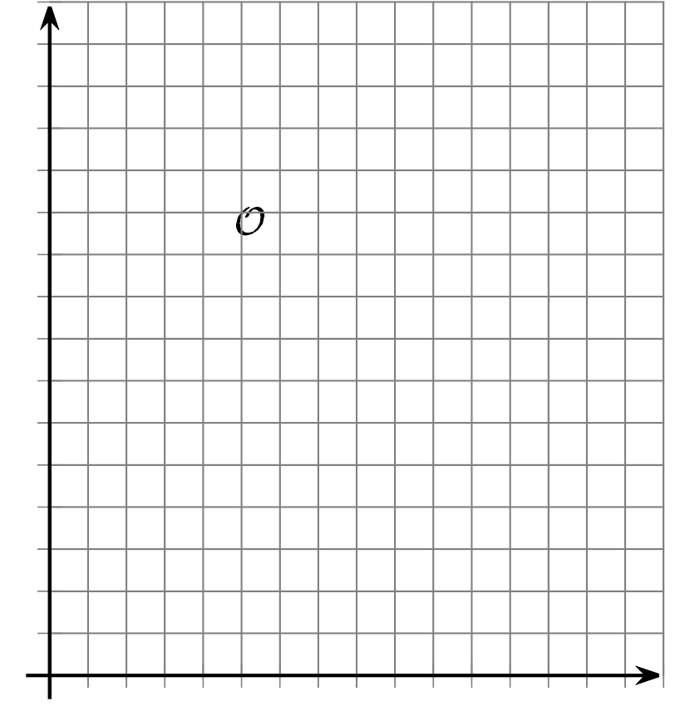
- About how many square yards will the algae cover after 2.5 weeks? Explain your reasoning.

Are you ready for more?
The scientists estimate that to keep the algae bloom from spreading after the treatment concludes, they will need to get the area covered under one square foot. How many weeks should they run the treatment in order to achieve this?

5.3: Insulin in the Body
A patient who is diabetic receives 100 micrograms of insulin. The graph shows the amount of insulin, in micrograms, remaining in his bloodstream over time, in minutes.
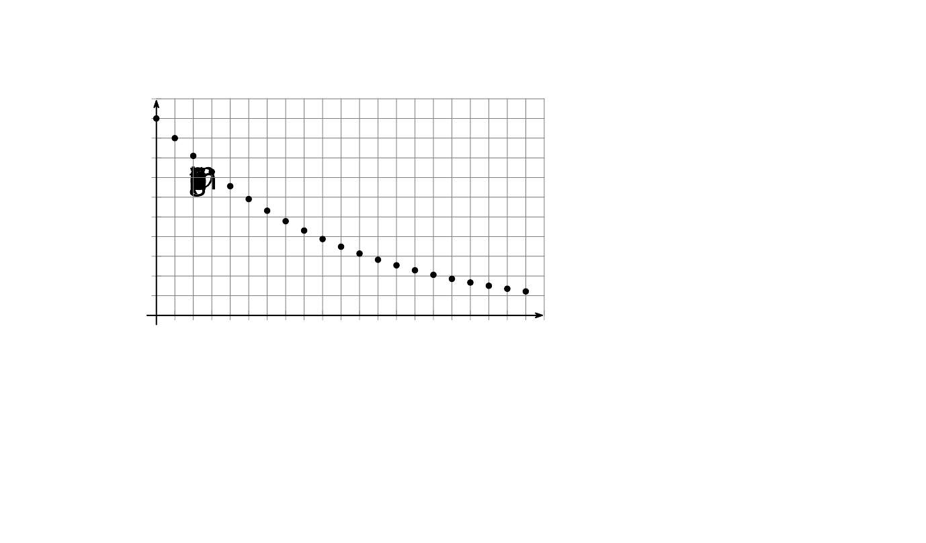
- Scientists have found that the amount of insulin in a patient’s body changes exponentially. How can you check if the graph supports the scientists’ claim?
- How much insulin broke down in the first minute? What fraction of the original insulin is that?
- How much insulin broke down in the second minute? What fraction is that of the amount one minute earlier?
- What fraction of insulin remains in the bloodstream for each minute that passes? Explain your reasoning.
- Complete the table to show the predicted amount of insulin 4 and 5 minutes after injection.
- time after injection (minutes) | - 0 | - 1 | - 2 | - 3 | - 4 | - 5
- insulin in the bloodstream (micrograms) | - 100 | - 90 | - 81 | - 72.9
- Describe how you would find how many micrograms of insulin remain in his bloodstream after 10 minutes. After $m$ minutes?

Lesson 5 Summary
Here is a graph showing the amount of caffeine in a person's body, measured in milligrams, over a period of time, measured in hours. We are told that the amount of caffeine in the person's body changes exponentially.
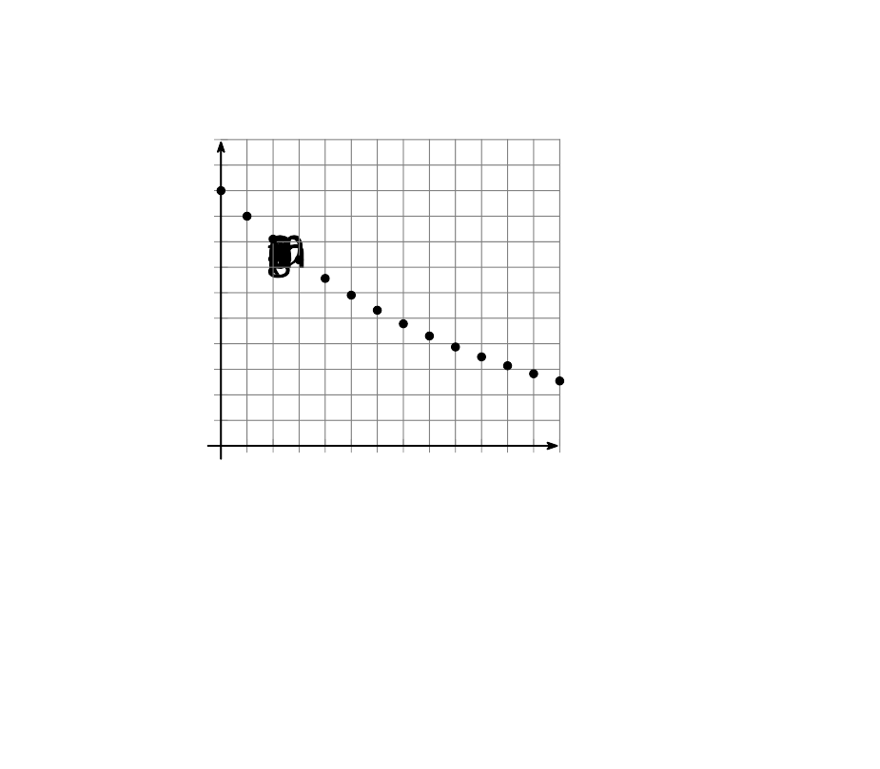
The graph includes the point $(0,200)$. This means that there were 200 milligrams of caffeine in the person's body when it was initially measured. The point $(1,180)$ tells us there were 180 milligrams of caffeine 1 hour later. Between 6 and 7 hours after the initial measurement, the amount of caffeine in the body fell below 100 milligrams.
We can use the graph to find out what fraction of caffeine remains in the body each hour. Notice that $\frac{180}{200}=\frac{9}{10}$ and $\frac{162}{180}=\frac{9}{10}$. As each hour passes, the amount of caffeine that stays in the body is multiplied by a factor of$\frac{9}{10}$.
If $y$ is the amount of caffeine, in milligrams, and $t$ is time, in hours, then this situation is modeled by the equation:
$y=200⋅{\left(\frac{9}{10}\right)}^{t}$
© CC BY 2019 by Illustrative Mathematics®

