Lesson 6 Practice Problems
- Which equation is equivalent to the equation $6x+9=12$?
  - $x+9=6$
  - $2x+3=4$
  - $3x+9=6$
  - $6x+12=9$
- Select all the equations that have the same solution as the equation $3x−12=24$.
  - $15x−60=120$
  - $3x=12$
  - $3x=36$
  - $x−4=8$
  - $12x−12=24$
- Jada has a coin jar containing $n$ nickels and $d$ dimes worth a total of $3.65. The equation $0.05n+0.1d=3.65$ is one way to represent this situation.
- Which equation is equivalent to the equation $0.05n+0.1d=3.65$?
  - $5n+d=365$
  - $0.5n+d=365$
  - $5n+10d=365$
  - $0.05d+0.1n=365$
- Select all the equations that have the same solution as $2x−5=15$.
  - $2x=10$
  - $2x=20$
  - $2\left(x−5\right)=15$
  - $2x−20=0$
  - $4x−10=30$
  - $15=5−2x$
- The number of hours spent in an airplane on a single flight is recorded on a dot plot. The mean is 5 hours and the standard deviation is approximately 5.82 hours. The median is 4 hours and the IQR is 3 hours. The value 26 hours is an outlier that should not have been included in the data.
- 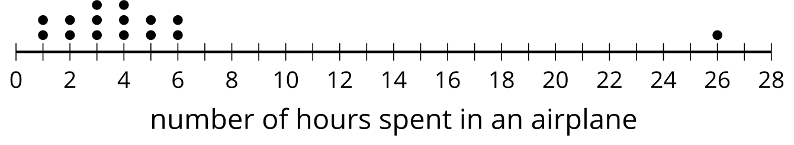
- When the outlier is removed from the data set:
  - What is the mean?
  - What is the standard deviation?
  - What is the median?
  - What is the IQR?
- (From Unit 1, Lesson 14.)
- A basketball coach purchases bananas for the players on his team. The table shows total price in dollars, $P$, of $n$ bananas.
- Which equation could represent the total price in dollars for $n$ bananas?
- number of bananas | - total price in dollars
- 7 | - 4.13
- 8 | - 4.72
- 9 | - 5.31
- 10 | - 5.90
  - $P=0.59n$
  - $P=5.90−0.59n$
  - $P=\frac{5.90}{n}$
  - $P=n+0.59$
- (From Unit 2, Lesson 3.)
- Kiran is collecting dimes and quarters in a jar. He has collected $10.00 so far and has $d$ dimes and $q$ quarters. The relationship between the numbers of dimes and quarters, and the amount of money in dollars is represented by the equation $0.1d+0.25q=10$.
- Select all the values $\left(d,q\right)$ that could be solutions to the equation.
  - $\left(100,0\right)$
  - $\left(20,50\right)$
  - $\left(50,20\right)$
  - $\left(0,100\right)$
  - $\left(10,36\right)$
- (From Unit 2, Lesson 4.)
- Here is a graph of the equation $3x−2y=12$.
- Select all coordinate pairs that represent a solution to the equation.
- 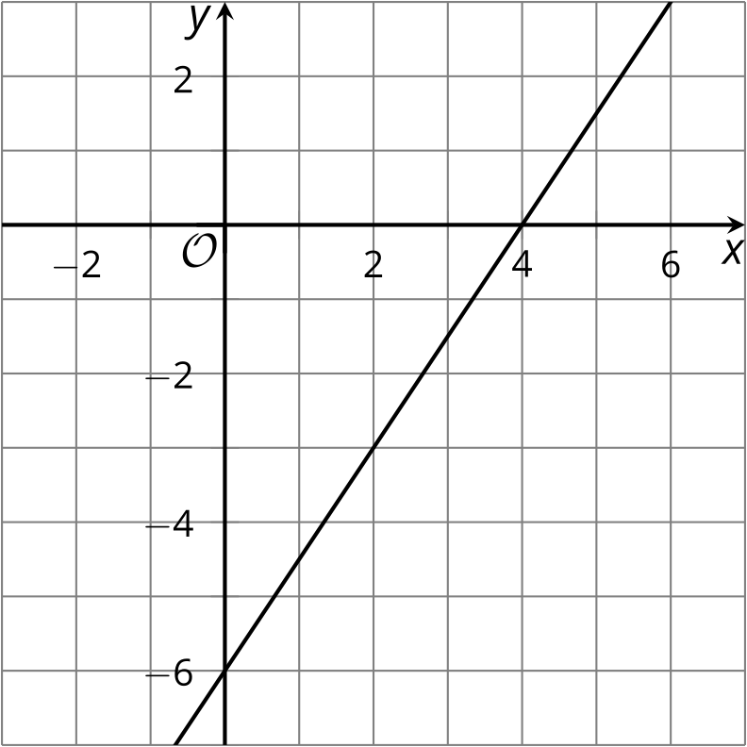
  - $\left(2,\text{-}3\right)$
  - $\left(4,0\right)$
  - $\left(5,\text{-}1\right)$
  - $\left(0,\text{-}6\right)$
  - $\left(2,3\right)$
- (From Unit 2, Lesson 5.)
- Jada bought some sugar and strawberries to make strawberry jam. Sugar costs $1.80 per pound, and strawberries cost $2.50 per pound. Jada spent a total of $19.40.
- Which point on the coordinate plane could represent the pounds of sugar and strawberries that Jada used to make jam?
- 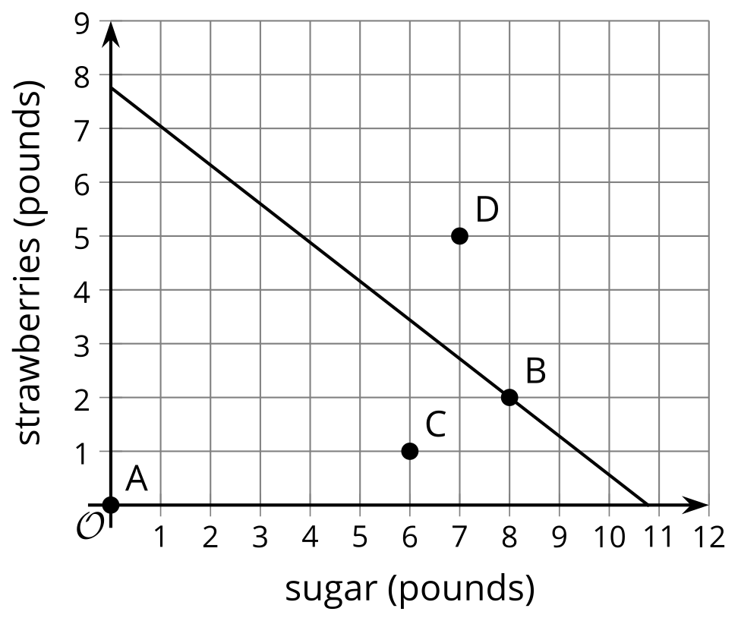
  - Point A
  - Point B
  - Point C
  - Point D
- (From Unit 2, Lesson 5.)
© CC BY 2019 by Illustrative Mathematics®

