Unit 2 Lesson 5: Points, Segments, and Zigzags

1 What's the Point? (Warm up)

Student Task Statement
If $A$ is a point on the plane and $B$ is a point on the plane, then $A$ is congruent to $B$.
Try to prove this claim by explaining why you can be certain the claim must be true, or try to disprove this claim by explaining why the claim cannot be true. If you can find a counterexample in which the “if” part (hypothesis) is true, but the “then” part (conclusion) is false, you have disproved the claim.

2 What's the Segment?

Student Task Statement
Prove the conjecture: If $AB$ is a segment in the plane and $CD$ is a segment in the plane with the same length as $AB$, then $AB$ is congruent to $CD$.

Activity Synthesis

$AB=CD$ so, $\overset{¯}{AB}≅\overset{¯}{CD}$
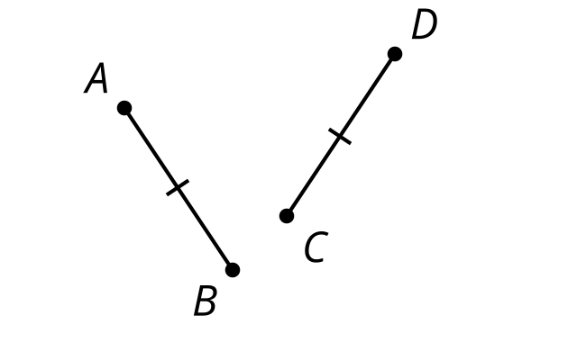

3 Zig Then Zag

Student Task Statement

$\overset{¯}{QR}≅\overset{¯}{XY},\overset{¯}{RS}≅\overset{¯}{YZ},∠R≅∠Y$
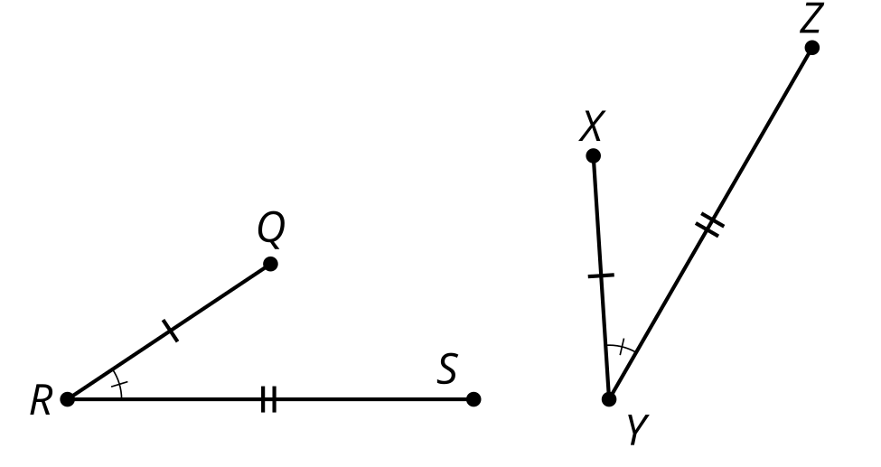
- Here are some statements about 2 zigzags. Put them in order to write a proof about figures $QRS$ and $XYZ$.
  - 1: Therefore, figure $QRS$ is congruent to figure $XYZ$.
  - 2: $S^{′}$ must be on ray $YZ$ since both $S^{′}$ and $Z$ are on the same side of $XY$ and make the same angle with it at $Y$.
  - 3: Segments $QR$ and $XY$ are the same length, so they are congruent. Therefore, there is a rigid motion that takes $QR$ to $XY$. Apply that rigid motion to figure $QRS$.
  - 4: Since points $S^{′}$ and $Z$ are the same distance along the same ray from $Y$, they have to be in the same place.
  - 5: If necessary, reflect the image of figure $QRS$ across $XY$ to be sure the image of $S$, which we will call $S^{′}$, is on the same side of $XY$ as $Z$.
- Take turns with your partner stating steps in the proof that figure $ABCD$ is congruent to figure $EFGH$.
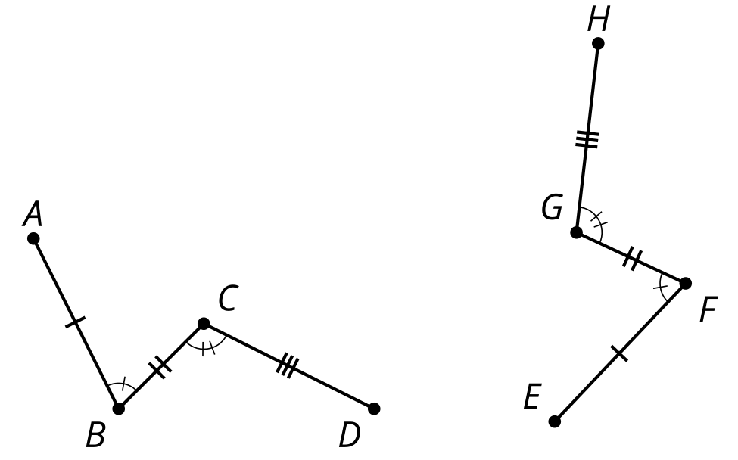
© CC BY 2019 by Illustrative Mathematics®

