Lesson 8: Equations and Graphs
- Let’s write an equation for a parabola.

8.1: Focus on Distance
The image shows a parabola with focus $\left(\text{-}2,2\right)$ and directrix $y=0$ (the $x$-axis). Points $A$, $B$, and $C$ are on the parabola.
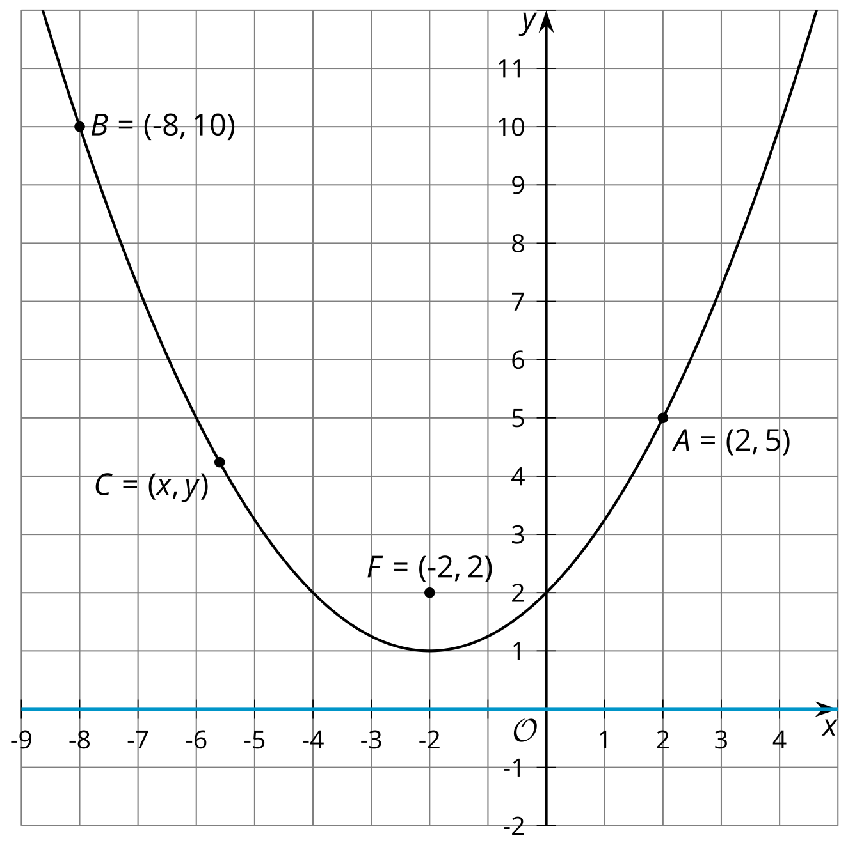
Without using the Pythagorean Theorem, find the distance from each plotted point to the parabola’s focus. Explain your reasoning.

8.2: Building an Equation for a Parabola
The image shows a parabola with focus $\left(3,2\right)$ and directrix $y=0$ (the $x$-axis).
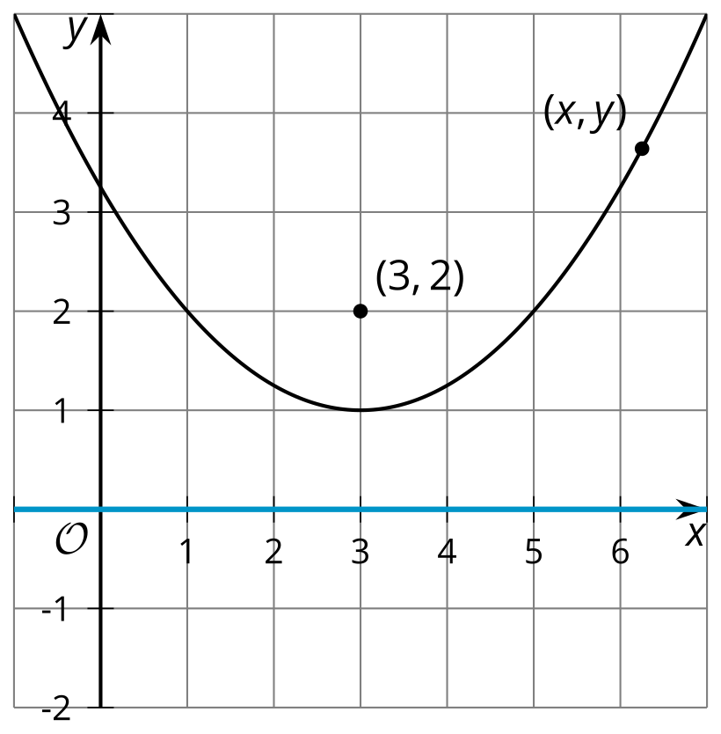
- Write an equation that would allow you to test whether a particular point $\left(x,y\right)$ is on the parabola.
- The equation you wrote defines the parabola, but it’s not in a very easy-to-read form. Rewrite the equation to be in vertex form: $y=a{\left(x−h\right)}^{2}+k$, where $\left(h,k\right)$ is the vertex.

8.3: Card Sort: Parabolas
Your teacher will give you a set of cards with graphs and equations of parabolas. Match each graph with the equation that represents it.

Are you ready for more?
In this section, you have examined points that are equidistant from a given point and a given line. Now consider a set of points that are half as far from a point as they are from a line.
- Write an equation that describes the set of all points that are $\frac{1}{2}$ as far from the point $\left(5,3\right)$ as they are from the $x$-axis.
- Use technology to graph your equation. Sketch the graph and describe what it looks like.

Lesson 8 Summary
The parabola in the image consists of all the points that are the same distance from the point $\left(1,4\right)$ as they are from the line $y=0$. Suppose we want to write an equation for the parabola—that is, an equation that says a given point $\left(x,y\right)$ is on the curve. We can draw a right triangle whose hypotenuse is the distance between point $\left(x,y\right)$ and the focus, $\left(1,4\right)$.
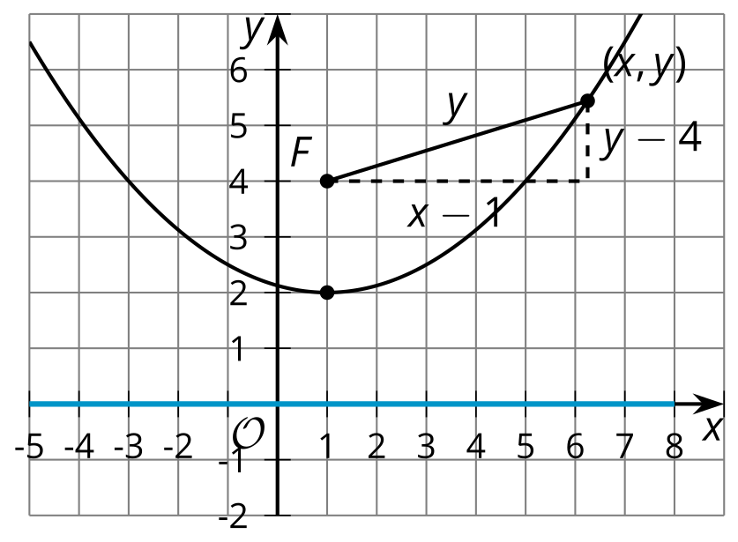
The distance from $\left(x,y\right)$ to the directrix, or the line $y=0$, is $y$ units. By definition, the distance from $\left(x,y\right)$ to the focus must be equal to the distance from the point to the directrix. So, the distance from $\left(x,y\right)$ to the focus can be labeled with $y$. To find the lengths of the legs of the right triangle, subtract the corresponding coordinates of the point $\left(x,y\right)$ and the focus, $\left(1,4\right)$. Substitute the expressions for the side lengths into the Pythagorean Theorem to get an equation defining the parabola.
${\left(x−1\right)}^{2}+{\left(y−4\right)}^{2}=y^{2}$
To get the equation looking more familiar, rewrite it in vertex form, or $y=a{\left(x−h\right)}^{2}+k$ where $\left(h,k\right)$ is the vertex.
${\left(x−1\right)}^{2}+{\left(y−4\right)}^{2}=y^{2}$
${\left(x−1\right)}^{2}+y^{2}−8y+16=y^{2}$
${\left(x−1\right)}^{2}−8y+16=0$
$\text{-}8y=\text{-}{\left(x−1\right)}^{2}−16$
$y=\frac{1}{8}{\left(x−1\right)}^{2}+2$
© CC BY 2019 by Illustrative Mathematics®

