Unit 1 Lesson 4: Parallelograms

1 Features of a Parallelogram (Warm up)

Student Task Statement
Figures A, B, and C are parallelograms. Figures D, E, and F are not parallelograms.
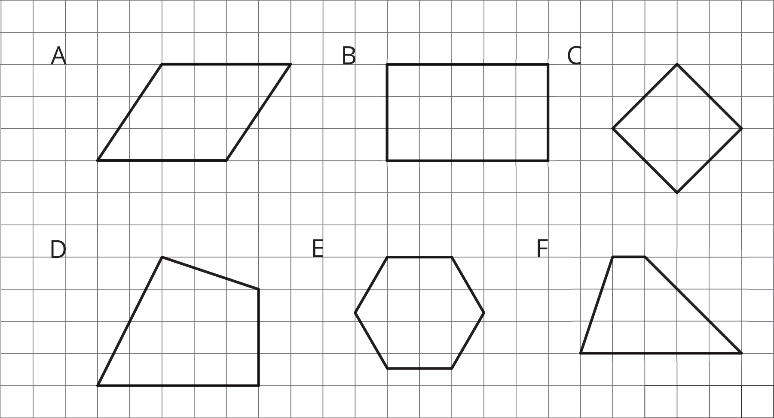
Study the examples and non-examples. What do you notice about:
- the number of sides that a parallelogram has?
- opposite sides of a parallelogram?
- opposite angles of a parallelogram?

2 Area of a Parallelogram

Student Task Statement
Find the area of each parallelogram. Show your reasoning.
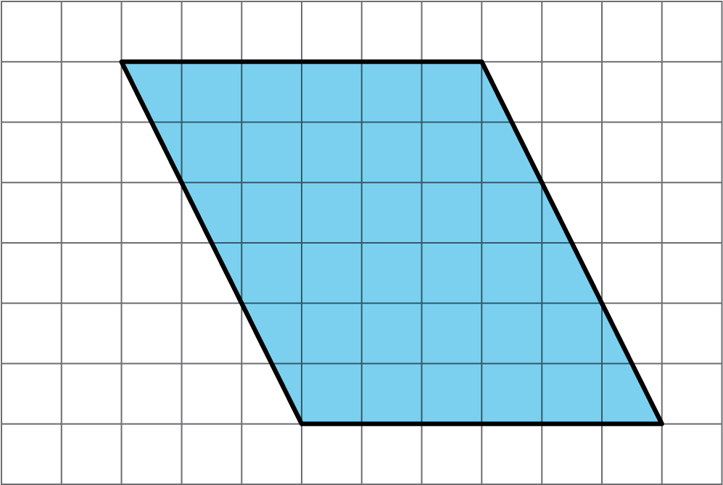
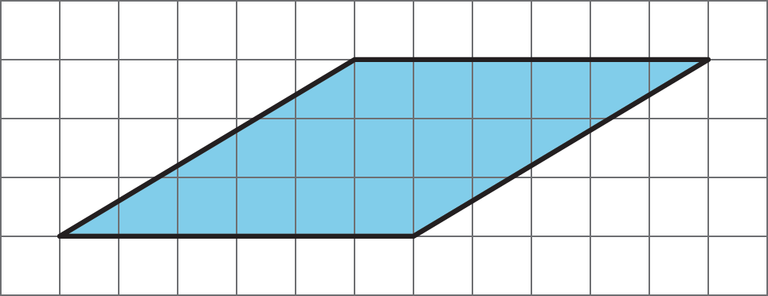

3 Lots of Parallelograms

Student Task Statement
Find the area of each parallelogram. Show your reasoning.
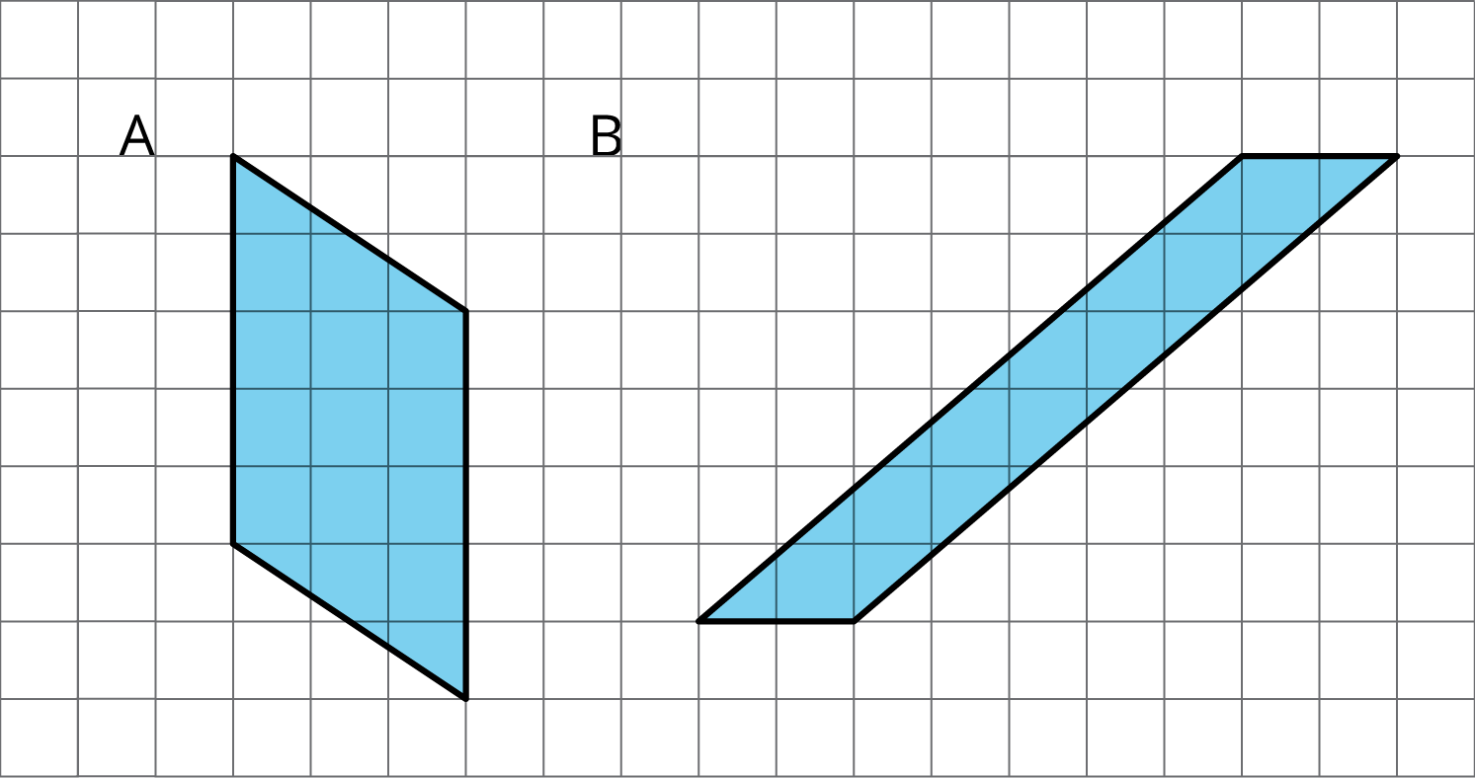
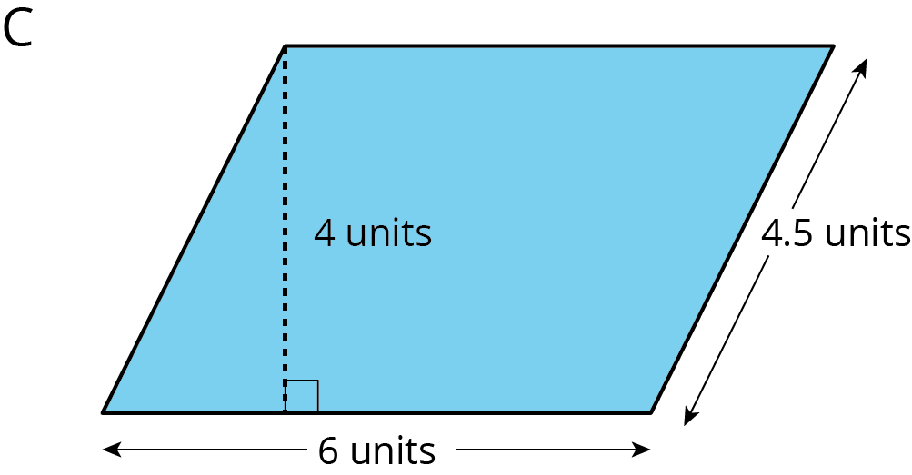

Images for Activity Synthesis
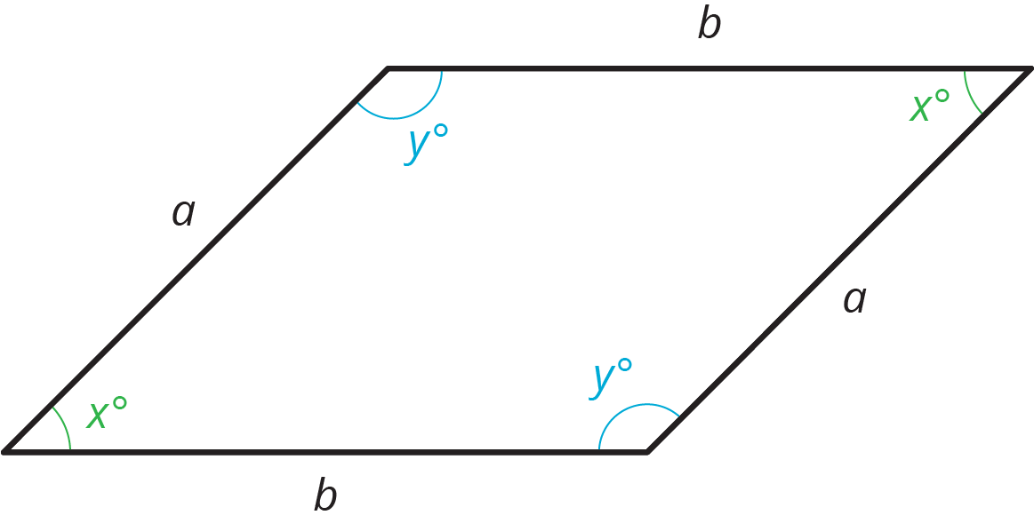
© CC BY Open Up Resources. Adaptations CC BY IM.

