Unit 4 Lesson 9: Patterns in the Multiplication Table

WU Notice and Wonder: Multiplication Table (Warm up)

Student Task Statement
What do you notice? What do you wonder?
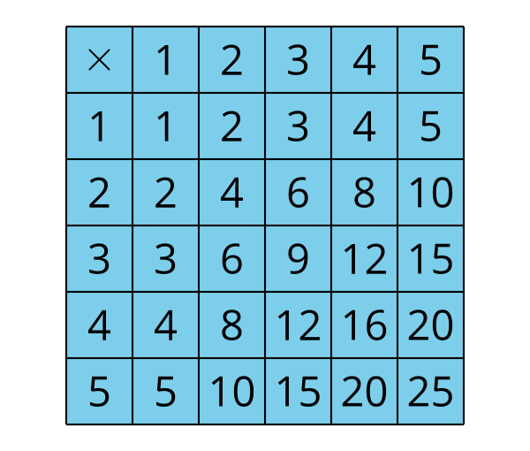

1 Products in the Table

Student Task Statement
Here is a partially completed multiplication table.
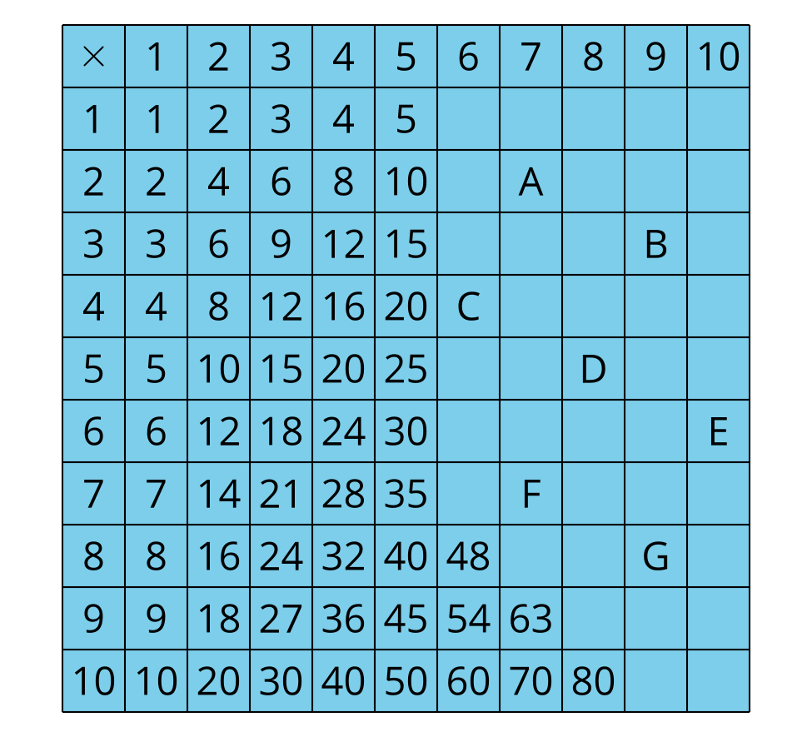
- Use the products in the table to help you find the numbers that should replace letters A–G. Be prepared to explain your reasoning.
- Find the number that should go in three other empty cells in the table. Use:
  - 7 as a factor
  - 9 as a factor
  - 10 as a factor
- Be prepared to explain your reasoning.

2 If I Know, Then I Know: Multiplication

Student Task Statement
- In each row, write down at least two multiplication facts you can figure out because you know the given multiplication fact in the left column. Be prepared to share your reasoning.
- If I know . . . , | - then I also know . . .
- $2×4$ | - $4×2$, $4×4$, $2×8$
- $3×5$
- $4×10$
- $7×2$
- $5×8$
- If time permits, complete the rest of the multiplication table. Use the multiplication facts you know to find those you don’t know.
© CC BY 2021 Illustrative Mathematics®

