Lesson 5: Center Day 1
- Let’s add numbers within 1,000.

Warm-up: How Many Do You See: Hundreds, Tens, and Ones
How many do you see? How do you see them?
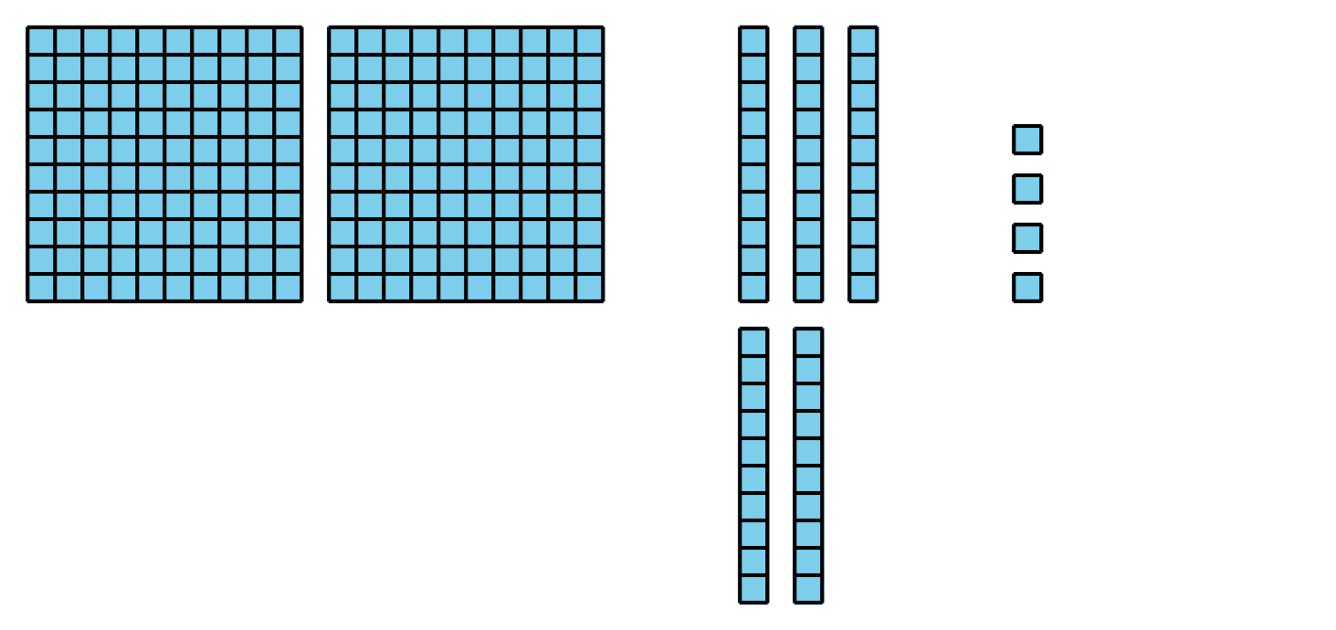
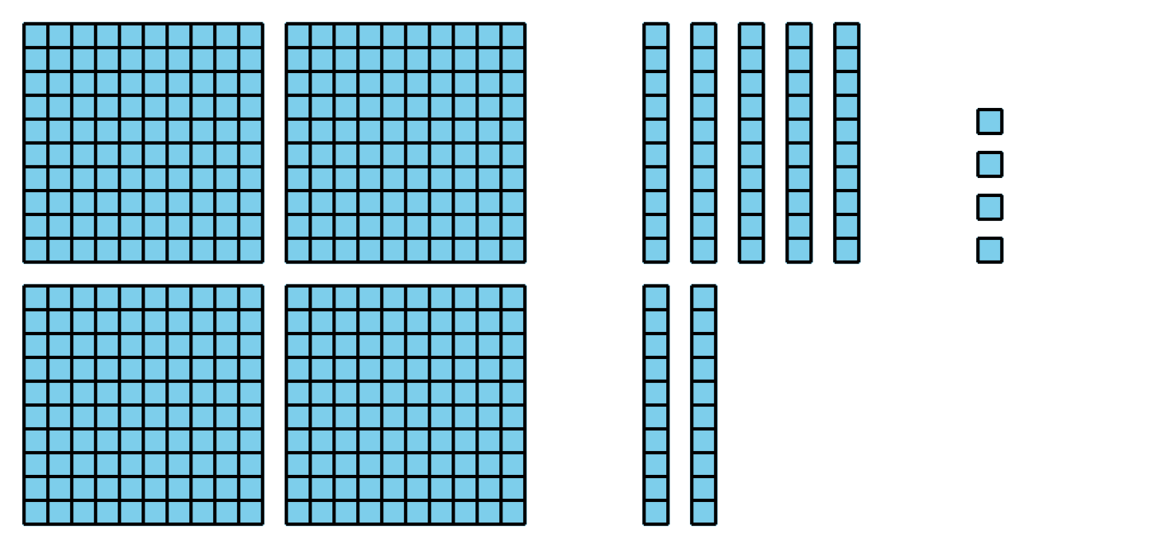
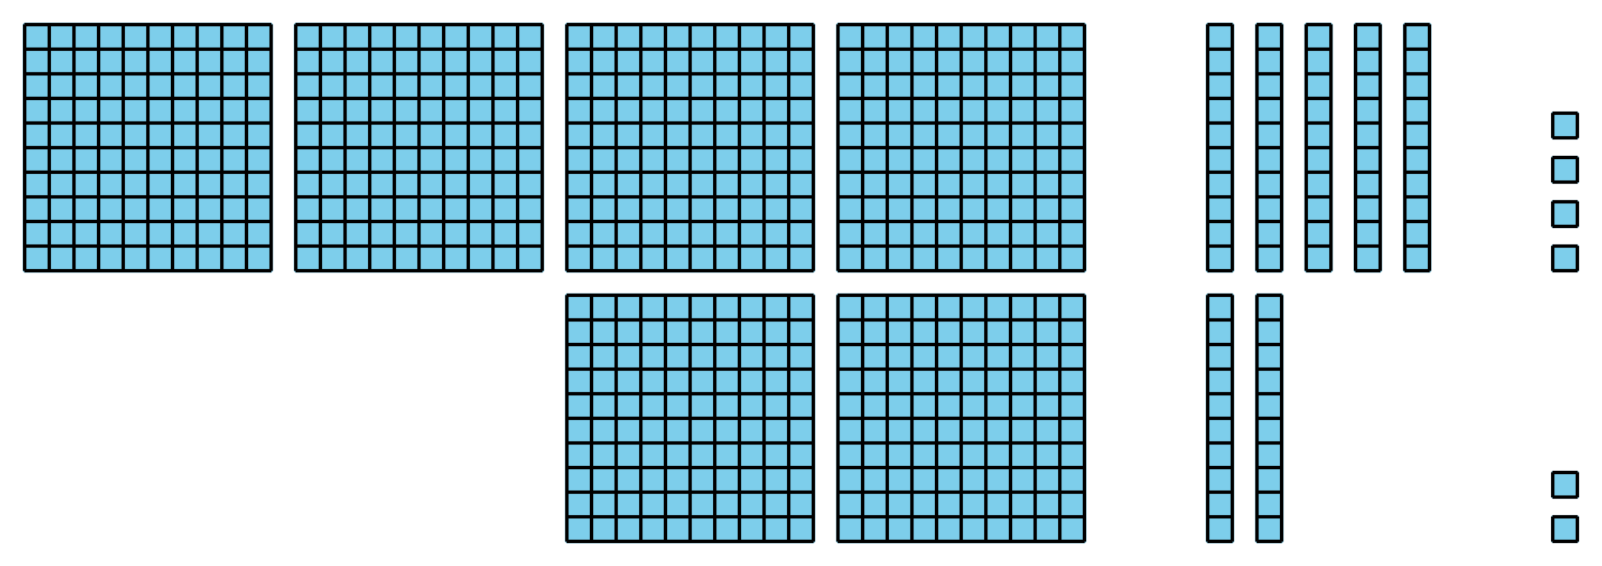

5.2: Centers: Choice Time
Choose a center.
Five in a Row: Addition and Subtraction
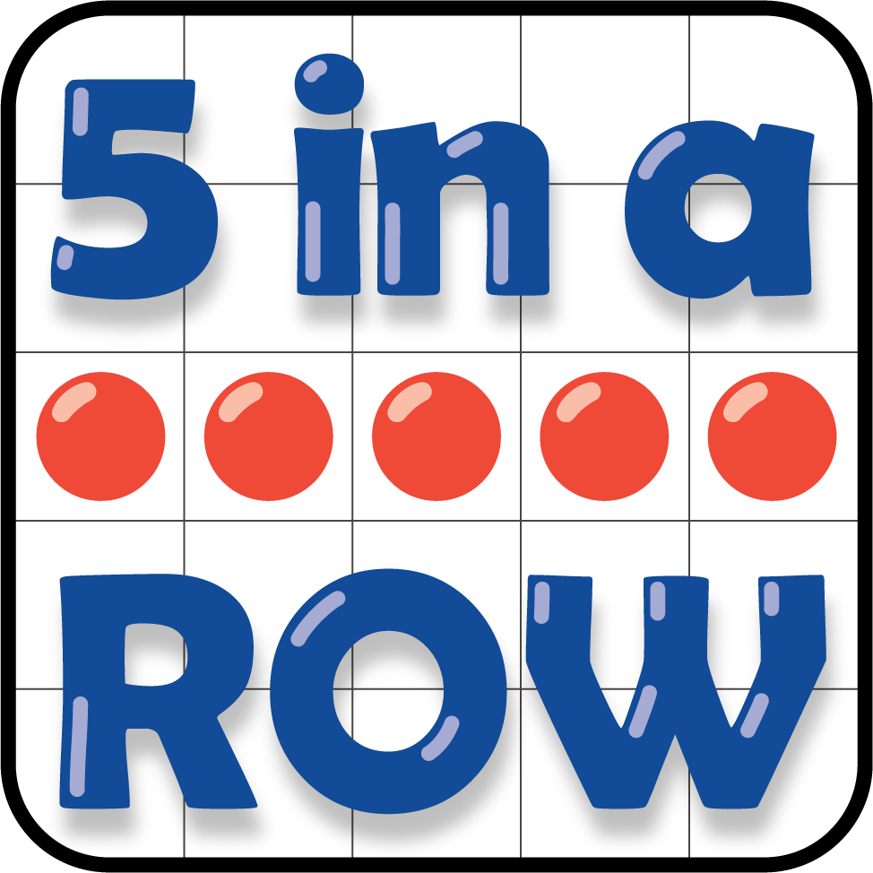
Get Your Numbers in Order
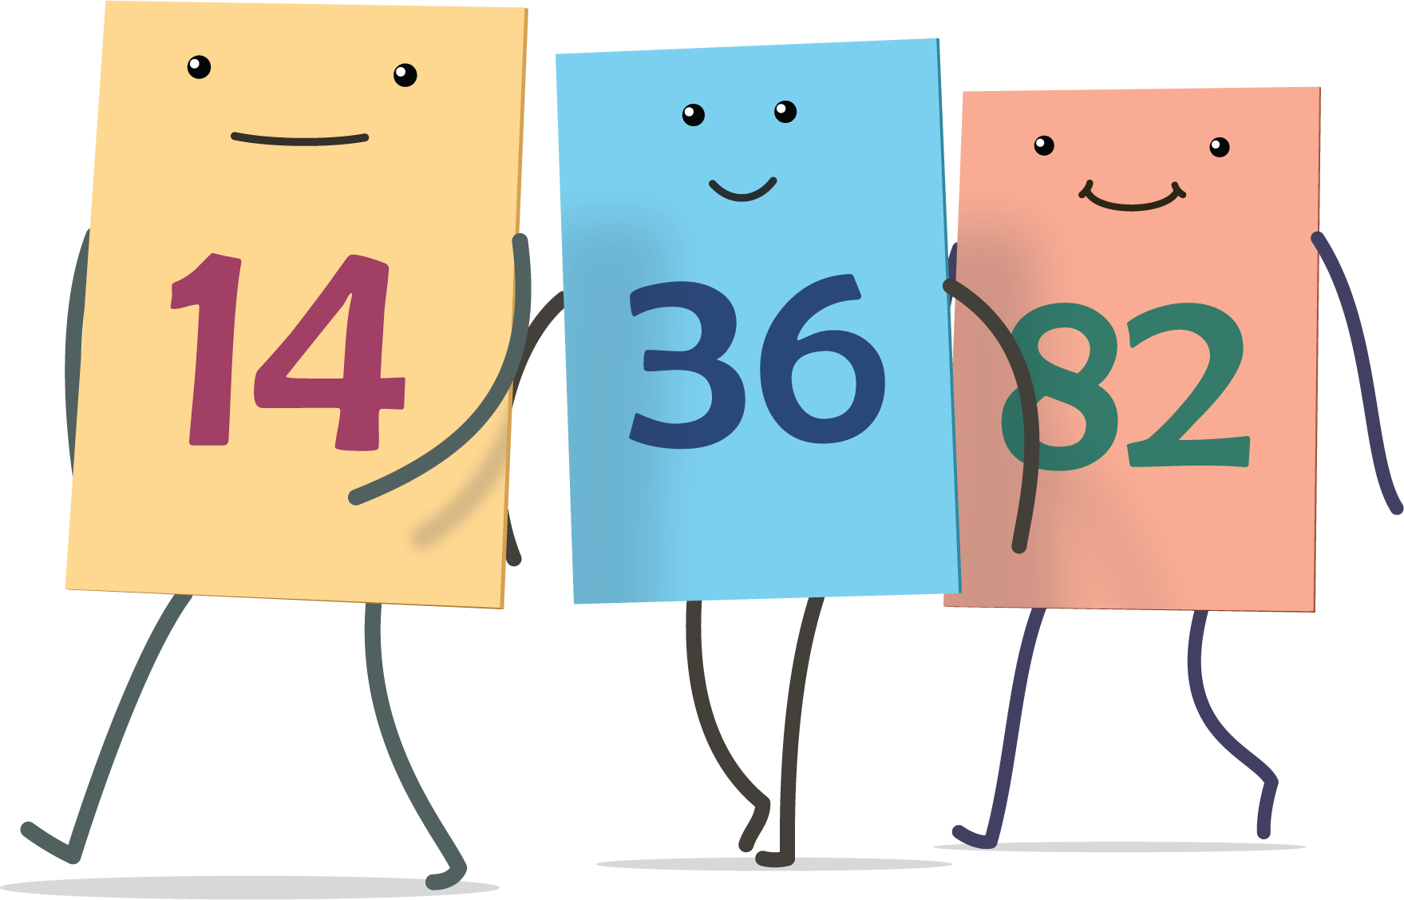
Mystery Number
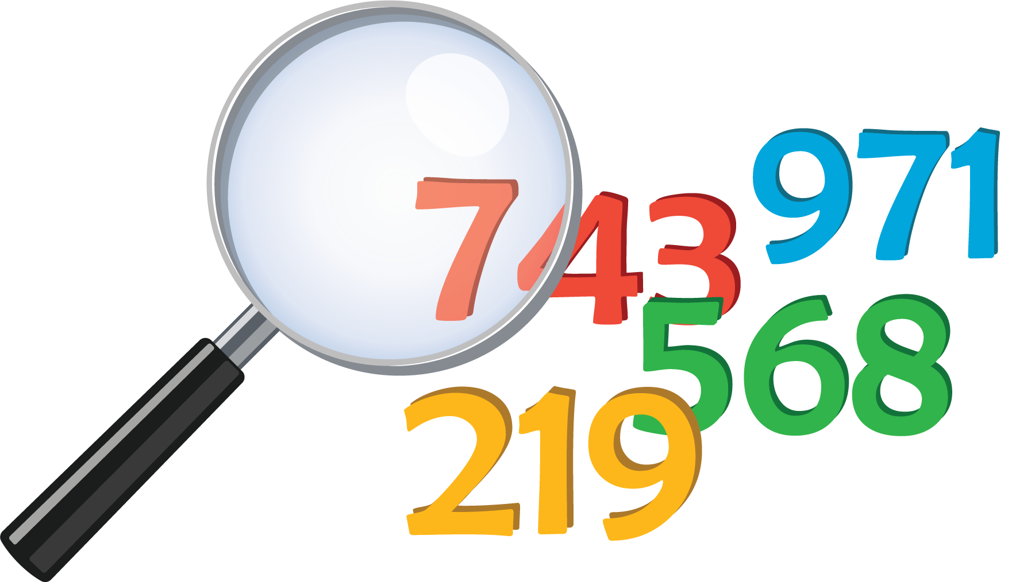
The Greatest of them All
© CC BY 2021 Illustrative Mathematics®

