Lesson 10: Using Algorithms with Partial Products: 2 Two-digit Numbers
- Let’s try to multiply two-digit numbers with an algorithm that uses partial products.

Warm-up: Number Talk: Products
Find the value of each expression mentally.
- $30×7$
- $15×14$
- $50×8$
- $25×16$

10.1: Partial Products, Recorded
- Tyler used an algorithm to find the value of $64×87$.
- 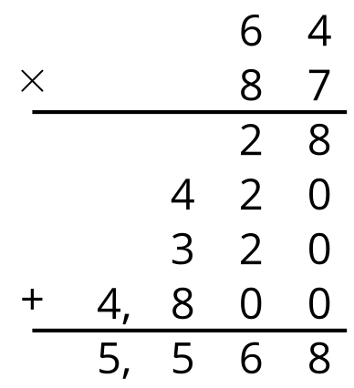
- How do you think he arrived at the last five numbers? Record your thinking. Be prepared to share it with a partner.
- Use Tyler’s method to find the value of $31×15$. Then, draw a diagram to check your answer.

10.2: Han’s Multiplication Mishap
- Decide with your partner who will find each product. Show your reasoning.
- Here is Han’s computation of $51×47$.
- 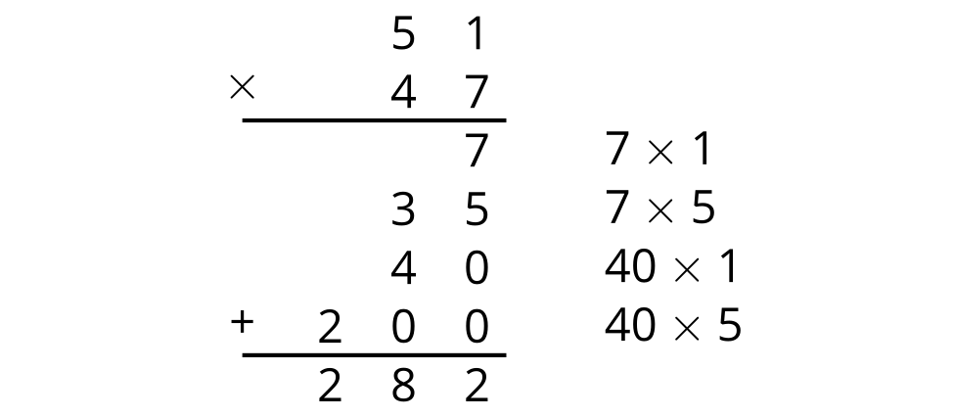
  - What error or errors did Han make?
  - Show the correct computation for finding the value of $51×47$.
© CC BY 2021 Illustrative Mathematics®

