Unit 4 Lesson 3: Interpreting Inequalities

1 True or False: Fractions and Decimals (Warm up)

Student Task Statement
Is each equation true or false? Be prepared to explain your reasoning.
- $3(12+5)=(3⋅12)⋅(3⋅5)$
- $\frac{1}{3}⋅\frac{3}{4}$ = $\frac{3}{4}⋅\frac{2}{6}$
- $2⋅(1.5)⋅12$ = $4⋅(0.75)⋅6$

2 Basketball Game

Student Task Statement
Noah scored $n$ points in a basketball game.
- What does $15<n$ mean in the context of the basketball game?
- What does $n<25$ mean in the context of the basketball game?
- Draw two number lines to represent the solutions to the two inequalities.
- Name a possible value for $n$ that is a solution to both inequalities.
- Name a possible value for $n$ that is a solution to $15<n$, but not a solution to $n<25$.
- Can -8 be a solution to $n$ in this context? Explain your reasoning.

3 Unbalanced Hangers

Student Task Statement
- Here is a diagram of an unbalanced hanger.
- 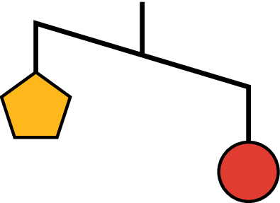
  - Jada says that the weight of one circle is greater than the weight of one pentagon. Write an inequality to represent her statement. Let $p$ be the weight of one pentagon and $c$ be the weight of one circle.
  - A circle weighs 12 ounces. Use this information to write another inequality to represent the relationship of the weights. Then, describe what this inequality means in this context.
- Here is another diagram of an unbalanced hanger.
- 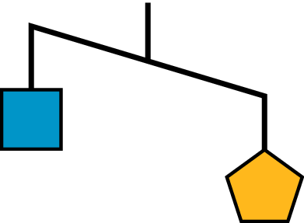
  - Write an inequality to represent the relationship of the weights. Let $p$ be the weight of one pentagon and $s$ be the weight of one square.
  - One pentagon weighs 8 ounces. Use this information to write another inequality to represent the relationship of the weights. Then, describe what this inequality means in this context.
  - Graph the solutions to this inequality on a number line.
- Based on your work so far, can you tell the relationship between the weight of a square and the weight of a circle? If so, write an inequality to represent that relationship. If not, explain your reasoning.
- This is another diagram of an unbalanced hanger.
- Andre writes the following inequality: $c+p<s$. Do you agree with his inequality? Explain your reasoning.
- Jada looks at another diagram of an unbalanced hangar and writes: $s+c>2t$, where $t$ represents the weight of one triangle. Draw a sketch of the diagram.
© CC BY Open Up Resources. Adaptations CC BY IM.

