Unit 8 Lesson 7 Cumulative Practice Problems
- Which of these triangles are definitely right triangles? Explain how you know. (Note that not all triangles are drawn to scale.)
- 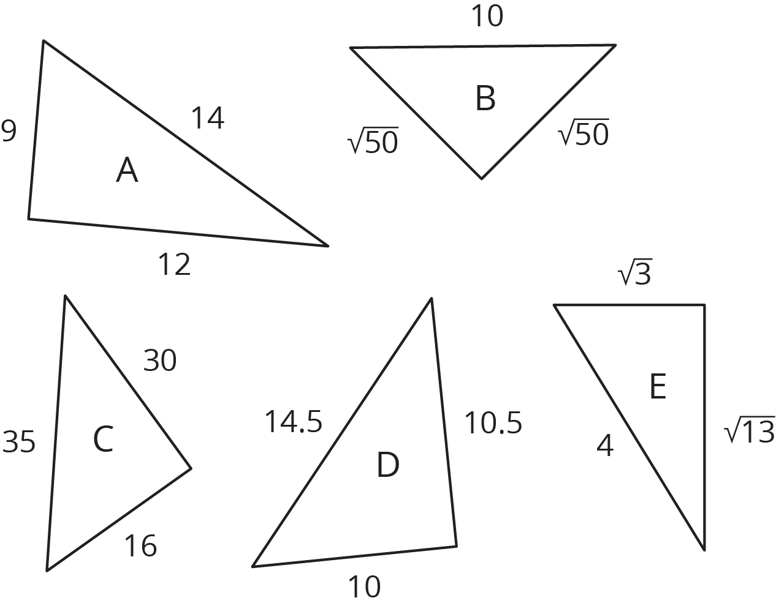

- A right triangle has a hypotenuse of 15 cm. What are possible lengths for the two legs of the triangle? Explain your reasoning.
- 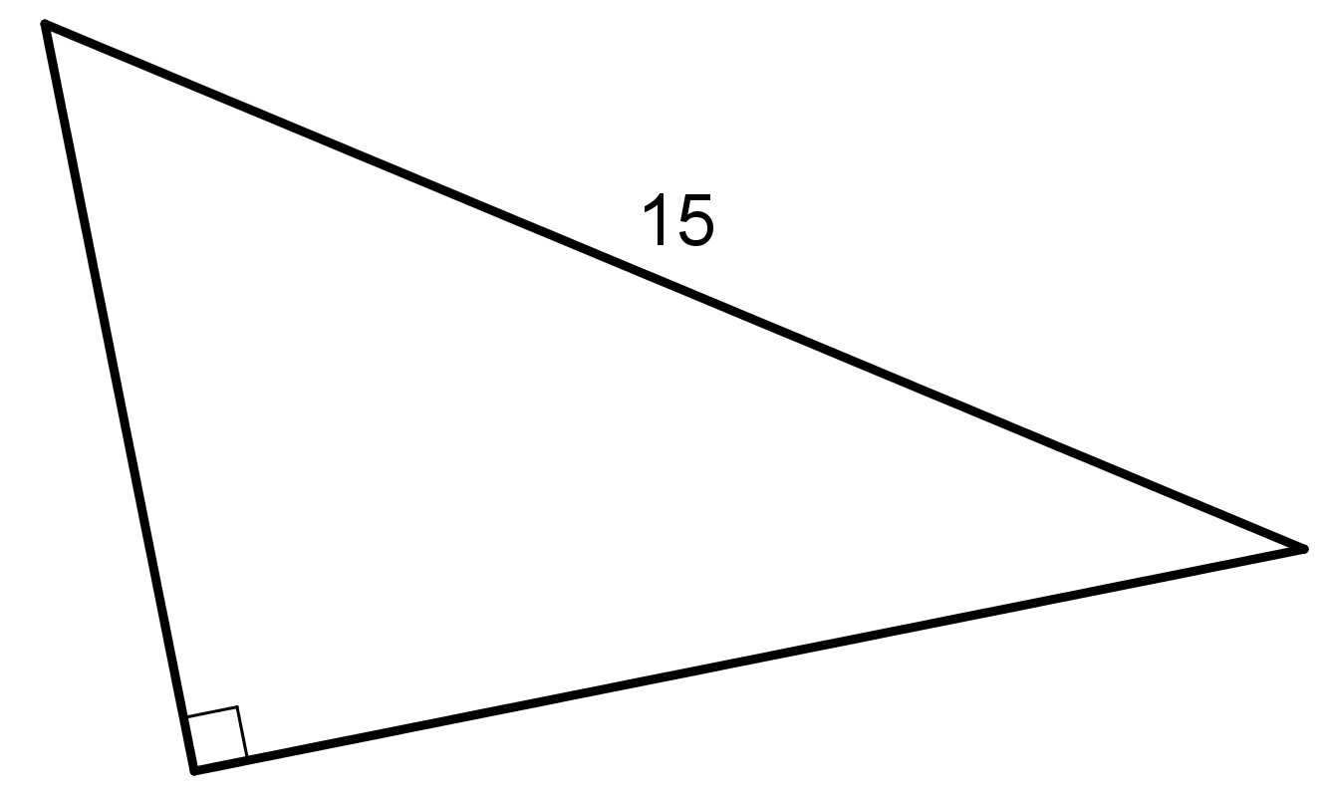

- In each part, $a$ and $b$ represent the length of a leg of a right triangle, and $c$ represents the length of its hypotenuse. Find the missing length, given the other two lengths.
  - $a=12,b=5,c=?$
  - $a=?,b=21,c=29$
- (From Unit 8, Lesson 6.)
- For which triangle does the Pythagorean Theorem express the relationship between the lengths of its three sides?
- 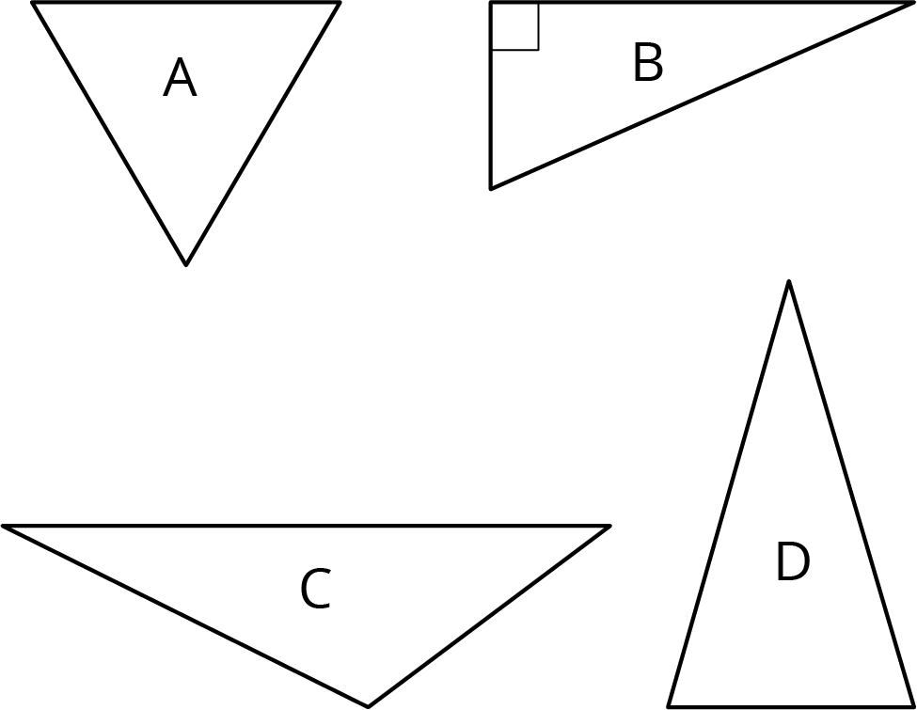
- (From Unit 8, Lesson 5.)
- Andre makes a trip to Mexico. He exchanges some dollars for pesos at a rate of 20 pesos per dollar. While in Mexico, he spends 9000 pesos. When he returns, he exchanges his pesos for dollars (still at 20 pesos per dollar). He gets back $\frac{1}{10}$ the amount he started with. Find how many dollars Andre exchanged for pesos and explain your reasoning. If you get stuck, try writing an equation representing Andre’s trip using a variable for the number of dollars he exchanged.
- (From Unit 4, Lesson 13.)
© CC BY Open Up Resources. Adaptations CC BY IM.

