Lesson 20: Percentages and Double Number Lines
Let’s use double number lines to represent percentages.

20.1: Fundraising Goal
Each of three friends—Lin, Jada, and Andre—had the goal of raising $40. How much money did each person raise? Be prepared to explain your reasoning.
- Lin raised 100% of her goal.
- Jada raised 50% of her goal.
- Andre raised 150% of his goal.

20.2: Three-Day Biking Trip
Elena biked 8 miles on Saturday. Use the double number line to answer the questions. Be prepared to explain your reasoning.
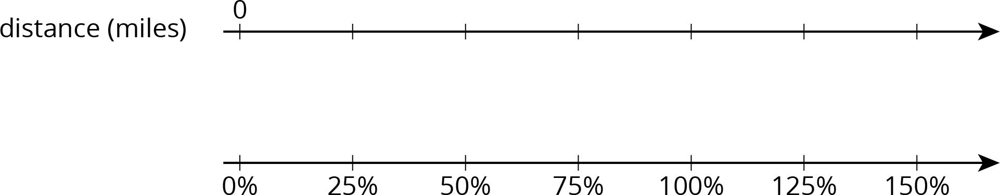
- What is 100% of her Saturday distance?
- On Sunday, she biked 75% of her Saturday distance. How far was that?
- On Monday, she biked 125% of her Saturday distance. How far was that?

20.3: Puppies Grow Up
- Jada has a new puppy that weighs 9 pounds. The vet says that the puppy is now at about 20% of its adult weight. What will be the adult weight of the puppy?
- Andre also has a puppy that weighs 9 pounds. The vet says that this puppy is now at about 30% of its adult weight. What will be the adult weight of Andre’s puppy?
- 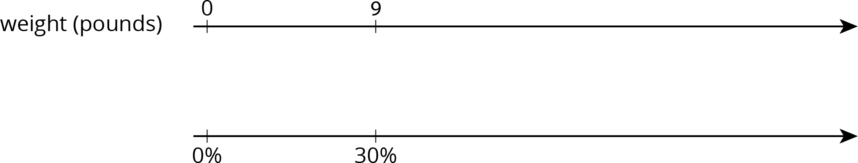
- What is the same about Jada and Andre’s puppies? What is different?

Are you ready for more?
A loaf of bread costs $2.50 today. The same size loaf cost 20 cents in 1955.
- What percentage of today’s price did someone in 1955 pay for bread?
- A job pays $10.00 an hour today. If the same percentage applies to income as well, how much would that job have paid in 1955?

Lesson 20 Summary
We can use a double number line to solve problems about percentages. For example, what is 30% of 50 pounds? We can draw a double number line like this:
We divide the distance between 0% and 100% and that between 0 and 50 pounds into ten equal parts. We label the tick marks on the top line by counting by 5s ($50÷10=5$) and on the bottom line counting by 10% ($100÷10=10$). We can then see that 30% of 50 pounds is 15 pounds.
We can also use a table to solve this problem.
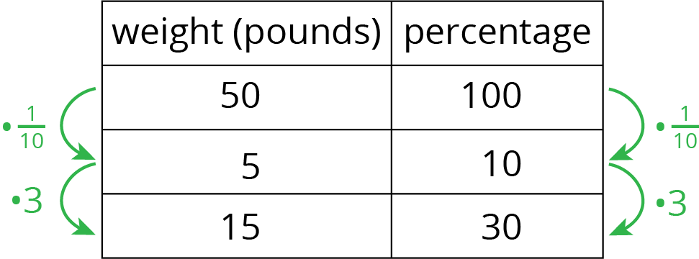
Suppose we know that 140% of an amount is $28. What is 100% of that amount? Let’s use a double number line to find out.
We divide the distance between 0% and 140% and that between $0 and $28 into fourteen equal intervals. We label the tick marks on the top line by counting by 2s and on the bottom line counting by 10%. We would then see that 100% is $20.
Or we can use a table as shown.
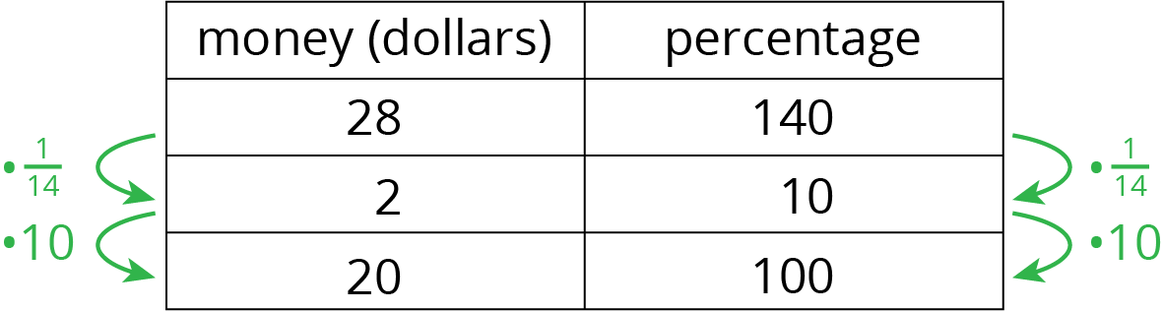
© CC BY Open Up Resources. Adaptations CC BY IM.

