Lesson 7 Practice Problems
- When Lin drives a golf ball, it travels a mean distance of 200 yards with a standard deviation of 20 yards, and the distribution of lengths is approximately normal. Approximately what percentage of her shots will travel less than 180 yards?
- A distribution is approximately normal with a mean of 18 and a standard deviation of 4. Match the interval with the approximate percentage of data that falls within that interval.
  - Less than 10
  - Between 6 and 30
  - Between 10 and 14
  - Between 10 and 18
  - Between 10 and 26
  - Between 14 and 22
  - Between 18 and 22
  - Greater than 22
  - 2.5%
  - 13.5%
  - 16%
  - 34%
  - 47.5%
  - 68%
  - 95%
  - 99.7%
- Tyler looks at this histogram of a distribution with a mean of 6.7 grams and a standard deviation of 1 gram. He claims that approximately 68% of the data is between 5.7 and 7.7 grams. What is the error in his thinking?
- 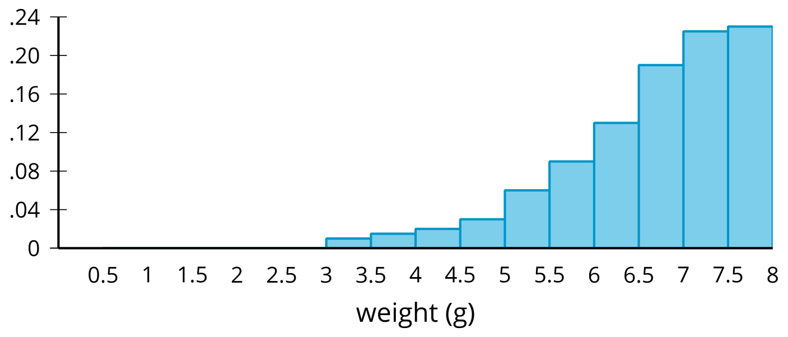
- Select all designs which describe an experimental study.
  - 100 randomly selected students are asked if they have their driver's license.
  - 50 baseball players are selected to wear compression sleeves during practice and games and another 50 players are selected not to wear compression sleeves during practice and games. The number of visits to the athletic trainer is recorded for both groups.
  - 50 athletes are asked if they stretch before practice. A different group of 50 athletes are asked if they drink more than 2 quarts of water on days they have practice. The results are recorded for both groups.
  - 100 students taking chemistry are randomly selected. 50 of the students have their arm length and wrist cicrumference measured. The other 50 students have their foot length and head circumference measured. The ratio of arm length to wrist circumference and foot length to head circumference are recorded.
  - 50 students volunteer to drink 2 quarts of water each day for a week. Another 50 students volunteer to drink 2 quarts of a sports drink each day for a week. Each day students record the number of hours they sleep.
- (From Unit 7, Lesson 2.)
- A normal curve with a mean of 400 and a standard deviation of 50 is shown. Shade the region under the curve within two standard deviations of the mean. How much of the data falls within the shaded region?
- 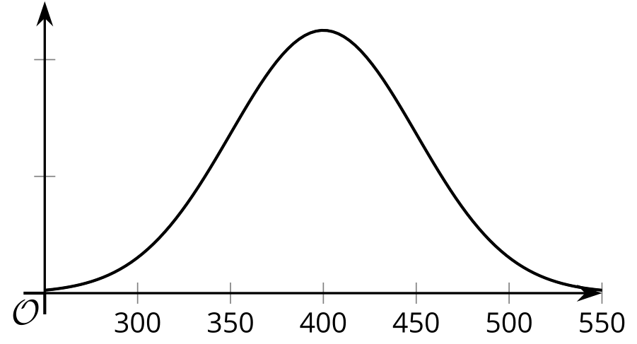
- (From Unit 7, Lesson 6.)
- How many data points are presented in the histogram?
- 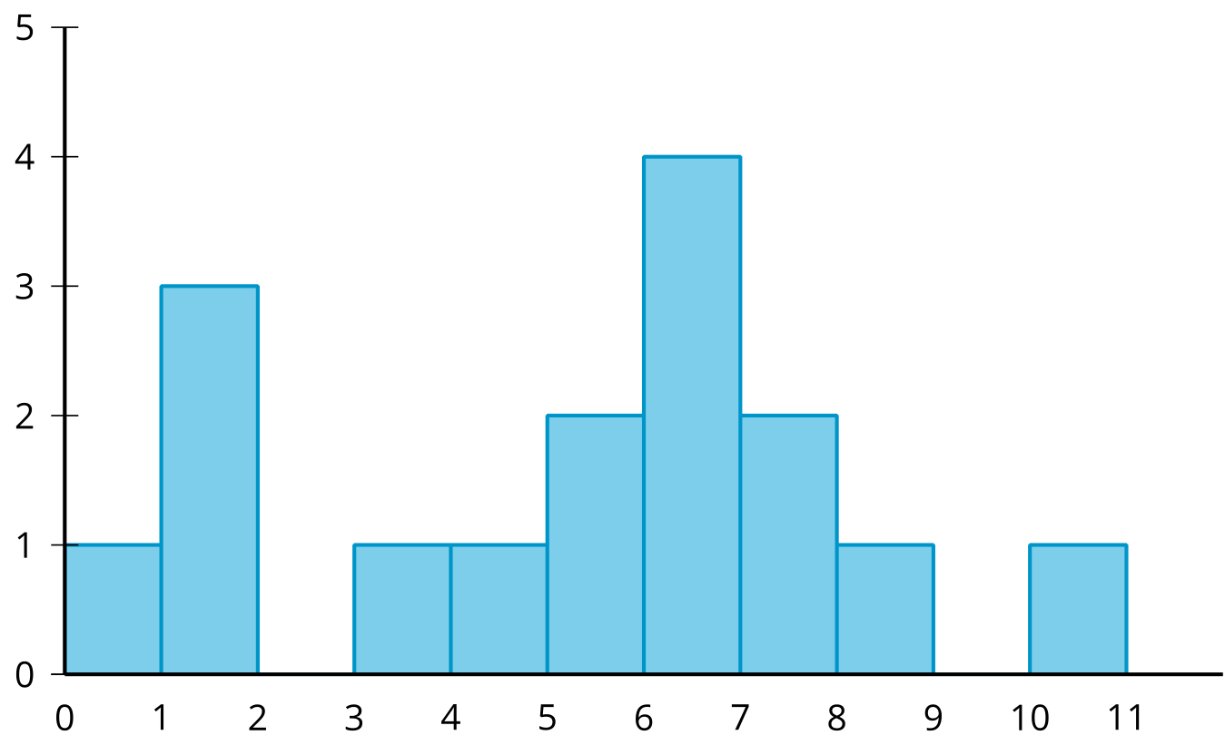
  - 5
  - 11
  - 15
  - 16
- (From Unit 7, Lesson 5.)
© CC BY 2019 by Illustrative Mathematics®

