Lesson 16: Multi-step Experiments
Let’s look at probabilities of experiments that have multiple steps.

16.1: True or False?
Is each equation true or false? Explain your reasoning.
$8=\left(8+8+8+8\right)÷3$
$\left(10+10+10+10+10\right)÷5=10$
$\left(6+4+6+4+6+4\right)÷6=5$

16.2: Spinning a Color and Number
The other day, you wrote the sample space for spinning each of these spinners once.
What is the probability of getting:
- Green and 3?
- Blue and any odd number?
- Any color other than red and any number other than 2?
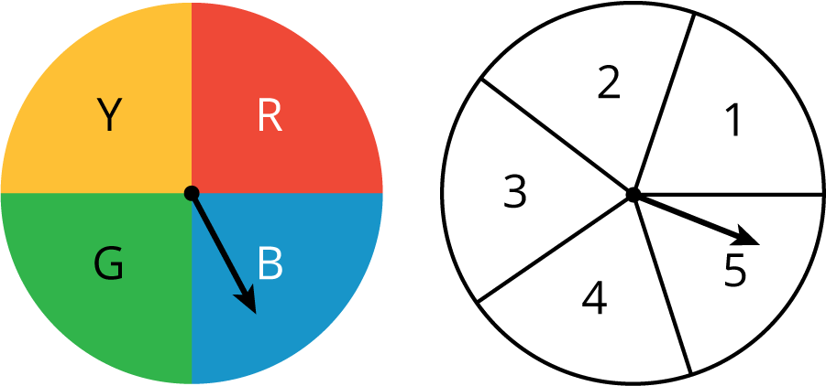

16.3: Cubes and Coins
The other day you looked at a list, a table, and a tree that showed the sample space for rolling a number cube and flipping a coin.
- Your teacher will assign you one of these three structures to use to answer these questions. Be prepared to explain your reasoning.
  - What is the probability of getting tails and a 6?
  - What is the probability of getting heads and an odd number?
  - Pause here so your teacher can review your work.
- Suppose you roll two number cubes. What is the probability of getting:
  - Both cubes showing the same number?
  - Exactly one cube showing an even number?
  - At least one cube showing an even number?
  - Two values that have a sum of 8?
  - Two values that have a sum of 13?
- Jada flips three quarters. What is the probability that all three will land showing the same side?

16.4: Pick a Card
Imagine there are 5 cards. They are colored red, yellow, green, white, and black. You mix up the cards and select one of them without looking. Then, without putting that card back, you mix up the remaining cards and select another one.
- Write the sample space and tell how many possible outcomes there are.
- What structure did you use to write all of the outcomes (list, table, tree, something else)? Explain why you chose that structure.
- What is the probability that:
  - You get a white card and a red card (in either order)?
  - You get a black card (either time)?
  - You do not get a black card (either time)?
  - You get a blue card?
  - You get 2 cards of the same color?
  - You get 2 cards of different colors?

Are you ready for more?
In a game using five cards numbered 1, 2, 3, 4, and 5, you take two cards and add the values together. If the sum is 8, you win. Would you rather pick a card and put it back before picking the second card, or keep the card in your hand while you pick the second card? Explain your reasoning.

Lesson 16 Summary
Suppose we have two bags. One contains 1 star block and 4 moon blocks. The other contains 3 star blocks and 1 moon block.
If we select one block at random from each, what is the probability that we will get two star blocks or two moon blocks?
To answer this question, we can draw a tree diagram to see all of the possible outcomes.
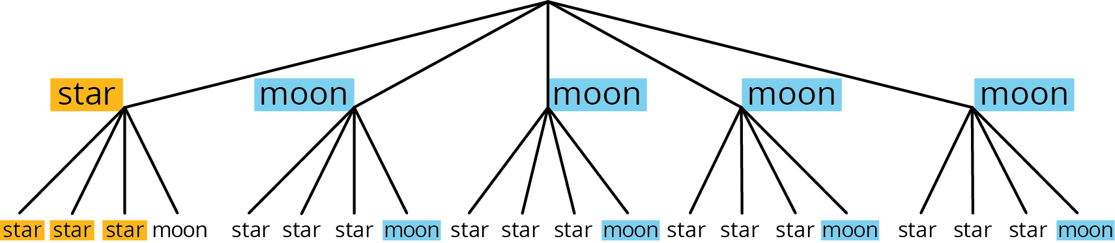
There are $5⋅4=20$ possible outcomes. Of these, 3 of them are both stars, and 4 are both moons. So the probability of getting 2 star blocks or 2 moon blocks is $\frac{7}{20}$.
In general, if all outcomes in an experiment are equally likely, then the probability of an event is the fraction of outcomes in the sample space for which the event occurs.
© CC BY Open Up Resources. Adaptations CC BY IM.

