Lesson 10 Practice Problems
- Select all of the ordered pairs $\left(x,y\right)$ that are solutions to the linear equation $2x+3y=6$.
  - $\left(0,2\right)$
  - $\left(0,6\right)$
  - $\left(2,3\right)$
  - $\left(3,\text{-}2\right)$
  - $\left(3,0\right)$
  - $\left(6,\text{-}2\right)$
- The graph shows a linear relationship between $x$ and $y$.
- $x$ represents the number of comic books Priya buys at the store, all at the same price, and $y$ represents the amount of money (in dollars) Priya has after buying the comic books.
- 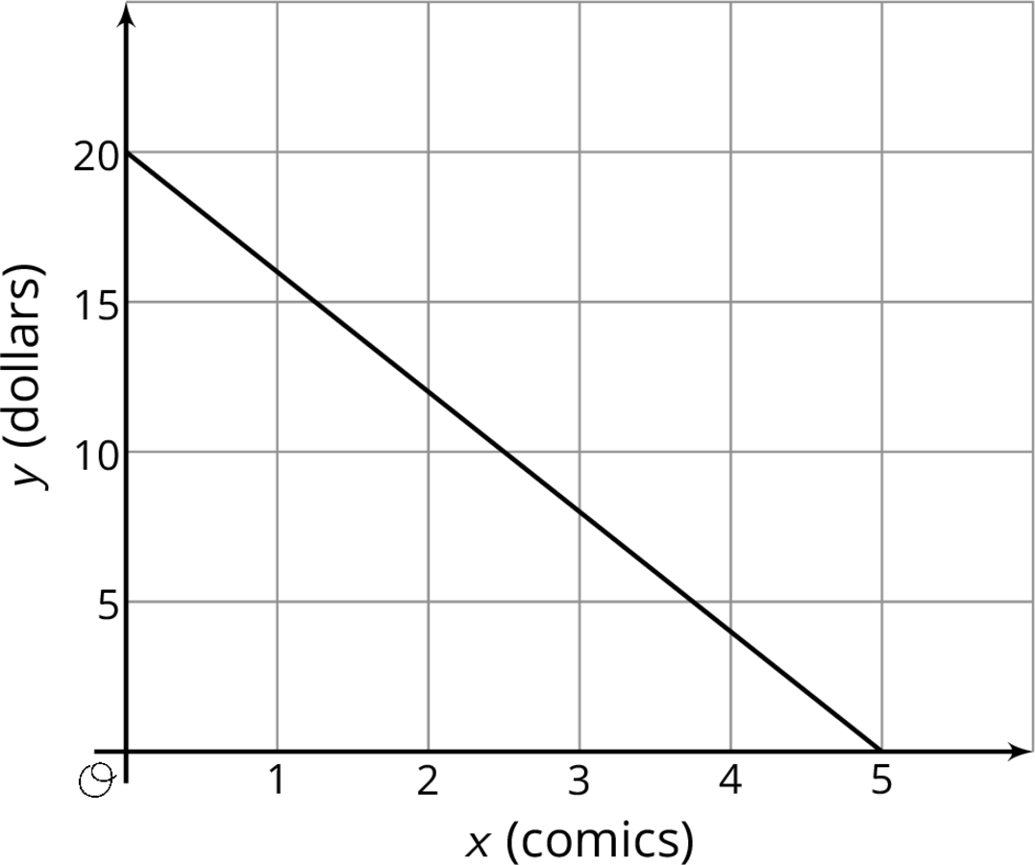
  - Find and interpret the $x$- and $y$-intercepts of this line.
  - Find and interpret the slope of this line.
  - Find an equation for this line.
  - If Priya buys 3 comics, how much money will she have remaining?
- Match each equation with its three solutions.
  - $y=1.5x$
  - $2x+3y=7$
  - $x−y=4$
  - $3x=\frac{y}{2}$
  - $y=\text{-}x+1$
  - $\left(14,21\right)$, $\left(2,3\right)$, $\left(8,12\right)$
  - $\left(\text{-}3,\text{-}7\right)$, $\left(0,\text{-}4\right)$, $\left(\text{-}1,\text{-}5\right)$
  - $\left(\frac{1}{8},\frac{7}{8}\right),\left(\frac{1}{2},\frac{1}{2}\right),\left(\frac{1}{4},\frac{3}{4}\right)$
  - $\left(1,1\frac{2}{3}\right),\left(\text{-}1,3\right),\left(0,2\frac{1}{3}\right)$
  - $\left(0.5,3\right)$, $\left(1,6\right)$, $\left(1.2,7.2\right)$
- A container of fuel dispenses fuel at the rate of 5 gallons per second. If $y$ represents the amount of fuel remaining in the container, and $x$ represents the number of seconds that have passed since the fuel started dispensing, then $x$ and $y$ satisfy a linear relationship.
- In the coordinate plane, will the slope of the line representing that relationship have a positive, negative, or zero slope? Explain how you know.
- (From Unit 5, Lesson 9.)
- A sandwich store charges a delivery fee to bring lunch to an office building. One office pays $33 for 4 turkey sandwiches. Another office pays $61 for 8 turkey sandwiches. How much does each turkey sandwich add to the cost of the delivery? Explain how you know.
- (From Unit 5, Lesson 4.)
© CC BY Open Up Resources. Adaptations CC BY IM.

