Lesson 5: Creating Double Number Line Diagrams
Let's draw double number line diagrams like a pro.

5.1: Ordering on a Number Line
- Locate and label the following numbers on the number line:
- $\frac{1}{2}$
- $\frac{1}{4}$
- $1\frac{3}{4}$
- 1.5
- 1.75
- Based on where you placed the numbers, locate and label four more fractions or decimals on the number line.

5.2: Just a Little Green
The other day, we made green water by mixing 5 ml of blue water with 15 ml of yellow water. We want to make a very small batch of the same shade of green water. We need to know how much yellow water to mix with only 1 ml of blue water.
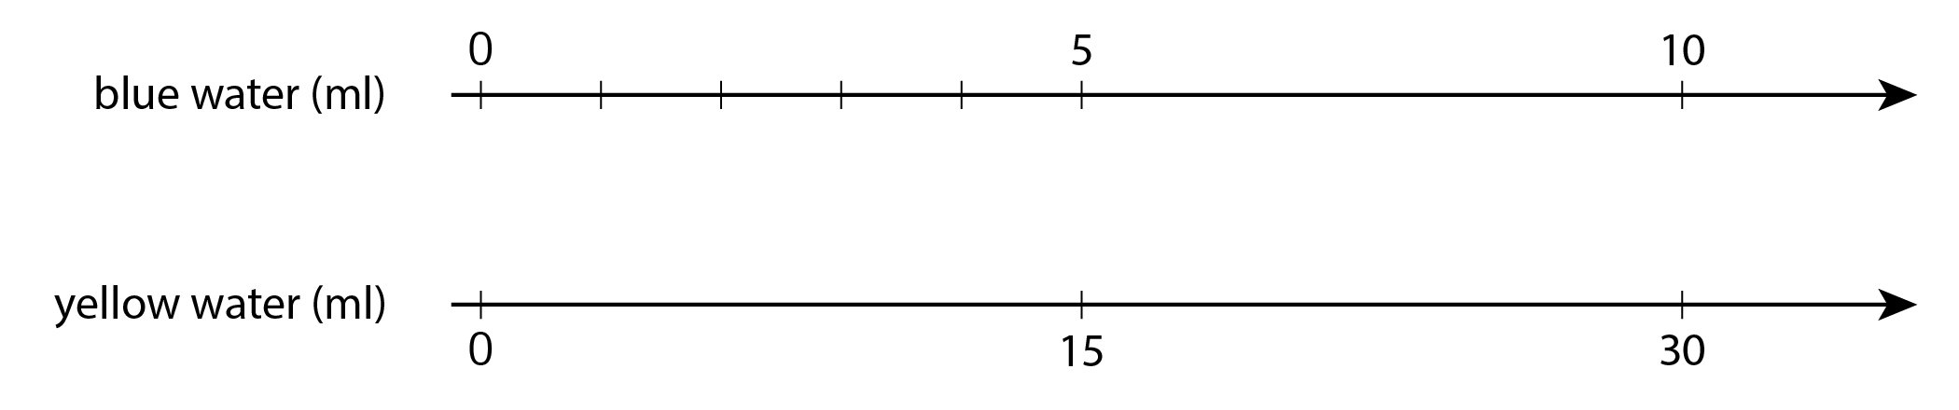
- On the number line for blue water, label the four tick marks shown.
- On the number line for yellow water, draw and label tick marks to show the amount of yellow water needed for each amount of blue water.
- How much yellow water should be used for 1 ml of blue water? Circle where you can see this on the double number line.
- How much yellow water should be used for 11 ml of blue water?
- How much yellow water should be used for 8 ml of blue water?
- Why is it useful to know how much yellow water should be used with 1 ml of blue water?

5.3: Art Paste on a Double Number Line
A recipe for art paste says “For every 2 pints of water, mix in 8 cups of flour.”
- Follow the instructions to draw a double number line diagram representing the recipe for art paste.
  - Use a ruler to draw two parallel lines.
  - Label the first line “pints of water.” Label the second line “cups of flour.”
  - Draw at least 6 equally spaced tick marks that line up on both lines.
  - Along the water line, label the tick marks with the amount of water in 0, 1, 2, 3, 4, and 5 batches of art paste.
  - Along the flour line, label the tick marks with the amount of flour in 0, 1, 2, 3, 4, and 5 batches of art paste.
- Compare your double number line diagram with your partner’s. Discuss your thinking. If needed, revise your diagram.
- Next, use your double number line to answer these questions:
  - How much flour should be used with 10 pints of water?
  - How much water should be used with 24 cups of flour?
  - How much flour per pint of water does this recipe use?

Are you ready for more?
A square with side of 10 units overlaps a square with side of 8 units in such a way that its corner $B$ is placed exactly at the center of the smaller square. As a result of the overlapping, the two sides of the large square intersect the two sides of the small square exactly at points $C$ and $E$, as shown. The length of $CD$ is 6 units.
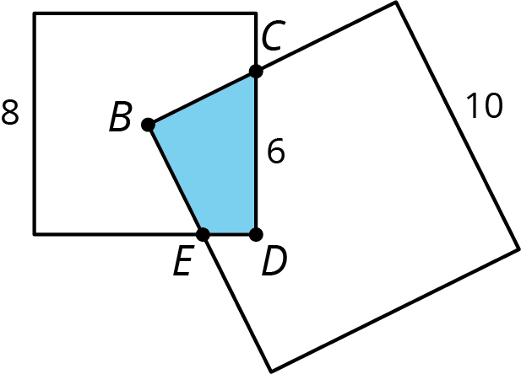
What is the area of the overlapping region $CDEB$?

5.4: Revisiting Tuna Casserole
The other day, we looked at a recipe for tuna casserole that called for 10 ounces of cream of chicken soup for every 3 cups of elbow-shaped pasta.
- Draw a double number line diagram that represents the amounts of soup and pasta in different-sized batches of this recipe.
- If you made a large amount of tuna casserole by mixing 40 ounces of soup with 15 cups of pasta, would it taste the same as the original recipe? Explain or show your reasoning.
- The original recipe called for 6 ounces of tuna for every 3 cups of pasta. Add a line to your diagram to represent the amount of tuna in different batches of casserole.
- How many ounces of soup should you mix with 30 ounces of tuna to make a casserole that tastes the same as the original recipe?

Lesson 5 Summary
Here are some guidelines to keep in mind when drawing a double number line diagram:
- The two parallel lines should have labels that describe what the numbers represent.
- The tick marks and numbers should be spaced at equal intervals.
- Numbers that line up vertically make equivalent ratios.
For example, the ratio of the number of eggs to cups of milk in a recipe is $4:1$. Here is a double number line that represents the situation:
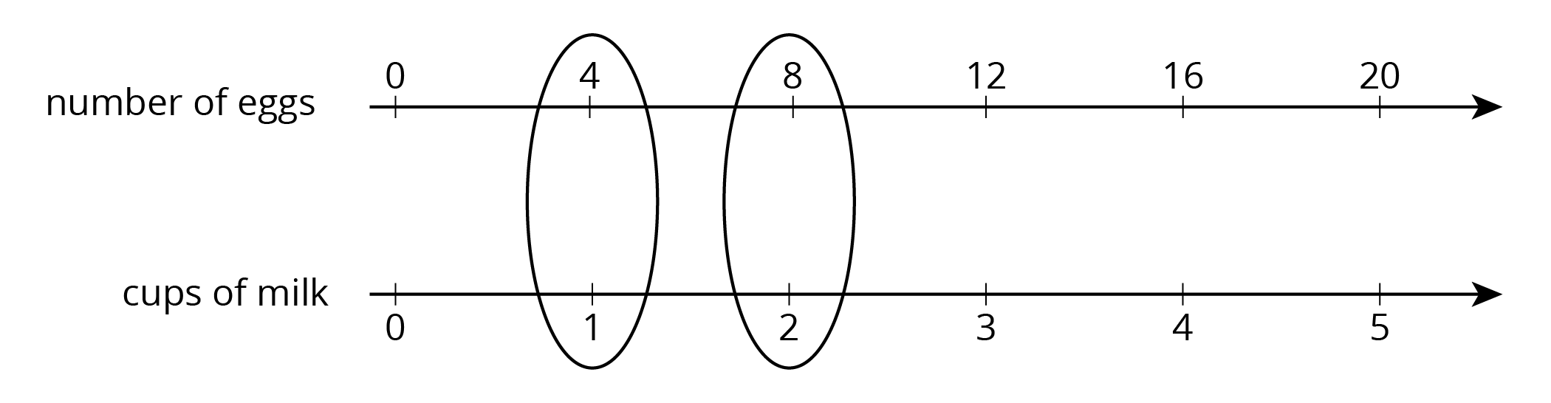
We can also say that this recipe uses “4 eggs per cup of milk” because the word per means “for each.”
© CC BY Open Up Resources. Adaptations CC BY IM.

