Unit 2 Lesson 25: Summing Up

1 Notice & Wonder: A Snowflake’s Return (Warm up)

Student Task Statement
What do you notice? What do you wonder?
iteration | total number of triangles added since the first
0  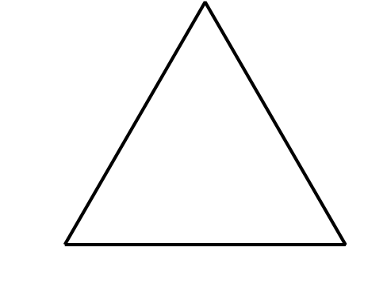 | 0
1 | 3
2 | $3+3\left(4\right)=15$
3 | $3+3\left(4\right)+3{\left(4\right)}^{2}=63$
$n$ | $3+3\left(4\right)+3{\left(4\right)}^{2}+...+3{\left(4\right)}^{n−1}$

2 A Geometric Addition Formula

Student Task Statement
Earlier, we learned that the $n$th term of a geometric sequence with an initial value of $a$ and a common ratio of $r$ is $a\left(r^{n−1}\right)$.
For a Koch Snowflake, it turns out that we can find the number of triangles added on at each iteration by having $a=3$ and $r=4$. The sum $s$ of the first $n$ terms in this geometric sequence tell us how many triangles total make up the $n$th iteration of the snowflake
$s=3+3\left(4\right)+3\left(4^{2}\right)+...+3\left(4^{n−1}\right)$
More generally, the sum of the first $n$ terms of any geometric sequence can be expressed as
$s=a+a\left(r\right)+a\left(r^{2}\right)+...+a\left(r^{n−1}\right)$
or
$s=a\left(1+r+r^{2}+...+r^{n−1}\right)$
- What would happen if we multiplied each side of this equation by $\left(1−r\right)$? (hint: $\left(x−1\right)\left(x^{3}+x^{2}+x+1\right)=x^{4}−1$.)
- Rewrite the new equation in the form of $s=$.
- Use this new formula to calculate how many triangles after the original are in the first 5, 10, and 15 iterations of the Koch Snowflake.

3 The Sum of Antibiotics

Student Task Statement
Han is prescribed a course of antibiotics for an infection. He is told to take a 150 mg dose of the antibiotic regularly every 12 hours for 15 days. Han is curious about the antibiotic and learns that at the end of the 12 hours, only 5% of the dose is still in his body.
- How much of the antibiotic is in the body right after the first, second, and third doses?
- When will the total amount of the antibiotic in Han be highest over the course of the 15 day treatment? Explain your reasoning.
© CC BY 2019 by Illustrative Mathematics®

