Unit 1 Lesson 1: Count and Add

WU What Do You Know About Math? (Warm up)

Student Task Statement
What do you know about math?
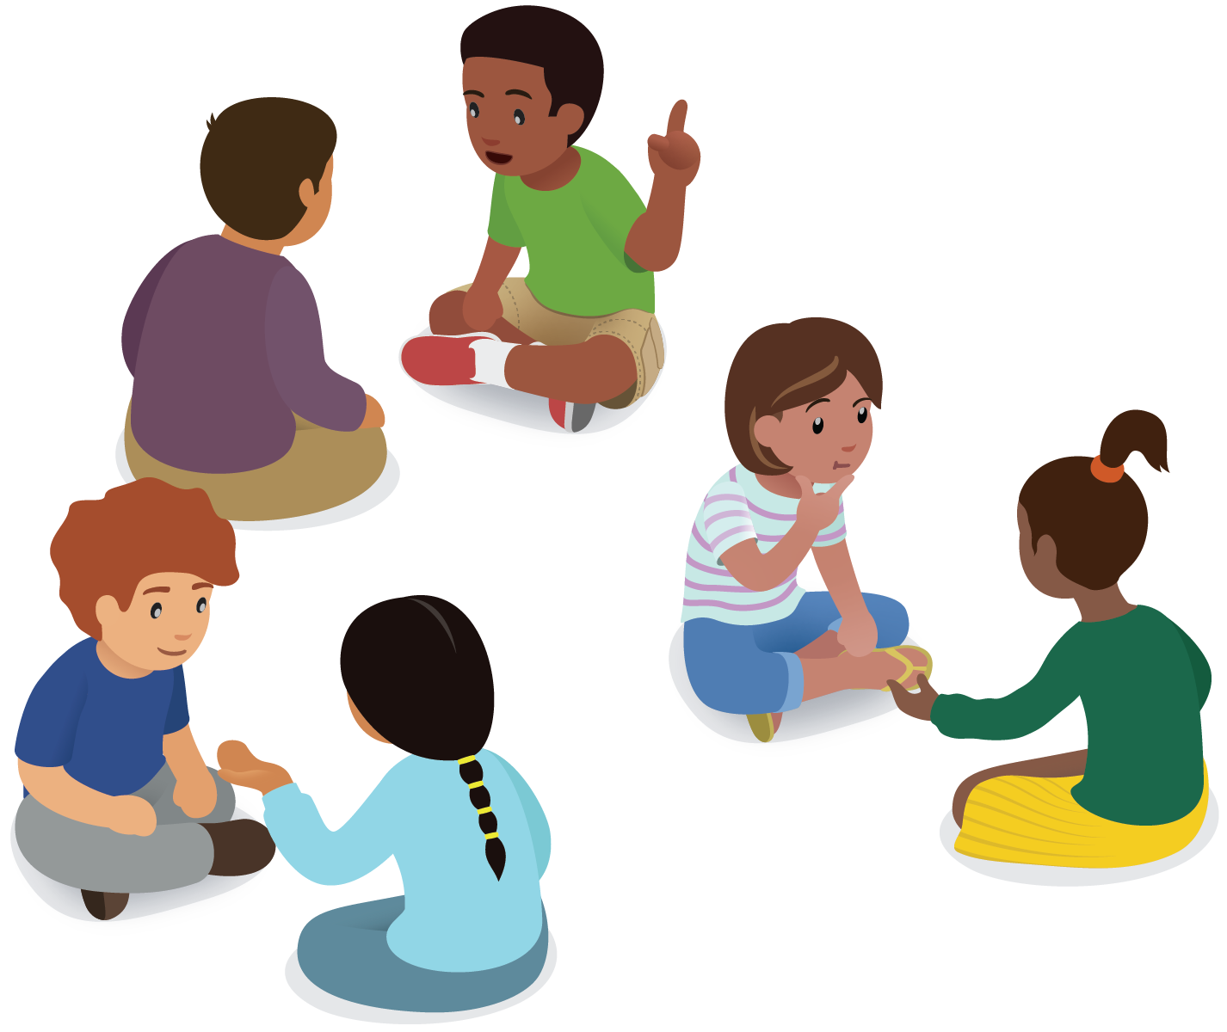

1 Revisit Counting Collections, Up to 20

Student Task Statement

2 Introduce: Number Race, Add to 10

Student Task Statement

Images for Activity Synthesis
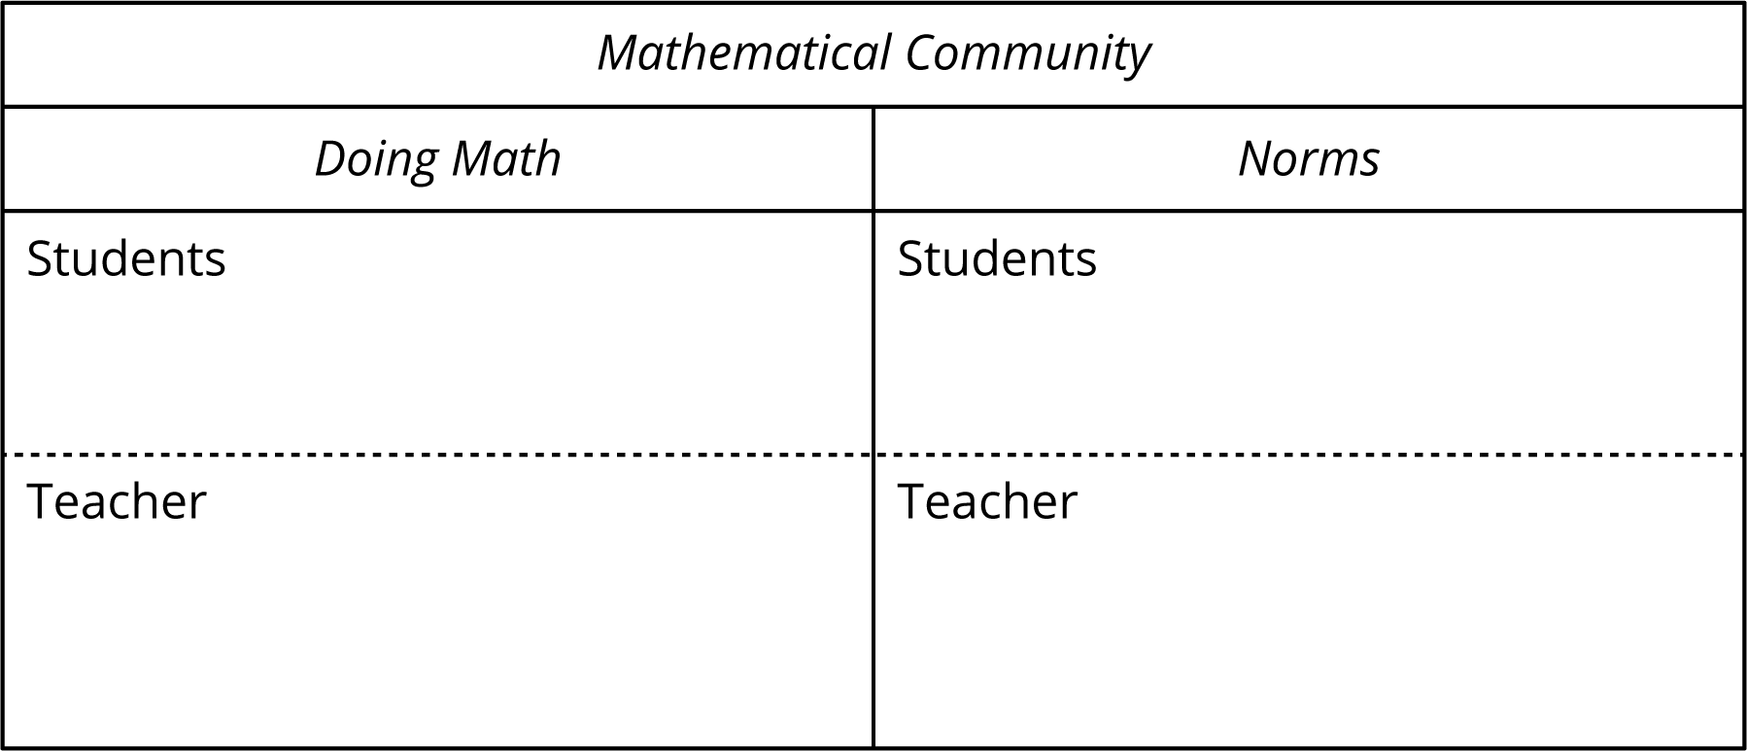
© CC BY 2021 Illustrative Mathematics®

