Lesson 14: Hundreds of Objects
- Let’s use place value to count real-world objects.

Warm-up: Notice and Wonder: Jar of Beans
What do you notice? What do you wonder?
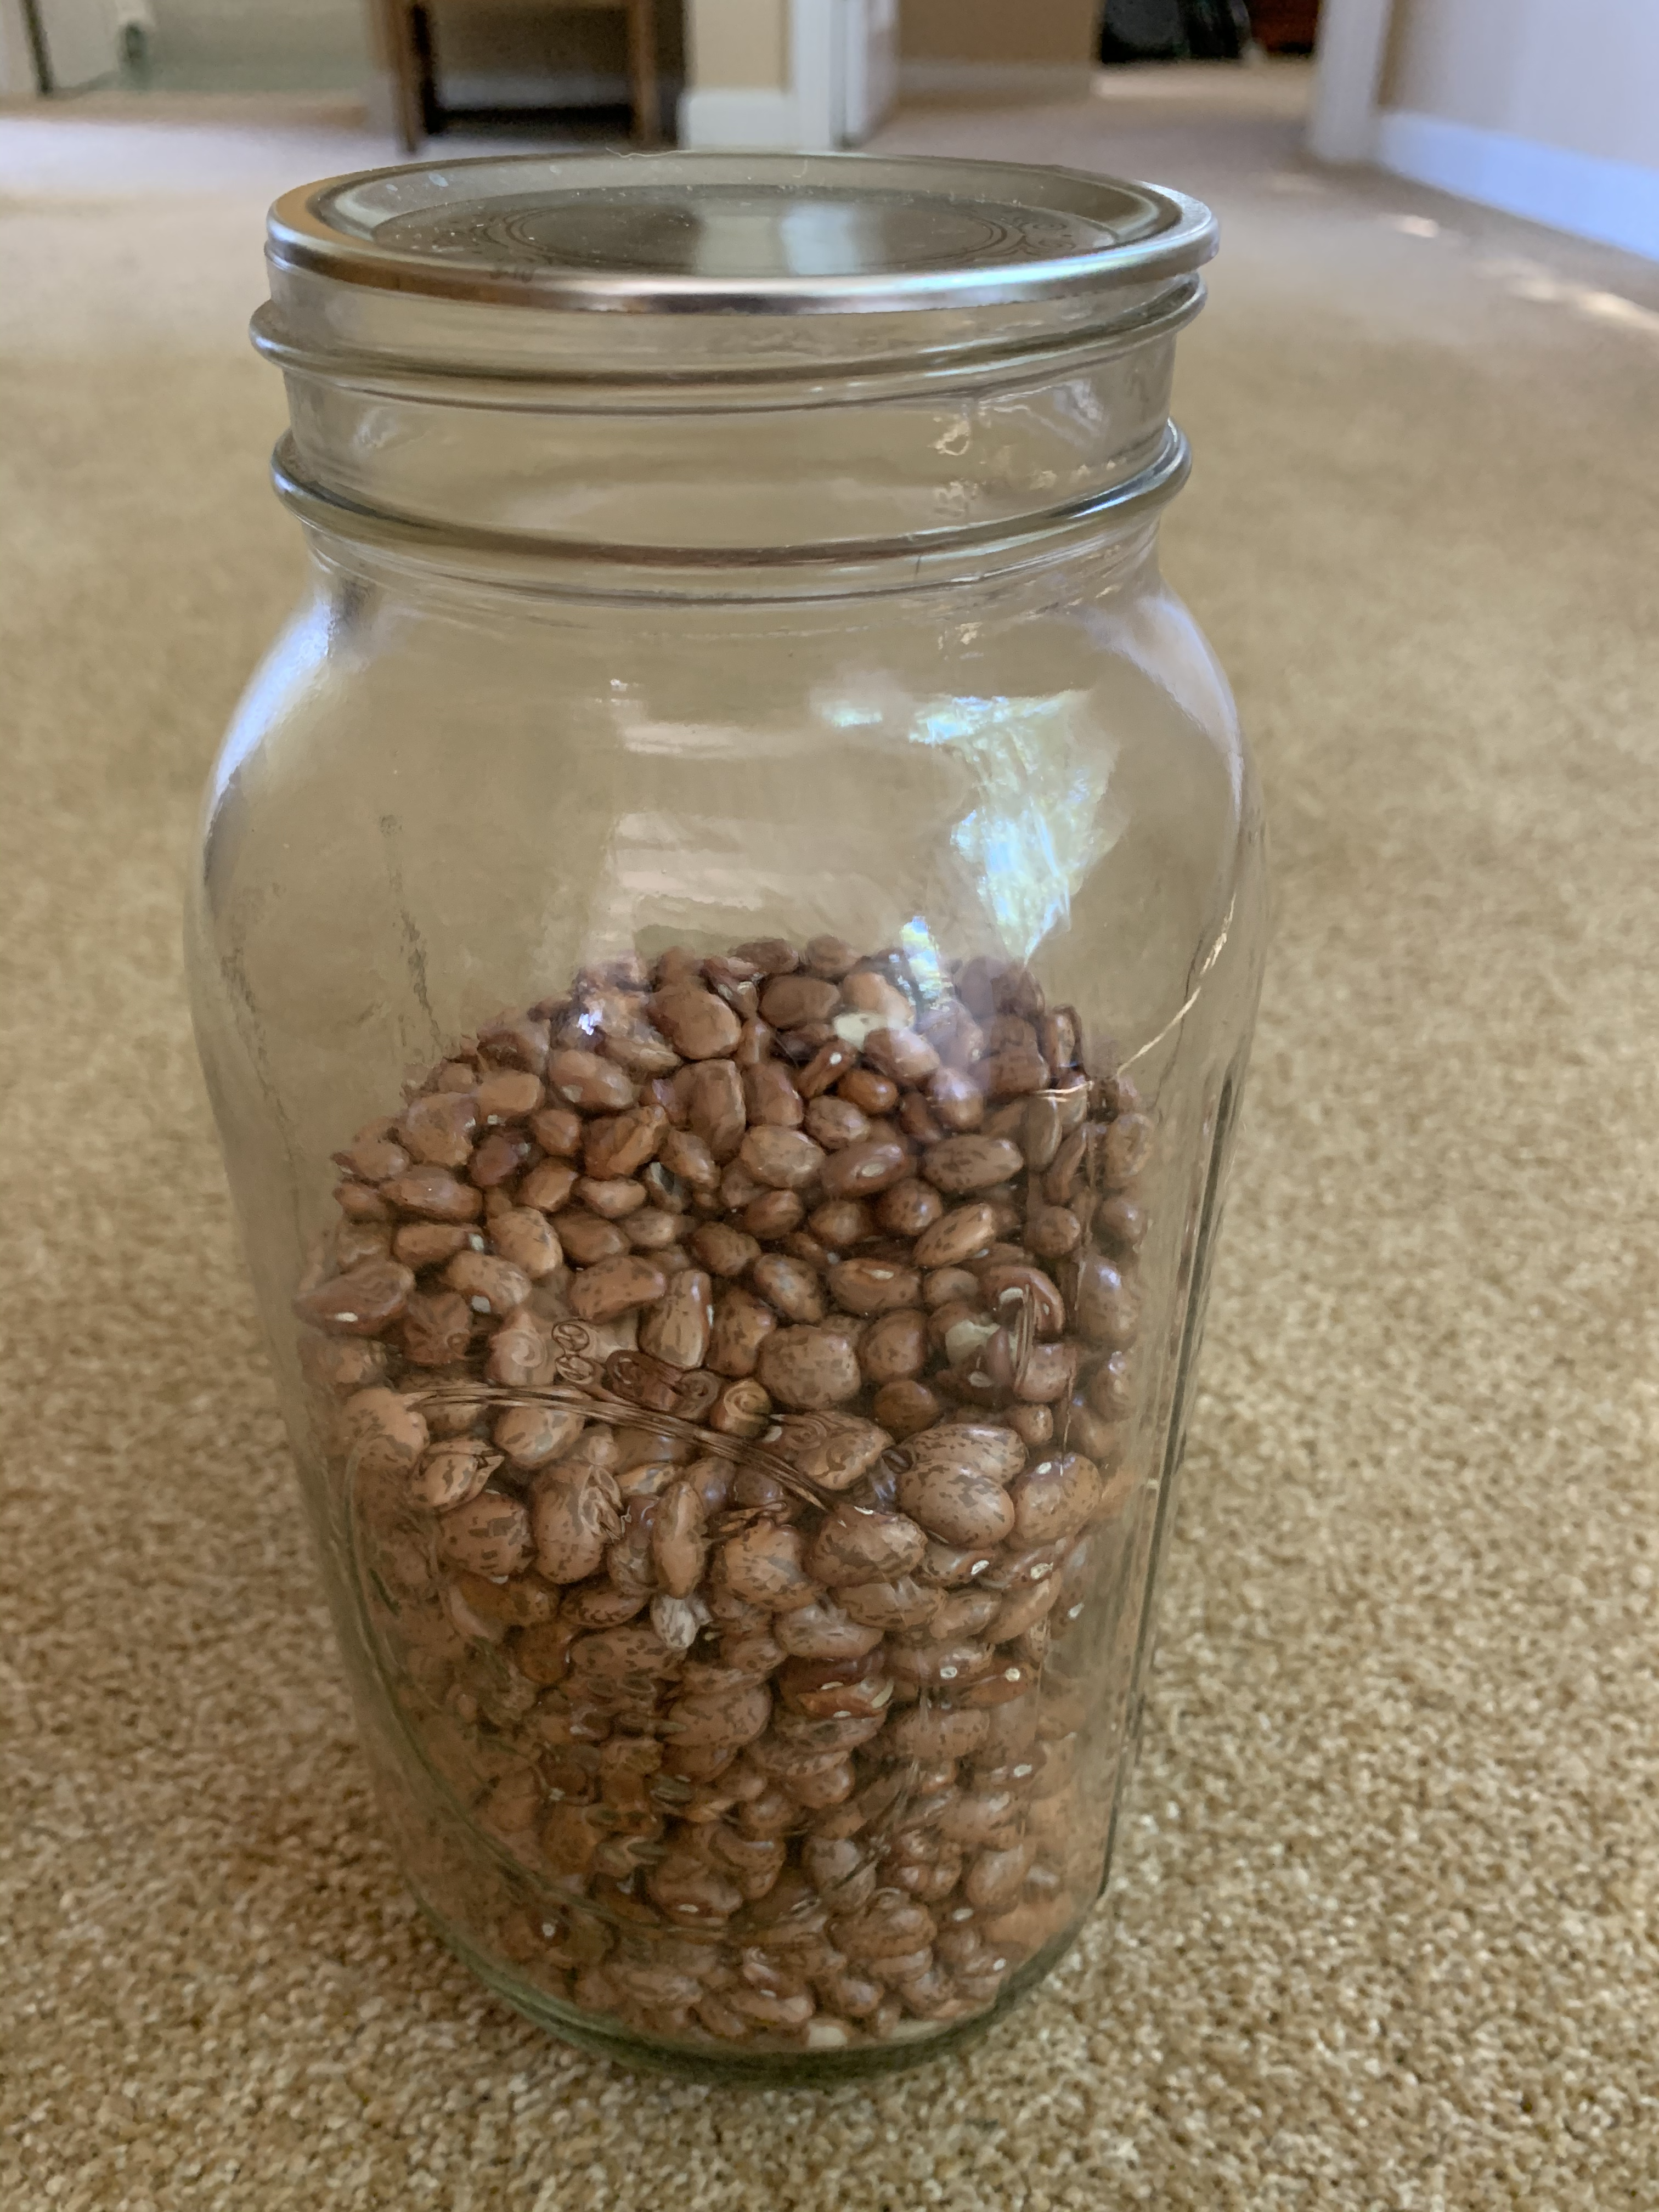

14.1: Cup of Beans
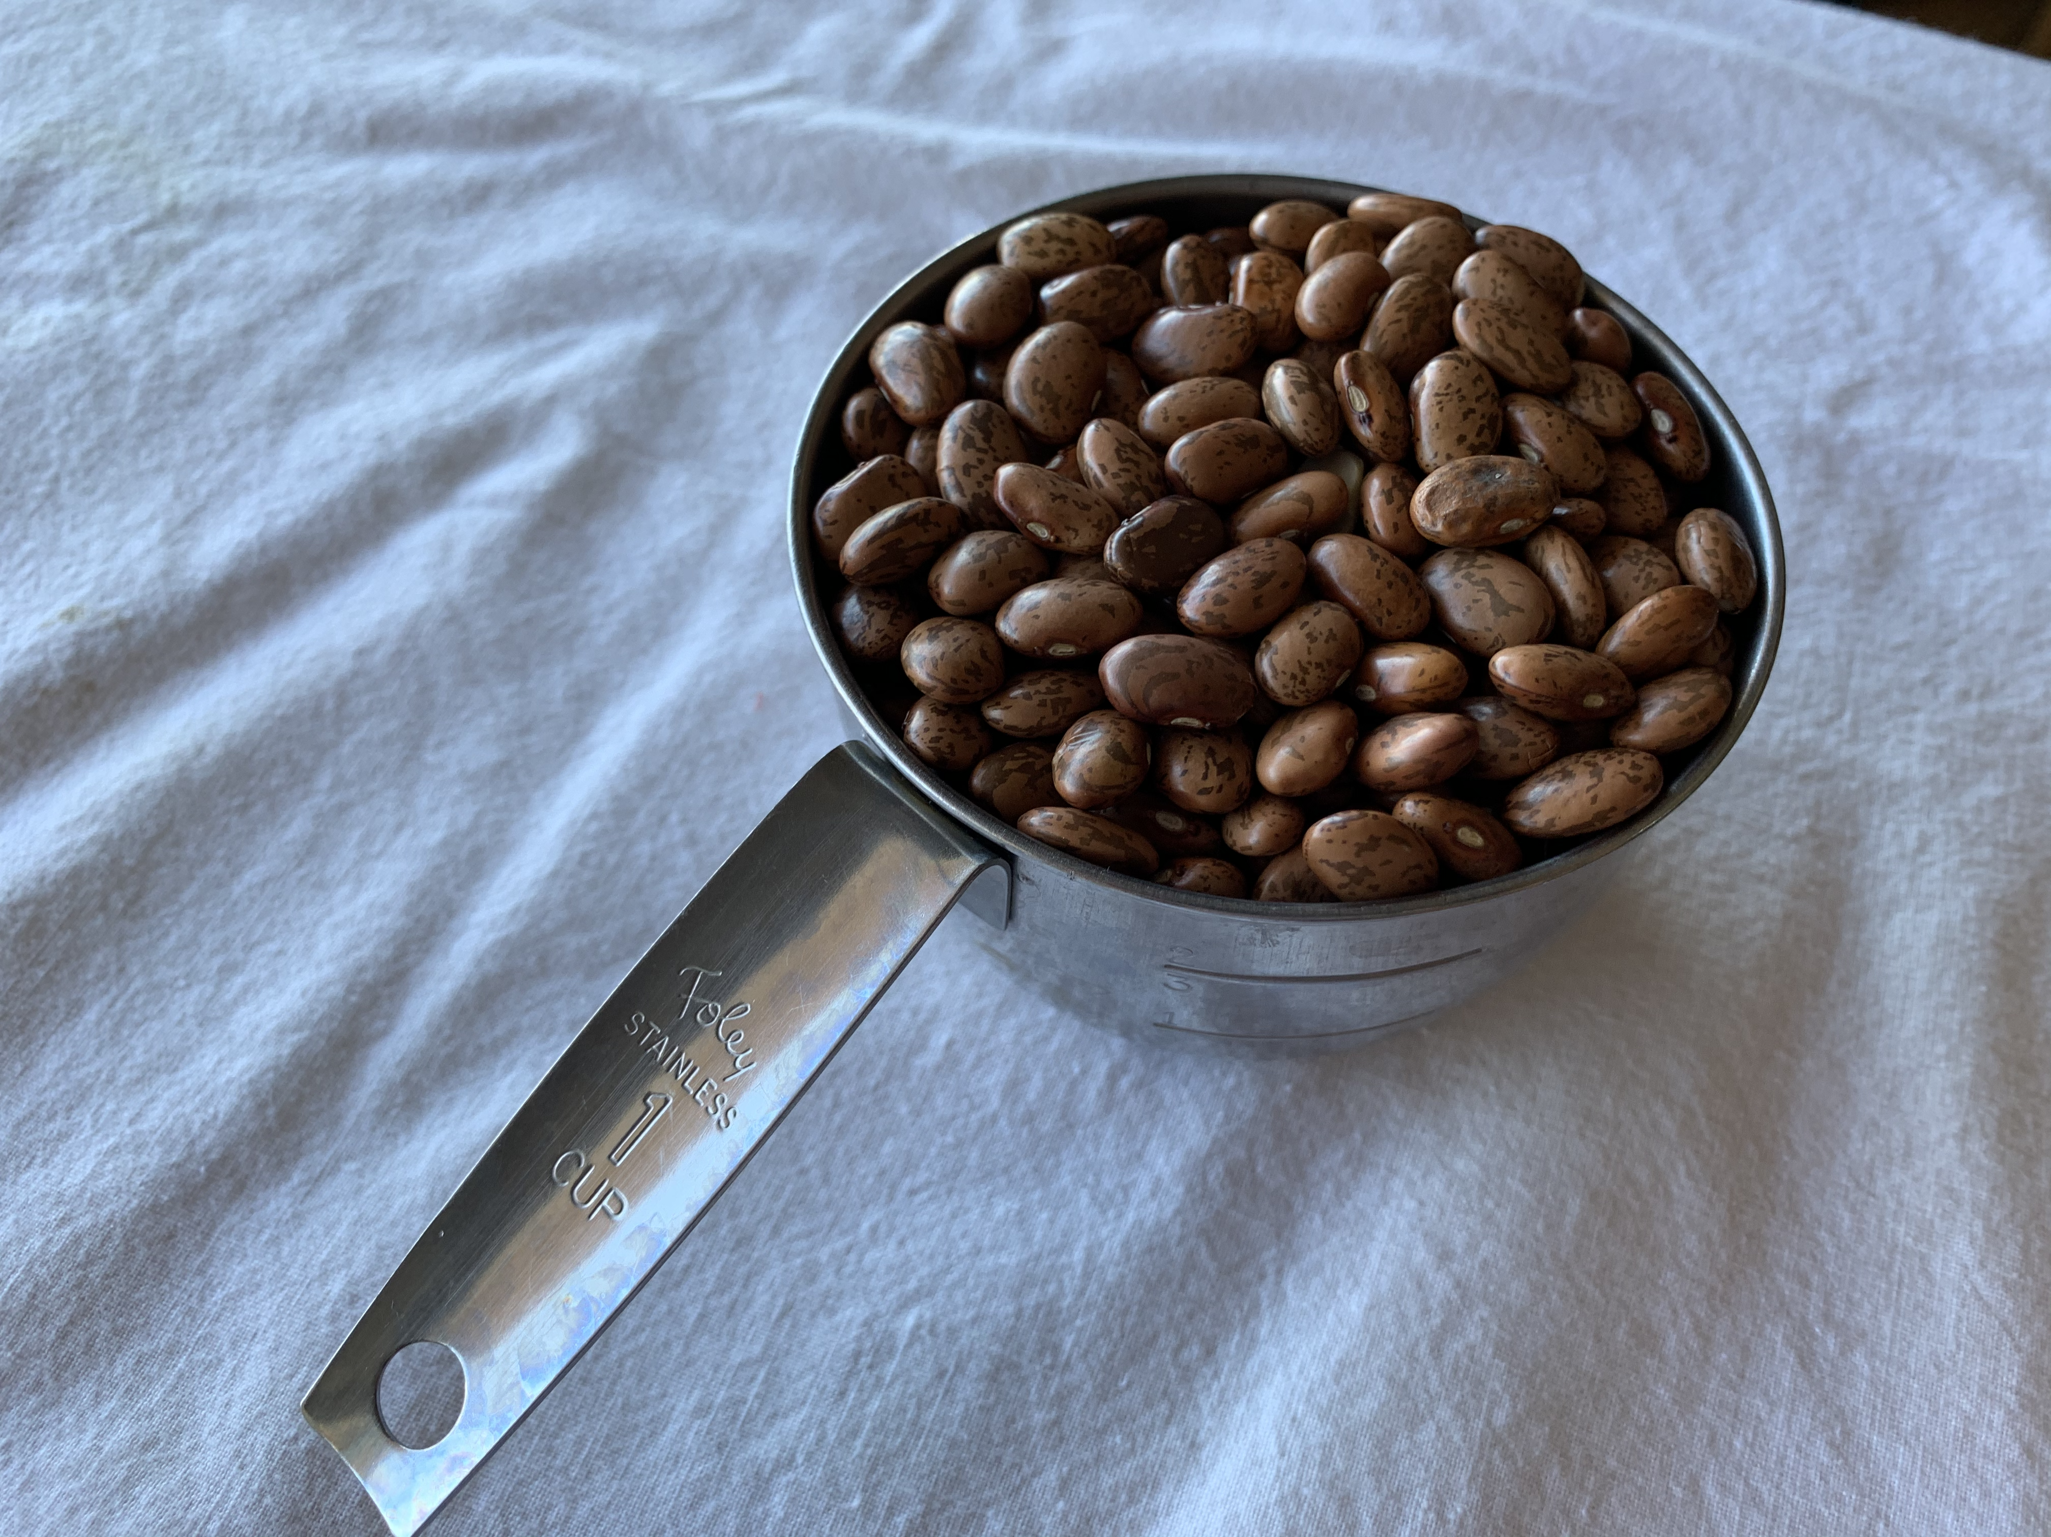
Clare, Noah, and Jada counted a cup of dried beans. They each came up with 529 beans. The following pictures show how each of them counted.
Jada’s counting strategy:
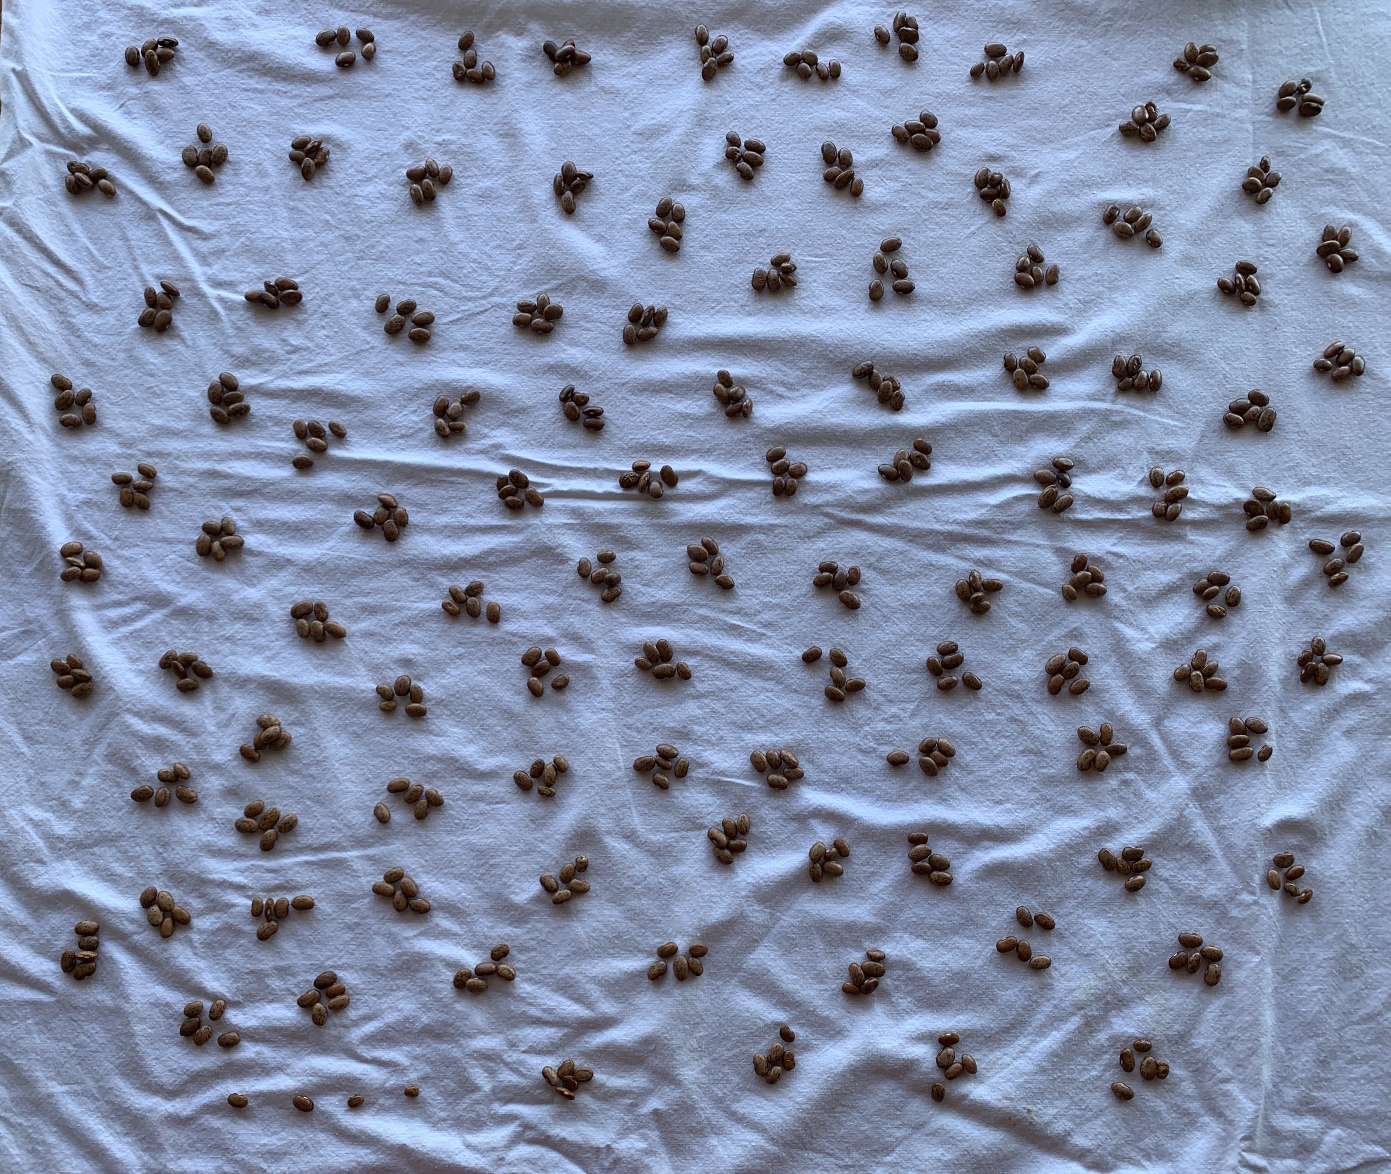
Noah’s counting strategy:
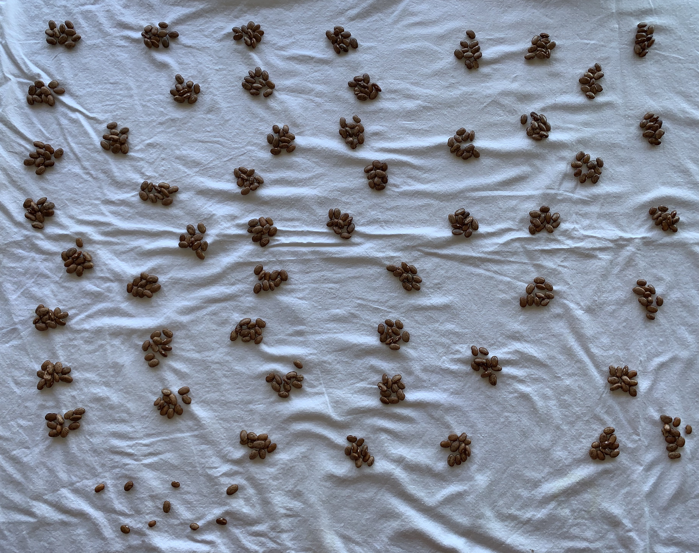
Clare’s counting strategy:
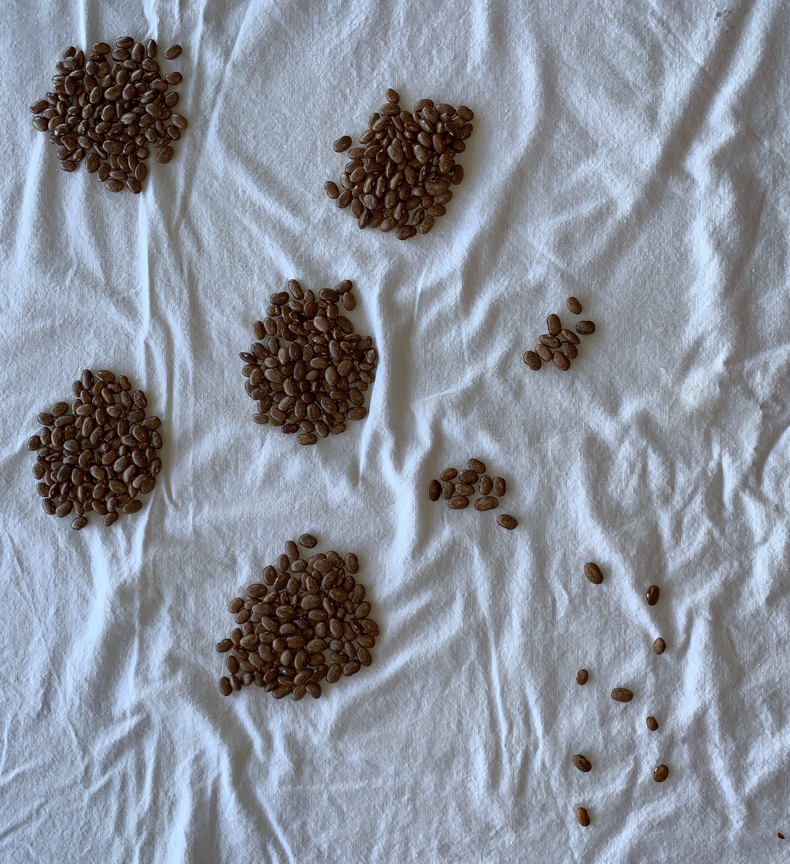
- What do you notice about each of their strategies?
- What is helpful about each strategy?
- What is challenging about each strategy?

14.2: Lots of Beans
Organize and count your beans. Use the space to record your thinking.
Gallery walk questions:
- How does this strategy help you count their beans?
- How can this be made clearer?
- How is this strategy the same as your strategy? How is it different?
- Does your group have more or fewer beans? Explain your reasoning.
© CC BY 2021 Illustrative Mathematics®

