Unit 6 Lesson 17: Let’s Make a Dollar

WU Number Talk: Add 25 (Warm up)

Student Task Statement
Find the value of each expression mentally.
- $25+10+10+5$
- $25+25$
- $25+25+25$
- $25+25+25+25$

1 Many Many Cents

Student Task Statement
- Coin Collection A
- 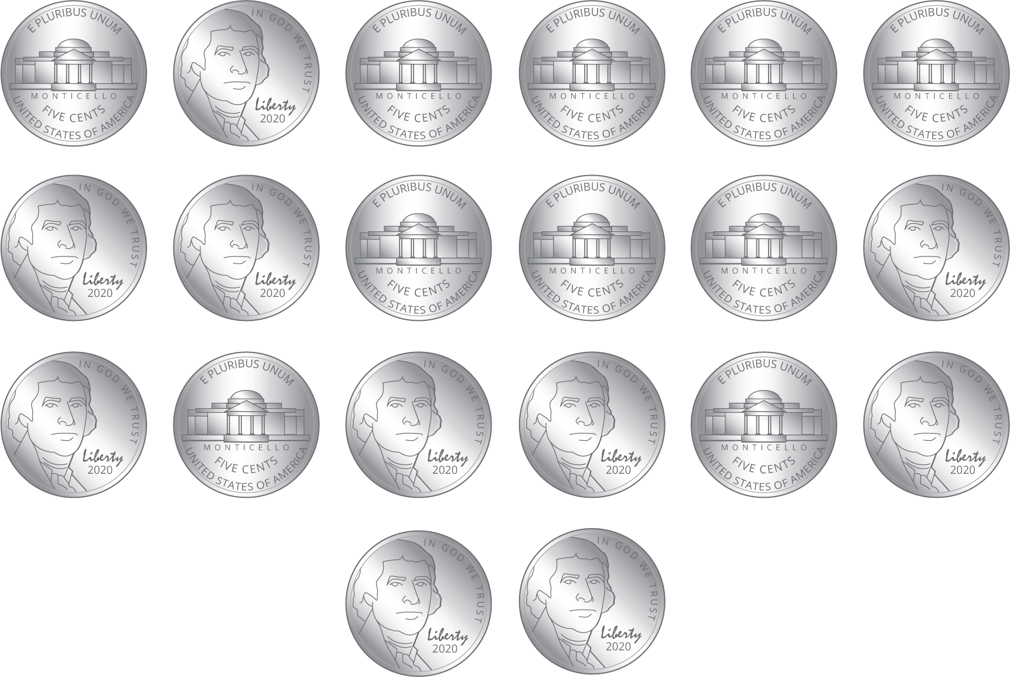
- Circle the coins
in this collection.
- quarters
- dimes
- nickels
- pennies
- How many coins? __________
- What is the value in cents?
Show your thinking.
- Coin Collection B
- 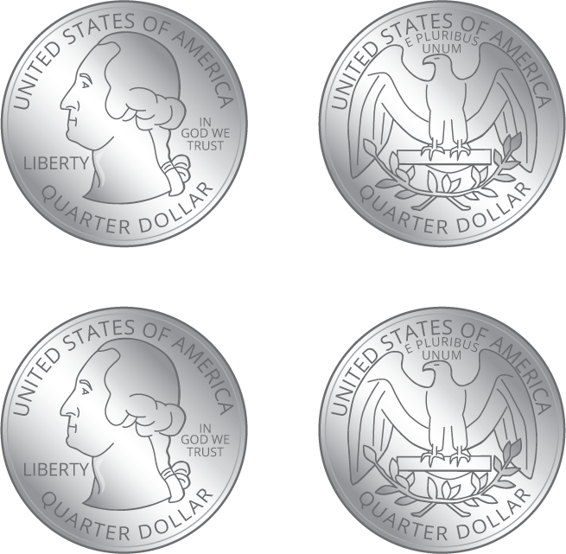
- Circle the coins
in this collection.
- quarters
- dimes
- nickels
- pennies
- How many coins? __________
- What is the value in cents?
Show your thinking.
- Coin Collection C
- Make a collection using only dimes that has the same value as Collection A.
- Glue or draw coins here.
- How many coins?__________
- What is the value in cents?
Show your thinking.

2 The Value of a Dollar

Images for Launch
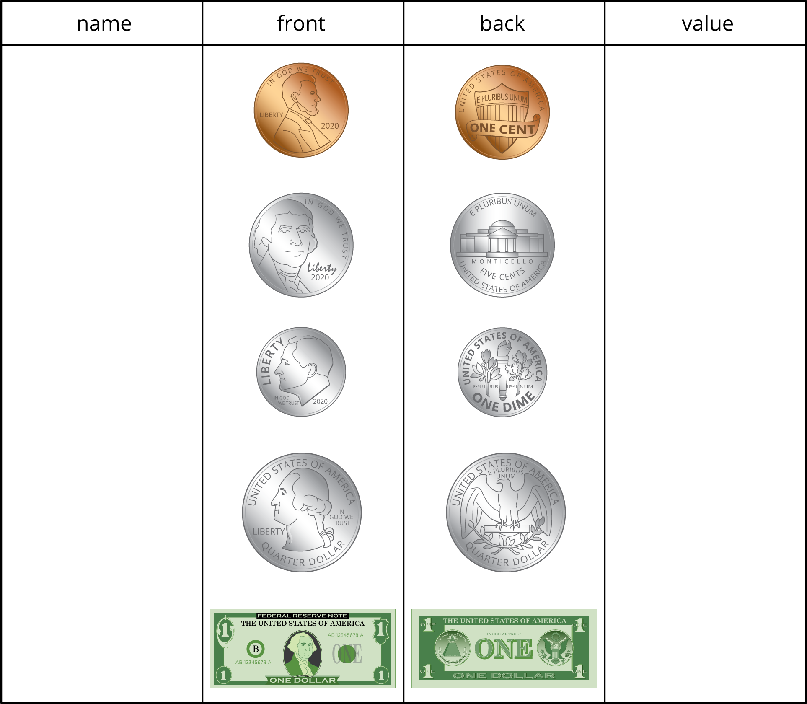
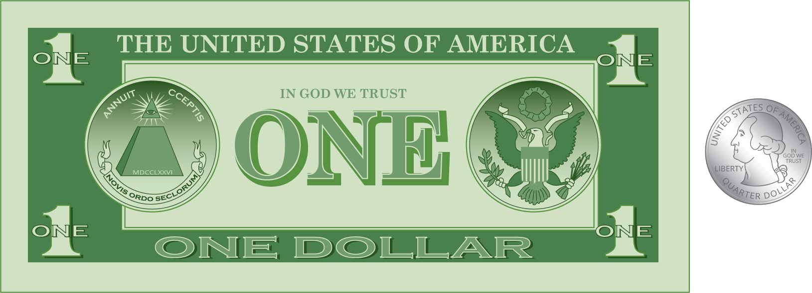

Student Task Statement
- Andre emptied his pockets and found these coins.
- 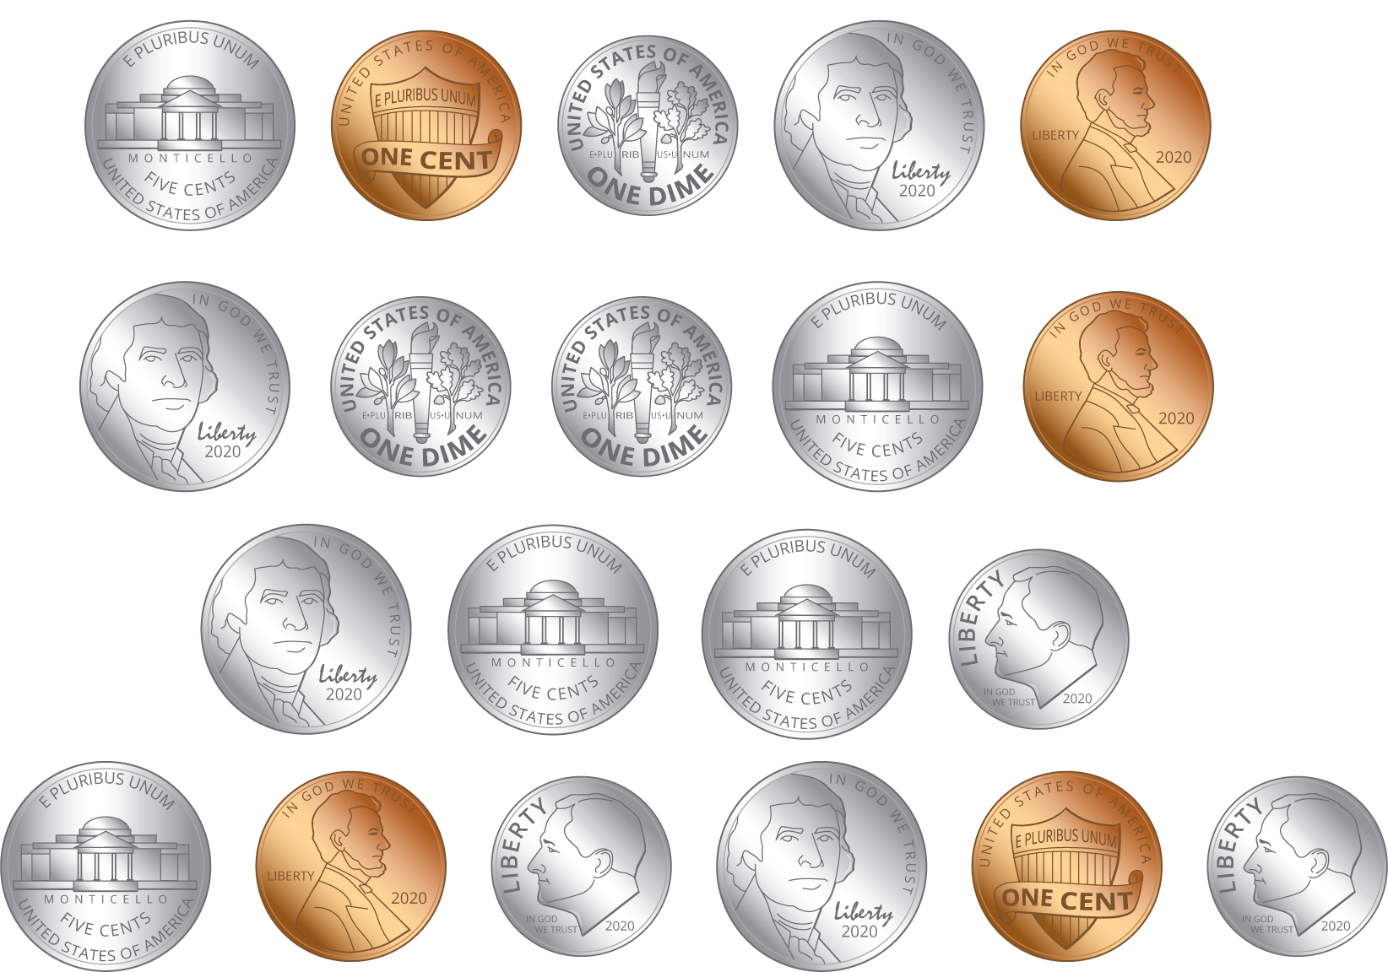
- How much money does he have? Show your thinking.
- Han emptied his pockets and found these coins.
- 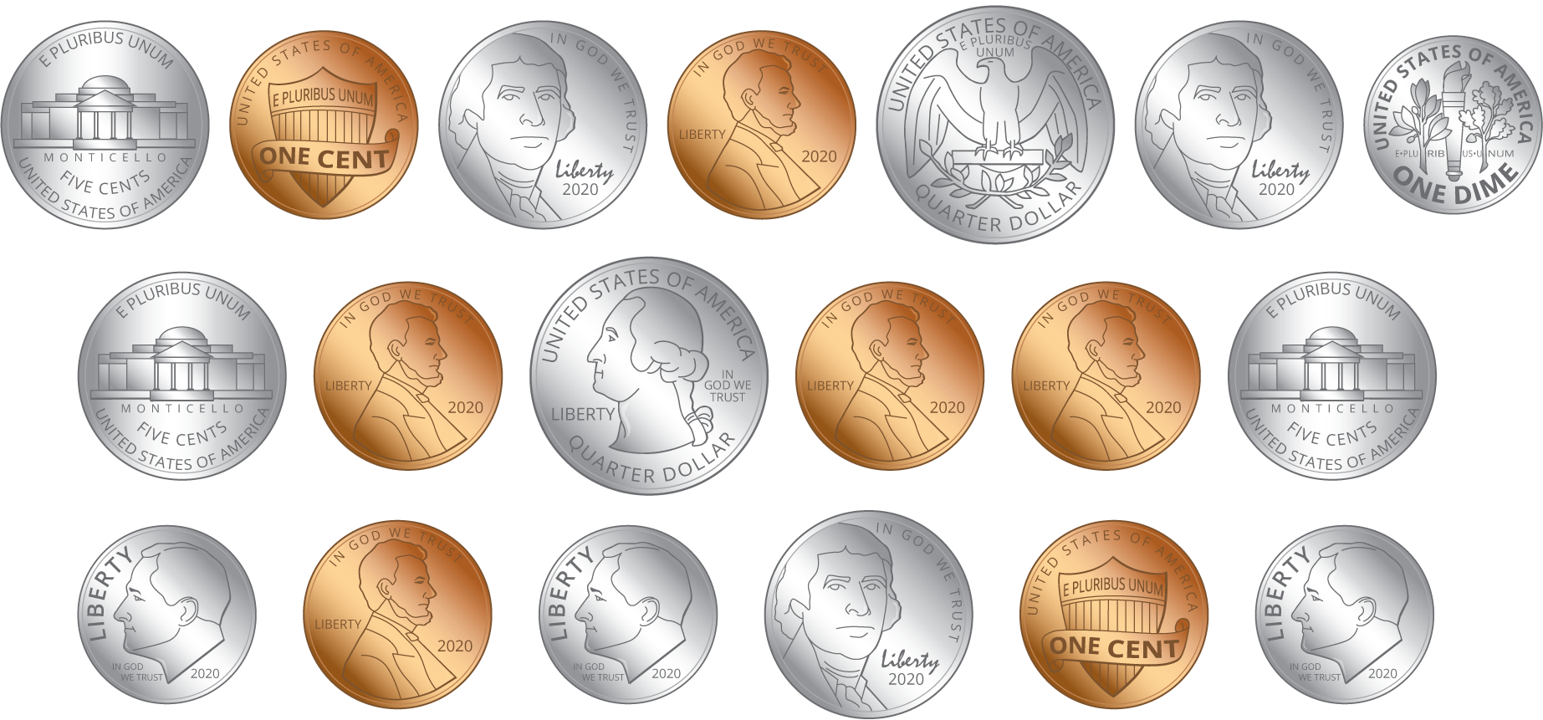
- How much money does he have? Show your thinking.
- Priya has $1 and 18¢ in her pocket.
  - If Priya only had coins in her pocket, what coins could she have?
  - Represent Priya’s coins:
  - If Priya had 1 dollar bill and some coins, what coins could she have?
  - Represent Priya's money:
© CC BY 2021 Illustrative Mathematics®

