Lesson 2: Attributes of Triangles and Quadrilaterals
- Let’s sort shapes into more specific categories.

Warm-up: True or False: Multiples of Ten
Decide if each statement is true or false. Be prepared to explain your reasoning.
- $3×60=9×10$
- $180=3×60$
- $6×40=24×10$
- $24×10=240$

2.1: Card Sort: Triangles
Sort the triangles into categories. Record your categories and be prepared to explain how you sorted the shapes.
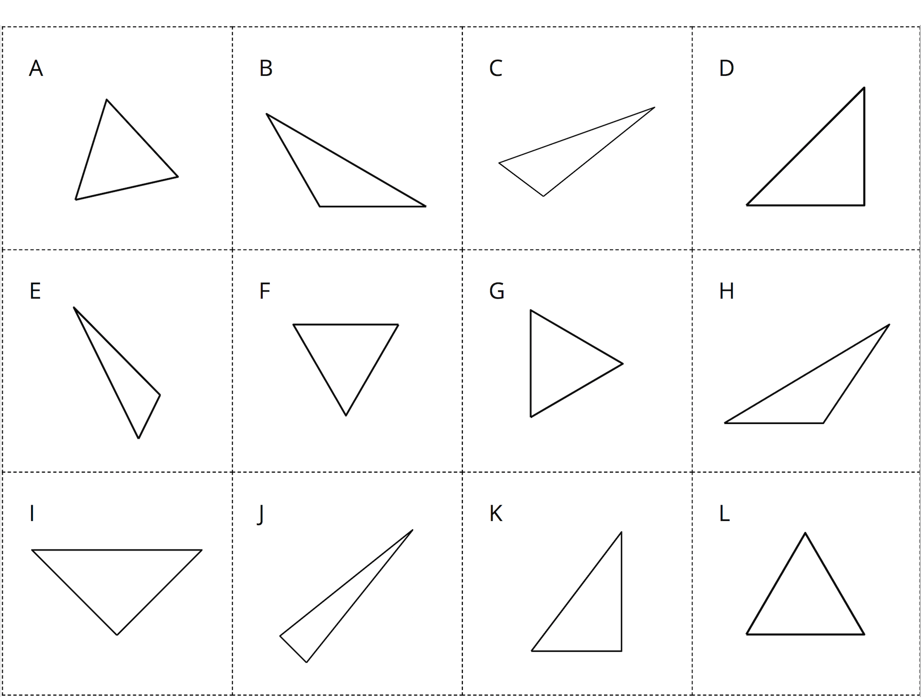

2.2: Card Sort: Quadrilaterals
Sort the quadrilaterals into categories. Record your categories and be prepared to explain how you sorted the shapes.
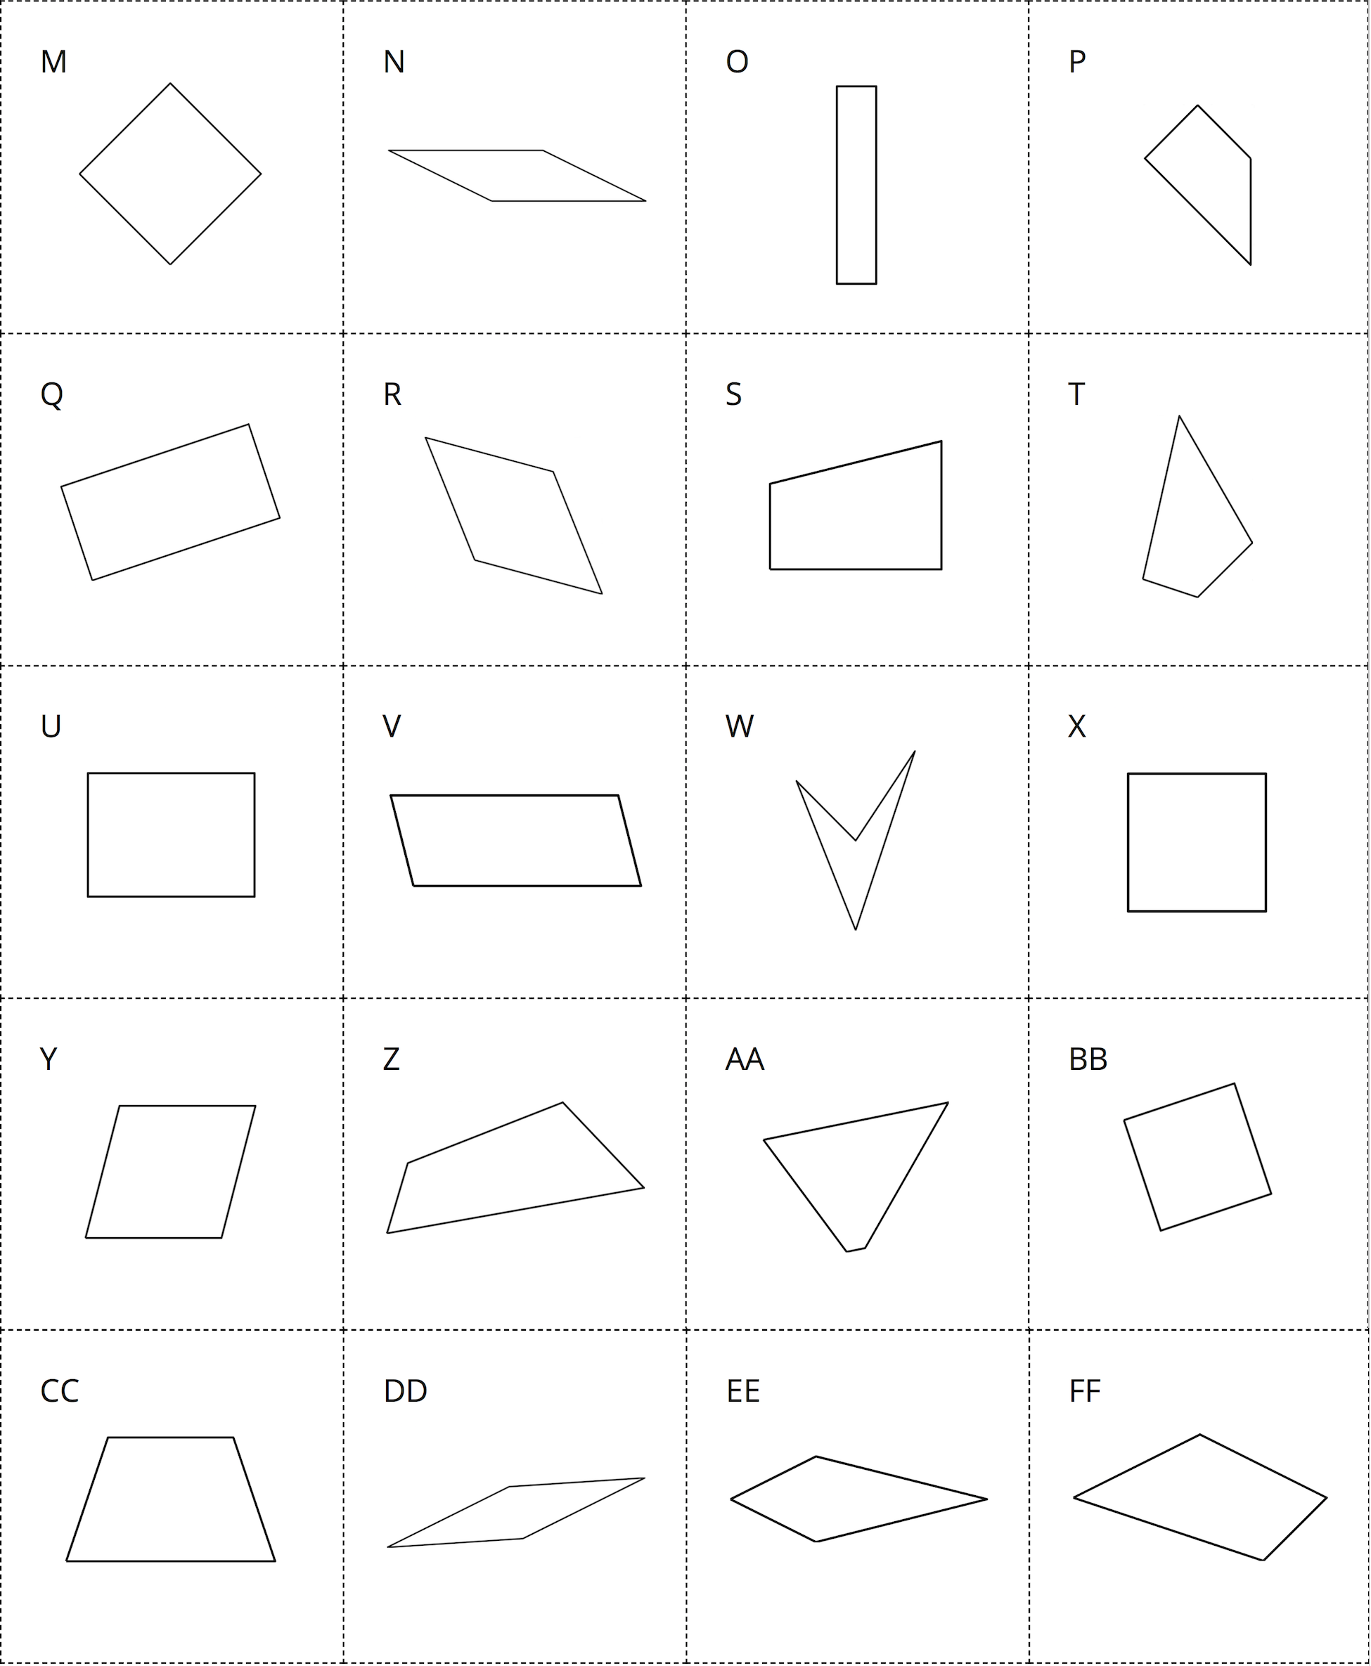
© CC BY 2021 Illustrative Mathematics®

