Lesson 4: Tiny House: Design and Solve

Standards Alignments
Building On | 3.MD.C, 3.MD.C.7.d
Addressing | 3.MD.C.7.b, 3.MD.C.7.d, 3.MD.D.8

Teacher-facing Learning Goals
- Apply understanding of area and perimeter to solve problems about design.

Student-facing Learning Goals
- Let’s design a tiny house.

Lesson Purpose
The purpose of this lesson is for students to design and solve problems about a tiny house.
In an earlier unit, students learned about area and perimeter. In this lesson, they apply their understanding of area and perimeter and their creativity to design a tiny house, which is generally a house under 400 square feet. After students design their tiny house (along with the furniture and other details), they write, revise, and answer problems involving area and perimeter that can be answered using their design.
If students need additional support with the concepts in this lesson, refer back to Unit 2, Section B in the curriculum materials.

Access for:

Students with Disabilities
- Engagement (Activity 1)

English Learners
- MLR8 (Activity 1)

Instructional Routines
Notice and Wonder (Warm-up)

Materials to Gather
- Materials from a previous activity: Activity 2

Lesson Timeline
Warm-up | 10 min
Activity 1 | 25 min
Activity 2 | 15 min
Lesson Synthesis | 5 min
Cool-down | 5 min

Teacher Reflection Question
What patterns did you notice in the designs students created today? What evidence did you see of students using their geometry knowledge to create their design?

Cool-down
(to be completed at the end of the lesson) 5min
Area and Perimeter

Standards Alignments
Addressing | 3.MD.C.7.b, 3.MD.D.8

Student-facing Task Statement
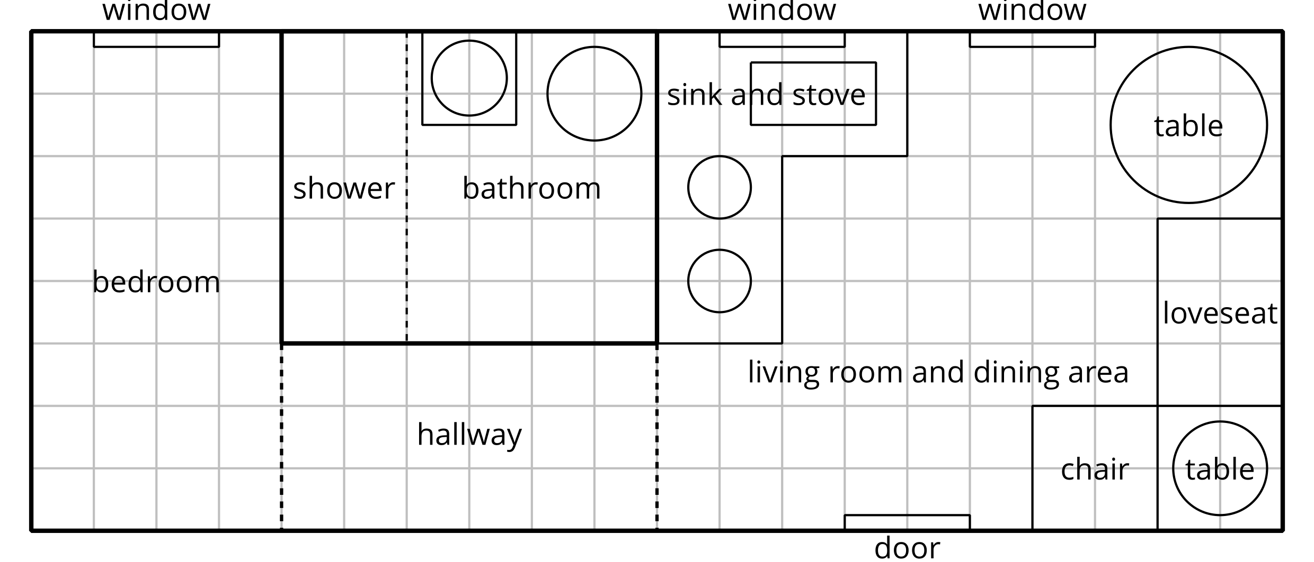
Each square on the diagram is 1 square foot.
- What is the combined area of the hallway and bedroom? Explain or show your reasoning.
- What is the perimeter of the living room and dining area? Explain or show your reasoning.

Student Responses
- 50 square feet. Sample response: The hallway is 3 feet by 6 feet so it has an area of 18 square feet. The bedroom is 4 feet by 8 feet so it has an area of 32 square feet. I added 32 and 18 to get 50.
- 36 feet. (The perimeter is the same whether students include the sink and stove or not.) Sample responses:
  - I found $2×10$ and $2×8$, then I added 20 and 16 to get 36.
  - I added the lengths of the two sides of the living room and the sides around the sink and stove, and the width of the hallway: $10+8+6+2+2+3+2+3$ and got 36.

