Unit 1 Lesson 8: Mondrian's Art

WU Notice and Wonder: Piet Mondrian’s Art (Warm up)

Student Task Statement
What do you notice? What do you wonder?
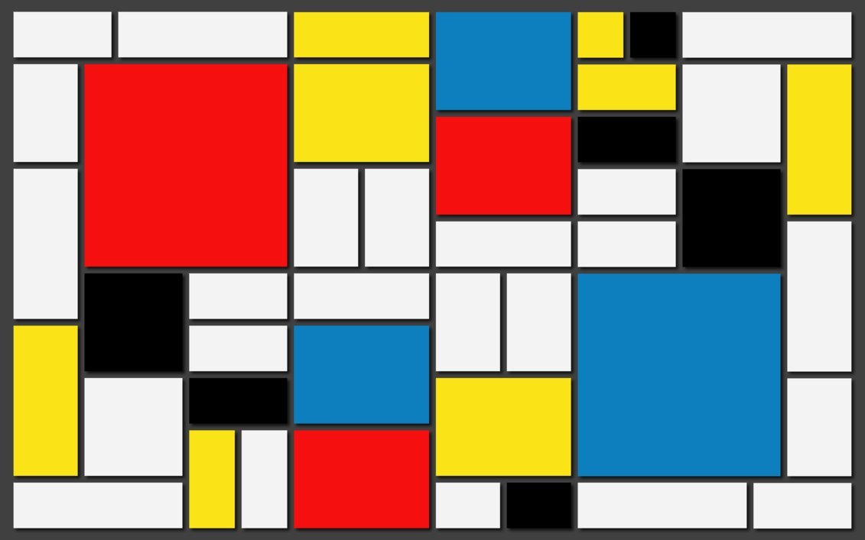
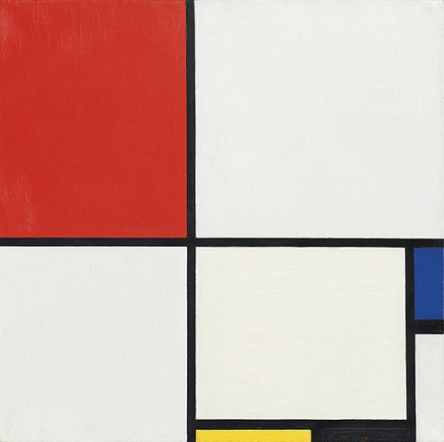

1 My Mondrian Outline

Student Task Statement
Create an outline for art in the Mondrian style, starting with an 18-by-24 grid.
Your artwork should:
- be partitioned into at least 12 rectangles
- include two different rectangles that have the same area
- include at least one rectangle whose area is a prime number
Try at least one of these challenges. Make a design where:
- all but two of the rectangles have a prime number for its area
- no two rectangles share a side entirely

2 Analyze the Rectangles

Student Task Statement
Trade artwork with your partner.
Using your partner’s artwork, look for and describe each of the following:
- Rectangles that have the same area
- Rectangles with an area that is a prime number
- Rectangles with an area that is a composite number
- Which challenge they completed
© CC BY 2021 Illustrative Mathematics®

