Lesson 15: Reasoning About Angles (Part 2)
- Let’s figure out missing angle measurements.

Warm-up: How Many Do You See: Obtuse Angles
How many angles do you see in the folded paper heart?
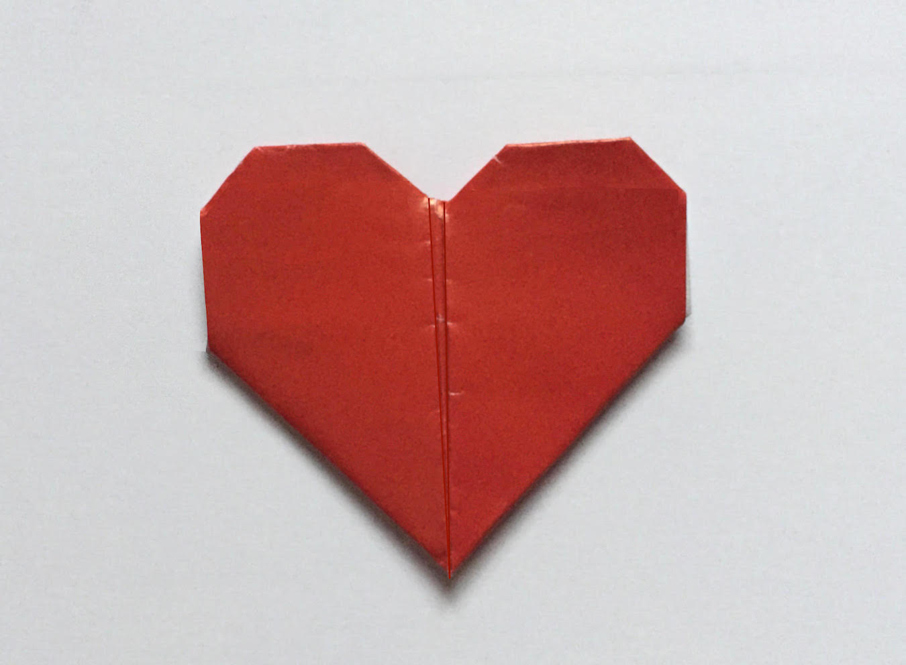

15.1: Shaded and Unshaded Angles
Find the measurement of each shaded angle. Show how you know.
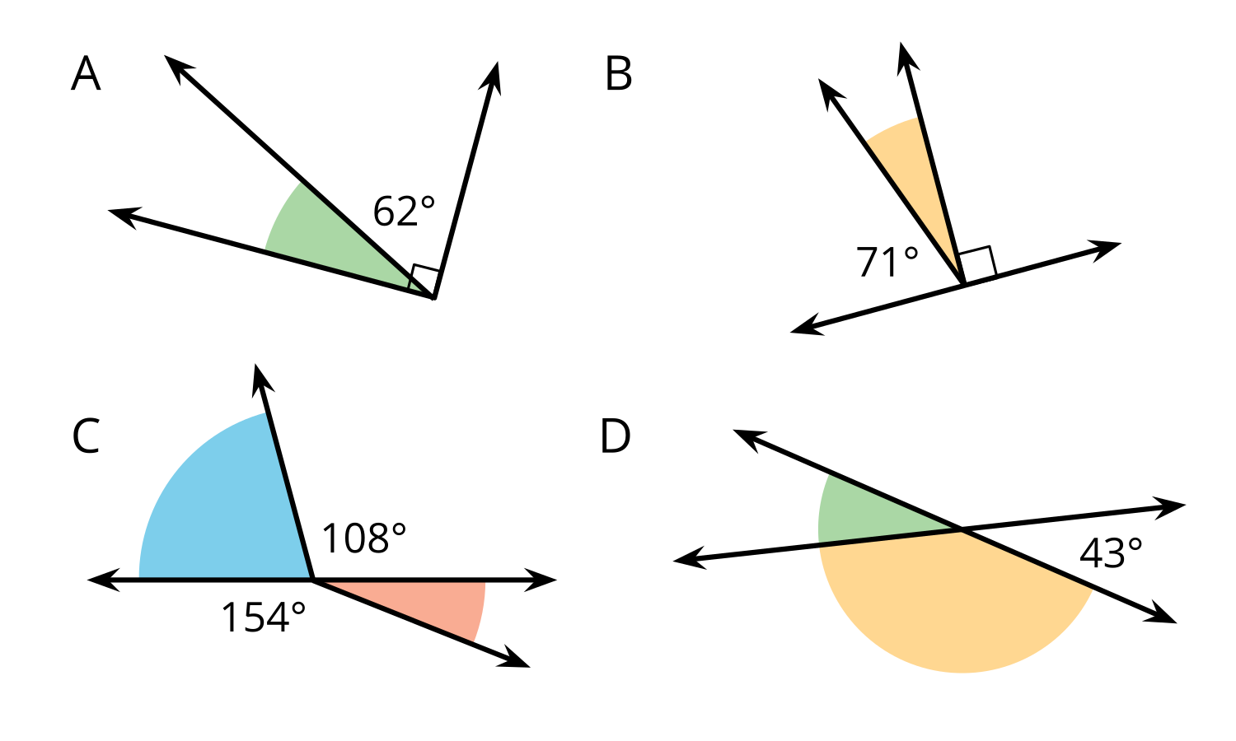

15.2: Info Gap: A Whole Bunch of Angles
Your teacher will give you either a problem card or a data card. Do not show or read your card to your partner.
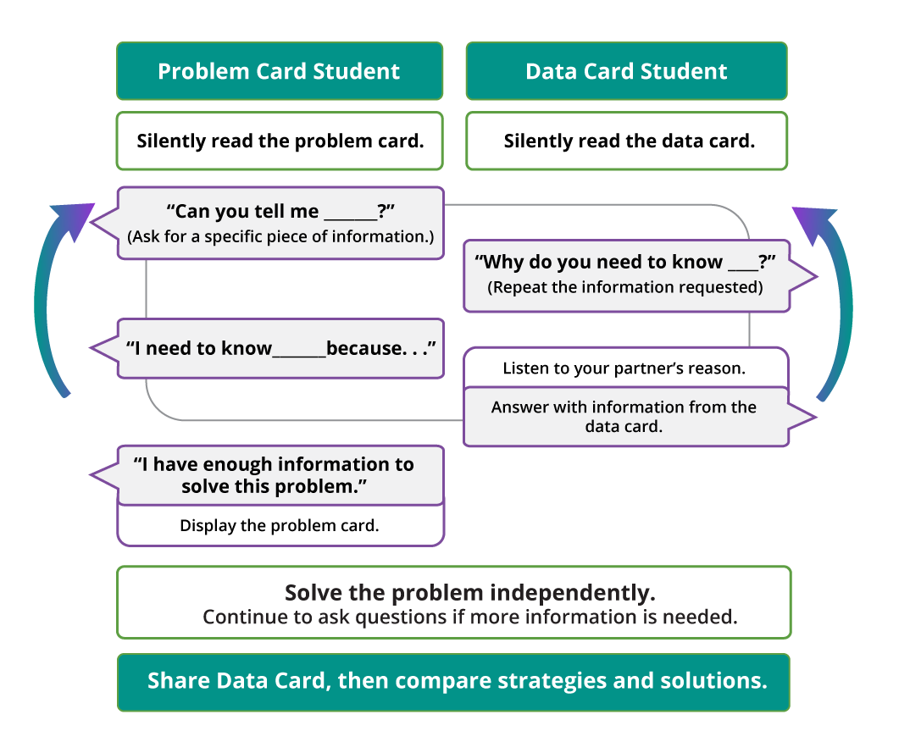
Pause here so your teacher can review your work. Ask your teacher for a new set of cards and repeat the activity, trading roles with your partner.

Section Summary
Section Summary
Earlier in the unit, we learned that a right angle measures exactly ${90}^{∘}$. In this section, we learned other ways to name angles based on their measurements.
- Acute angles are less than 90º.
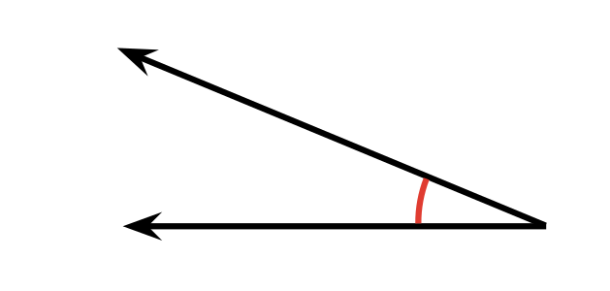
- Obtuse angles are greater than 90º but less than 180º.
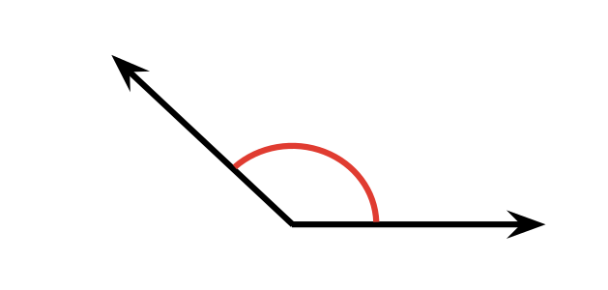
- Straight angles are exactly 180º.
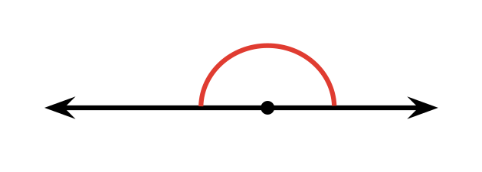
We also solved problems about angles. For example, if two angles make a right angle or a straight angle, we can use the size of one angle to find the other.
The shaded angle here must be ${28}^{∘}$ because it makes a right angle when combined with the ${62}^{∘}$ angle.
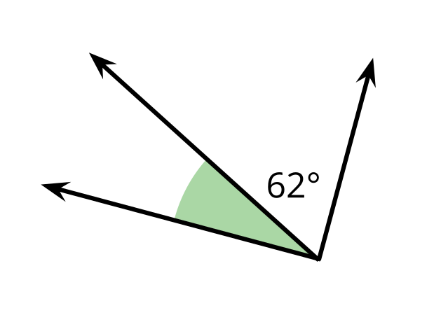
Another example: Knowing that a full turn measures ${360}^{∘}$, we reasoned that the long hand of a clock makes:
- a ${360}^{∘}$ angle every hour
- a ${180}^{∘}$ angle every one-half hour
- a ${90}^{∘}$ angle every 15 minutes
- a ${60}^{∘}$ angle every 10 minutes
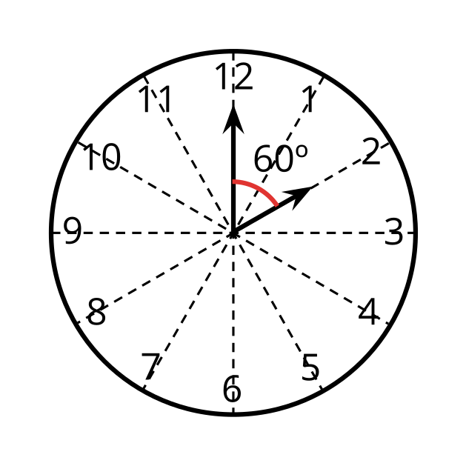
© CC BY 2021 Illustrative Mathematics®

