Unit 5 Lesson 17 Cumulative Practice Problems
- Here is data on the number of cases of whooping cough from 1939 to 1955.
- year | - number of cases
- 1941 | - 222,202
- 1950 | - 120,718
- 1945 | - 133,792
- 1942 | - 191,383
- 1953 | - 37,129
- 1939 | - 103,188
- 1951 | - 68,687
- 1948 | - 74,715
- 1955 | - 62,786
- 1952 | - 45,030
- 1940 | - 183,866
- 1954 | - 60,866
- 1944 | - 109,873
- 1946 | - 109,860
- 1943 | - 191,890
- 1949 | - 69,479
- 1947 | - 156,517
  - Make a new table that orders the data by year.
  - Circle the years in your table that had fewer than 100,000 cases of whooping cough.
  - Based on this data, would you expect 1956 to have closer to 50,000 cases or closer to 100,000 cases?
- In volleyball statistics, a block is recorded when a player deflects the ball hit from the opposing team. Additionally, scorekeepers often keep track of the average number of blocks a player records in a game. Here is part of a table that records the number of blocks and blocks per game for each player in a women’s volleyball tournament. A scatter plot that goes with the table follows.
- blocks | - blocks per game
- 13 | - 1.18
- 1 | - 0.17
- 5 | - 0.42
- 0 | - 0
- 0 | - 0
- 7 | - 0.64
- 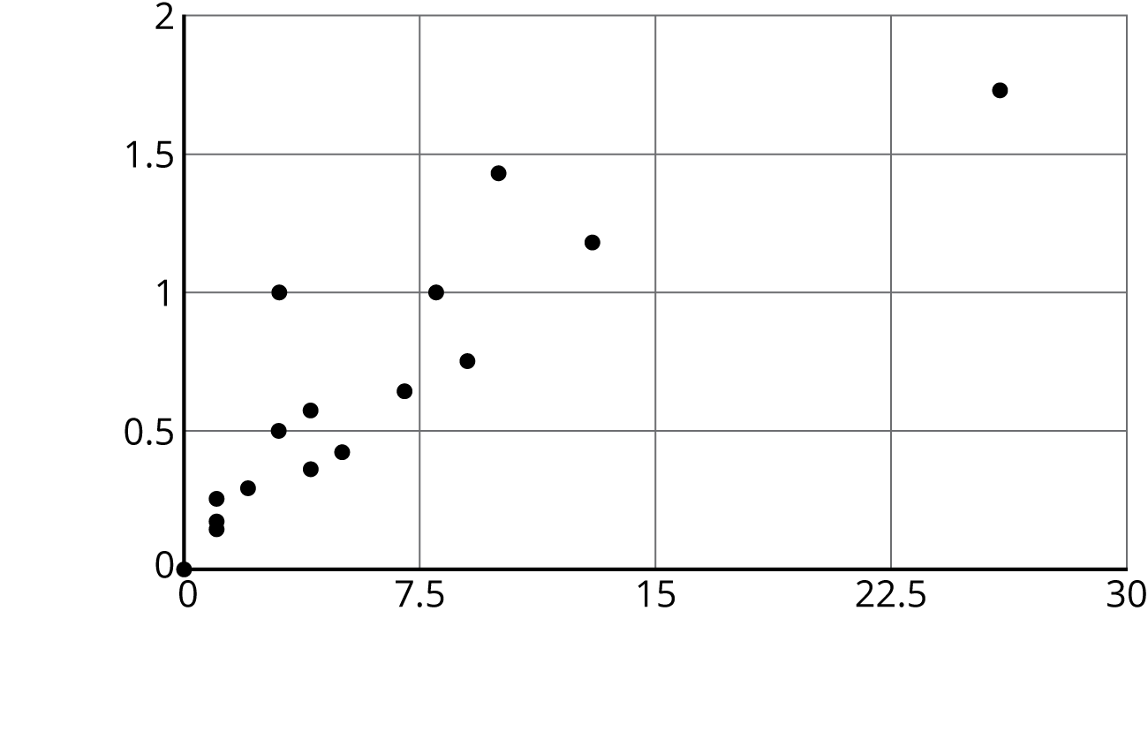
- Label the axes of the scatter plot with the necessary information.
- In hockey, a player gets credited with a “point” in their statistics when they get an assist or goal. The table shows the number of assists and number of points for 15 hockey players after a season.
- assists | - points
- 22 | - 28
- 16 | - 18
- 46 | - 72
- 19 | - 29
- 13 | - 26
- 9 | - 13
- 16 | - 22
- 8 | - 18
- 12 | - 13
- 12 | - 17
- 37 | - 50
- 7 | - 12
- 17 | - 34
- 27 | - 58
- 18 | - 34
- Make a scatter plot of this data. Make sure to scale and label the axes.
© CC BY Open Up Resources. Adaptations CC BY IM.

