Unit 6 Lesson 24 Cumulative Practice Problems
  - A cube’s volume is 512 cubic units. What is the length of its edge?
  - If a sphere fits snugly inside this cube, what is its volume?
  - What fraction of the cube is taken up by the sphere? What percentage is this? Explain or show your reasoning.
- Sphere A has radius 2 cm. Sphere B has radius 4 cm.
  - Calculate the volume of each sphere.
  - The radius of Sphere B is double that of Sphere A. How many times greater is the volume of B?
- Three cones have a volume of $192π$ cm³. Cone A has a radius of 2 cm. Cone B has a radius of 3 cm. Cone C has a radius of 4 cm. Find the height of each cone.
- (From Unit 6, Lesson 20.)
- The graph represents the average price of regular gasoline in the United States in dollars as a function of the number of months after January 2014.
- 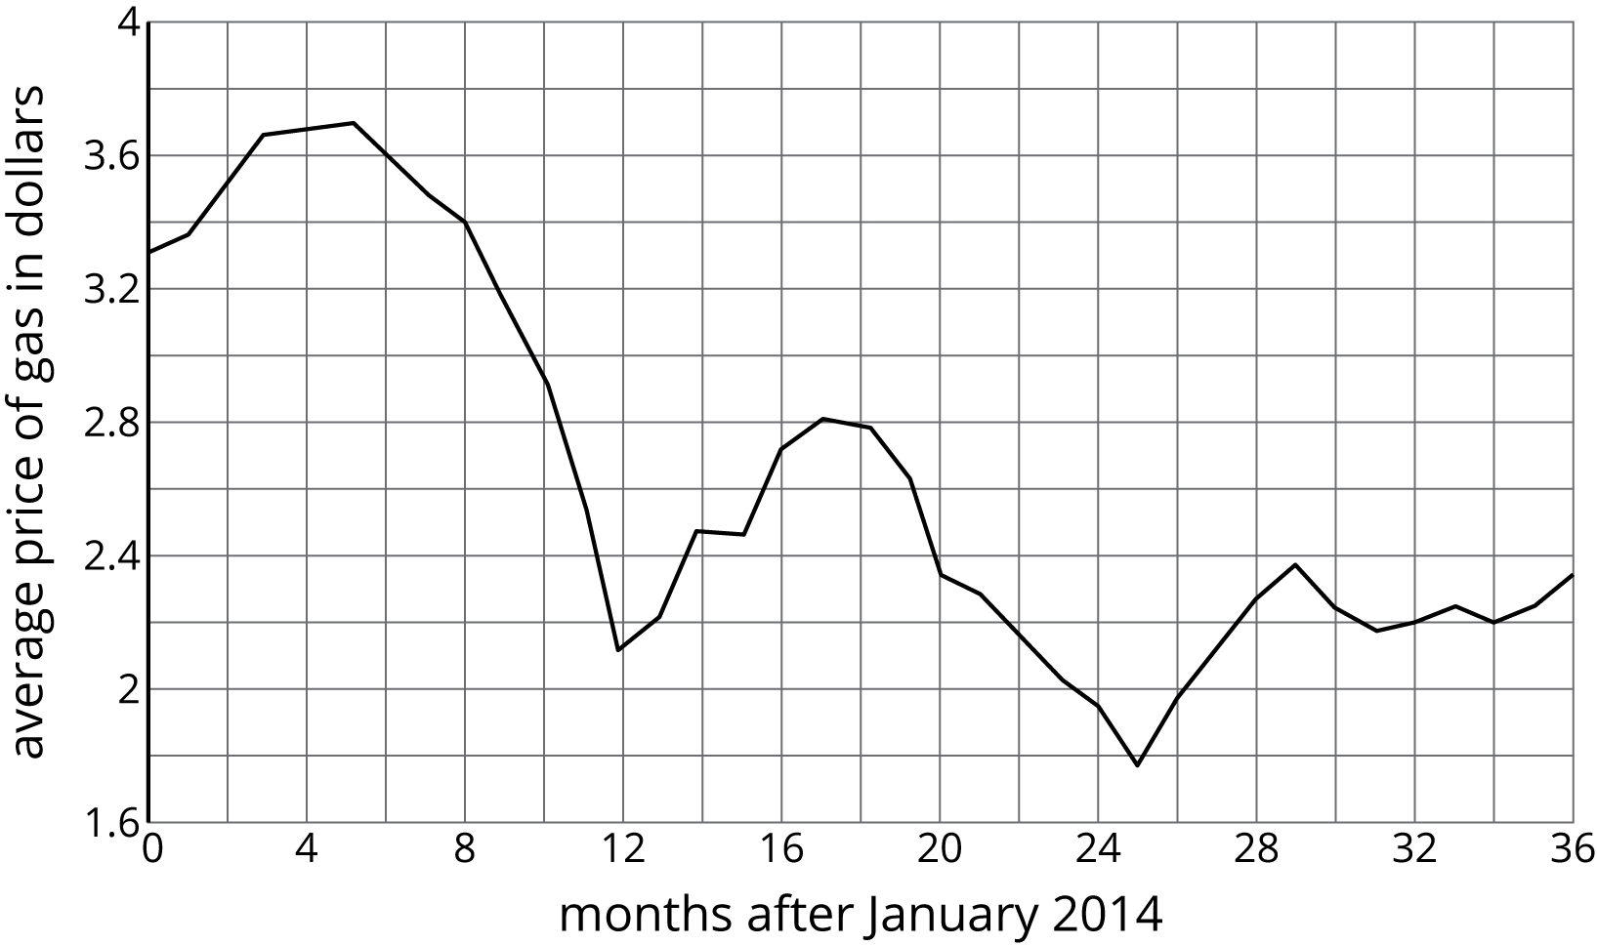
  - How many months after January 2014 was the price of gas the greatest?
  - Did the average price of gas ever get below $2?
  - Describe what happened to the average price of gas in 2014.
- (From Unit 6, Lesson 5.)
- Match the description of each sphere to its correct volume.
  - Sphere A: radius of 4 cm
  - Sphere B: diameter of 6 cm
  - Sphere C: radius of 8 cm
  - Sphere D: radius of 6 cm
  - $288π$ cm³
  - $\frac{256}{3}π$ cm³
  - $36π$ cm³
  - $\frac{2048}{3}π$ cm3
- While conducting an inventory in their bicycle shop, the owner noticed the number of bicycles is 2 fewer than 10 times the number of tricycles. They also know there are 410 wheels on all the bicycles and tricycles in the store. Write and solve a system of equations to find the number of bicycles in the store.
- (From Unit 5, Lesson 16.)
© CC BY Open Up Resources. Adaptations CC BY IM.

