Unit 7 Lesson 8 Cumulative Practice Problems
- Are these two triangles identical? Explain how you know.
- 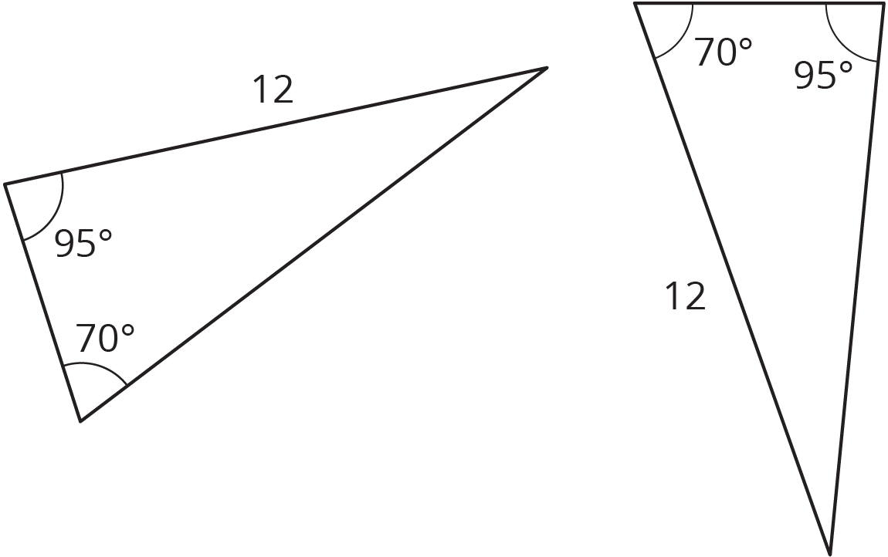
- Are these triangles identical? Explain your reasoning.
- 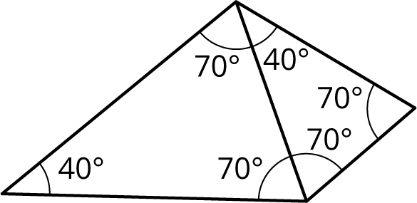

- Tyler claims that if two triangles each have a side length of 11 units and a side length of 8 units, and also an angle measuring ${100}^{∘}$, they must be identical to each other. Do you agree? Explain your reasoning.
- The markings on the number line are equally spaced. Label the other markings on the number line.
- (From Unit 5, Lesson 8.)
- A passenger on a ship dropped his camera into the ocean. If it is descending at a rate of -4.2 meters per second, how long until it hits the bottom of the ocean, which is at -1,875 meters?
- (From Unit 5, Lesson 9.)
- Apples cost $1.99 per pound.
  - How much do $3\frac{1}{4}$ pounds of apples cost?
  - How much do $x$ pounds of apples cost?
  - Clare spent $5.17 on apples. How many pounds of apples did Clare buy?
- (From Unit 4, Lesson 3.)
- Diego has a glue stick with a diameter of 0.7 inches. He sets it down 3.5 inches away from the edge of the table, but it rolls onto the floor. How many rotations did the glue stick make before it fell off of the table?
- (From Unit 3, Lesson 5.)
© CC BY Open Up Resources. Adaptations CC BY IM.

