Lesson 11 Practice Problems
- For each equation, find $y$ when $x=\text{-}3$. Then find $x$ when $y=2$
  - $y=6x+8$
  - $y=\frac{2}{3}x$
  - $y=\text{-}x+5$
  - $y=\frac{3}{4}x−2\frac{1}{2}$
  - $y=1.5x+11$
- True or false: The points $\left(6,13\right)$, $\left(21,33\right)$, and $\left(99,137\right)$ all lie on the same line. The equation of the line is $y=\frac{4}{3}x+5$. Explain or show your reasoning.
- Here is a linear equation: $y=\frac{1}{4}x+\frac{5}{4}$
  - Are $\left(1,1.5\right)$ and $\left(12,4\right)$ solutions to the equation? Explain or show your reasoning.
  - Find the $x$-intercept of the graph of the equation. Explain or show your reasoning.
- Find the coordinates of $B$, $C$, and $D$ given that $AB$ = 5 and $BC$ = 10.
- 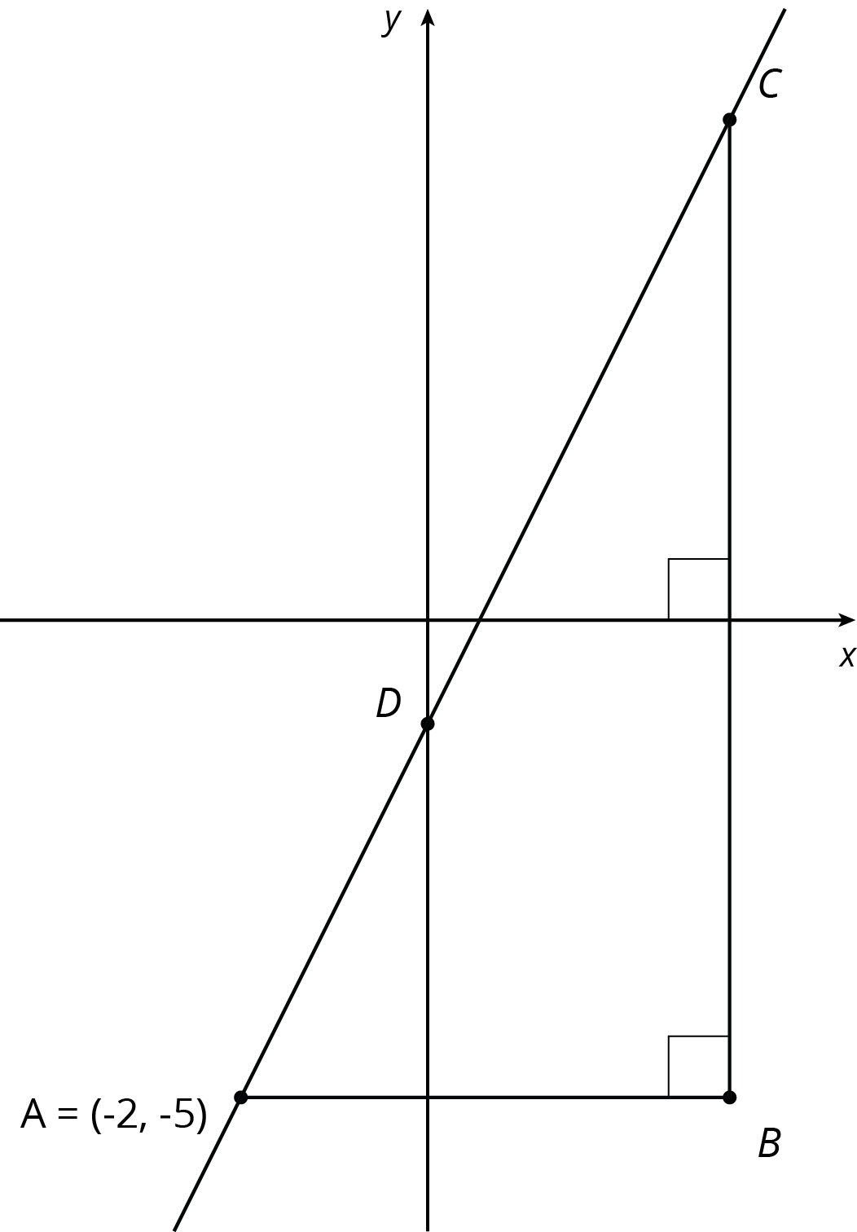
- (From Unit 2, Lesson 16.)
- Match each graph of a linear relationship to a situation that most reasonably reflects its context.
- 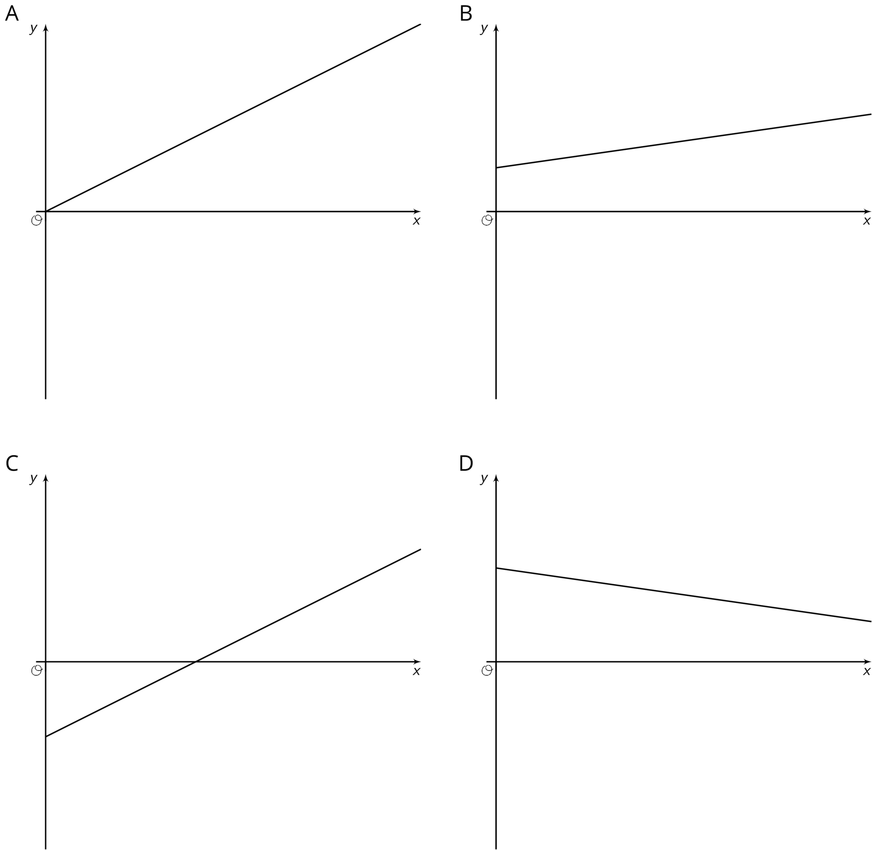
  - Graph A
  - Graph B
  - Graph C
  - Graph D
  - $y$ is the weight of a kitten $x$ days after birth.
  - $y$ is the distance left to go in a car ride after $x$ hours of driving at a constant rate toward its destination.
  - $y$ is the temperature, in degrees C, of a gas being warmed in a laboratory experiment.
  - $y$ is the amount of calories consumed eating $x$ crackers.
- (From Unit 5, Lesson 8.)
© CC BY Open Up Resources. Adaptations CC BY IM.

