Lesson 6: Per Each
Let's use ratios to describe cost and speed.

6.1: Number Talk: Dividing by Powers of 10
Find the quotient mentally.
$30÷10$
$34÷10$
$3.4÷10$
$34÷100$

6.2: More Shopping
- Four bags of chips cost $6.
  - What is the cost per bag?
  - At this rate, how much will 7 bags of chips cost?
- At a used book sale, 5 books cost $15.
  - What is the cost per book?
  - At this rate, how many books can you buy for $21?
- Neon bracelets cost $1 for 4.
  - What is the cost per bracelet?
  - At this rate, how much will 11 neon bracelets cost?
- Pause here so your teacher can review your work.
- Your teacher will assign you one of the problems. Create a visual display that shows your solution to the problem. Be prepared to share your solution with the class.

6.3: Moving 10 Meters
Your teacher will set up a straight path with a 1-meter warm-up zone and a 10-meter measuring zone. Follow the following instructions to collect the data.
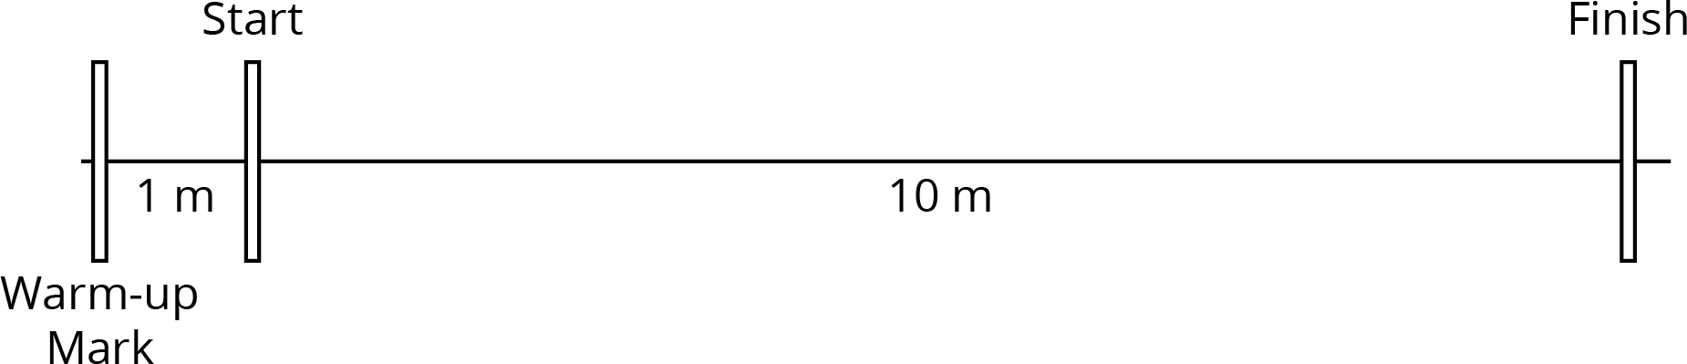
​

  - The person with the stopwatch (the “timer”) stands at the finish line. The person being timed (the “mover”) stands at the warm-up line.
  - On the first round, the mover starts moving at a slow, steady speed along the path. When the mover reaches the start line, they say, “Start!” and the timer starts the stopwatch.
  - The mover keeps moving steadily along the path. When they reach the finish line, the timer stops the stopwatch and records the time, rounded to the nearest second, in the table.
  - On the second round, the mover follows the same instructions, but this time, moving at a quick, steady speed. The timer records the time the same way.
  - Repeat these steps until each person in the group has gone twice: once at a slow, steady speed, and once at a quick, steady speed.
- your slow moving time (seconds) | - your fast moving time (seconds)
- After you finish collecting the data, use the double number line diagrams to answer the questions. Use the times your partner collected while you were moving.
- Moving slowly:
- Moving quickly:
  - Estimate the distance in meters you traveled in 1 second when moving slowly.
  - Estimate the distance in meters you traveled in 1 second when moving quickly.
  - Trade diagrams with someone who is not your partner. How is the diagram representing someone moving slowly different from the diagram representing someone moving quickly?

Lesson 6 Summary
The unit price is the price of 1 thing—for example, the price of 1 ticket, 1 slice of pizza, or 1 kilogram of peaches.
If 4 movie tickets cost $28, then the unit price would be the cost per ticket. We can create a double number line to find the unit price.
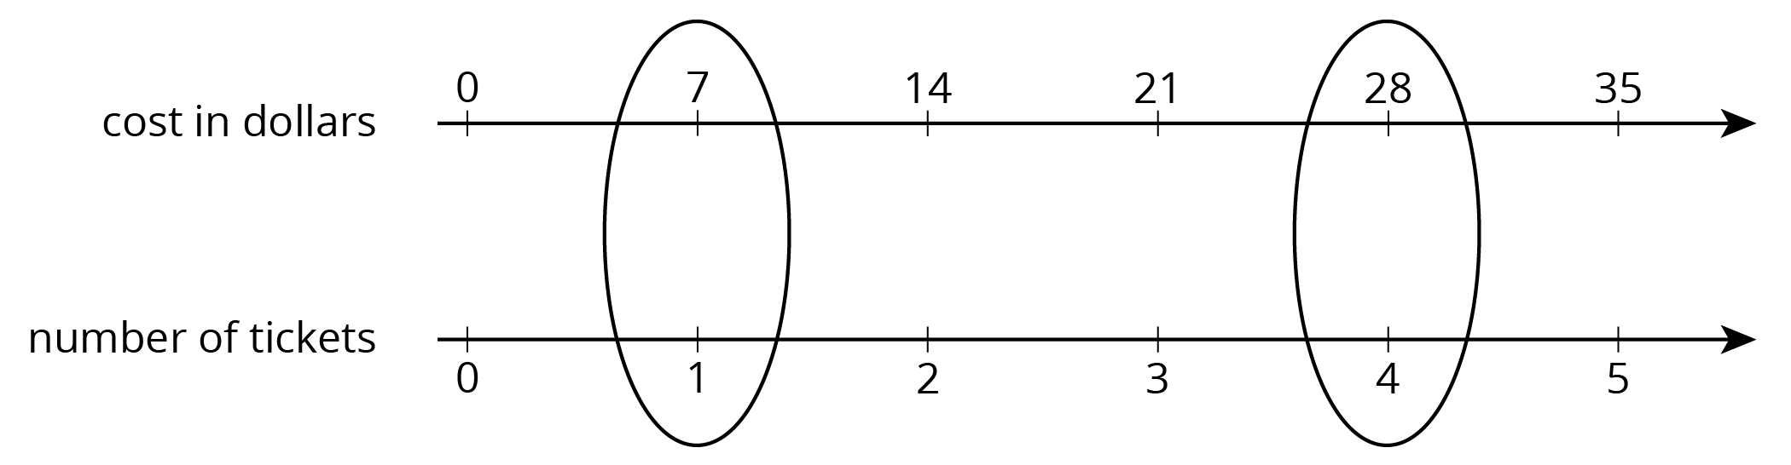
This double number line shows that the cost for 1 ticket is $7. We can also find the unit price by dividing, $28÷4=7$, or by multiplying, $28⋅\frac{1}{4}=7$.
Double number lines can also be used to make sense of objects moving at a constant speed. Suppose a train traveled 100 meters in 5 seconds at a constant speed.
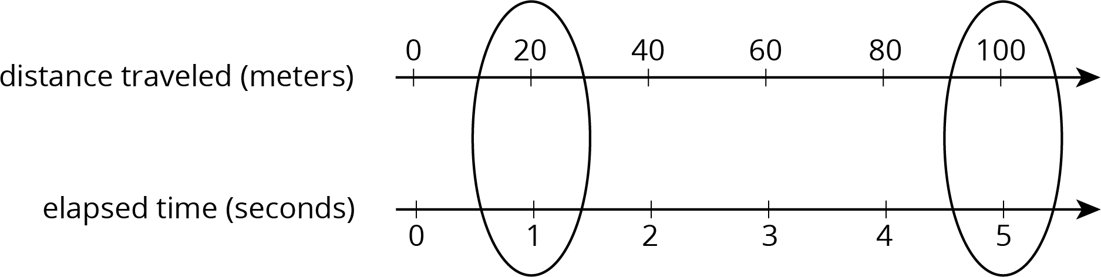
The double number line shows that the train’s speed was 20 meters per second. We can also find the speed by dividing: $100÷5=20$.
Once we know the speed in meters per second, many questions about the situation become simpler to answer because we can multiply the amount of time an object travels by the speed to get the distance. For example, at this rate, how far would the train go in 30 seconds? Because $20⋅30=600$ , the train would go 600 meters in 30 seconds.
© CC BY Open Up Resources. Adaptations CC BY IM.

