Lesson 5 Practice Problems
- Here is a histogram of a distribution with 94 data points.
- 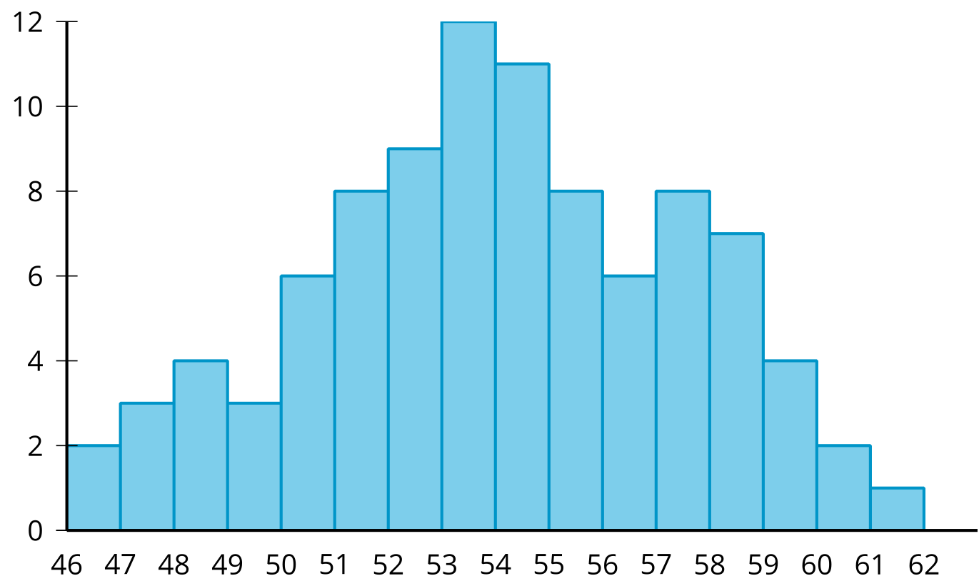
- For each given interval, find the proportion of data points which fall in that interval.
  - 47 to 48
  - 50 to 51
  - 53 to 54
- This relative frequency histogram shows the distribution of average daily temperatures (in degrees Fahrenheit) for a town over the course of 5 years.
- 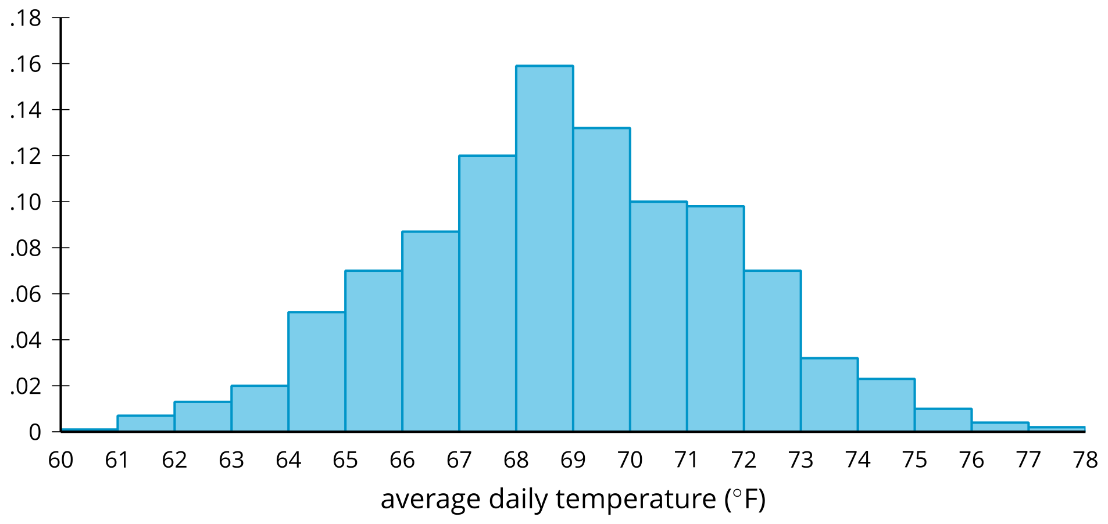
- Match each temperature interval with the proportion of days over the 5 years whose average temperature fell in that interval.
  - 60 to 66 degrees Fahrenheit
  - 66 to 68 degrees Fahrenheit
  - 68 to 70 degrees Fahrenheit
  - 70 to 71 degrees Fahrenheit
  - 73 to 74 degrees Fahrenheit
  - 0.032
  - 0.10
  - 0.163
  - 0.207
  - 0.291
- Two curves representing normal distributions are shown. Does the solid curve or dashed curve have a greater standard deviation? Explain how you know.
- 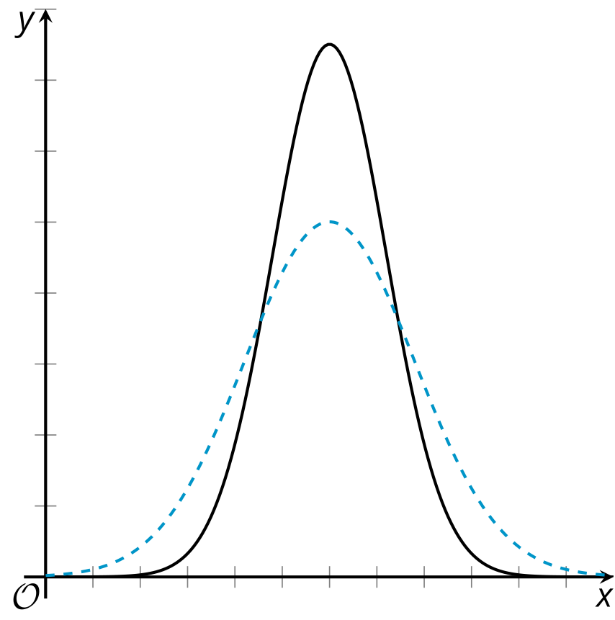
- Here are 2 distributions.

- set A
- 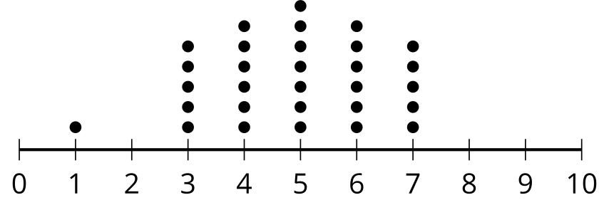

- set B
- 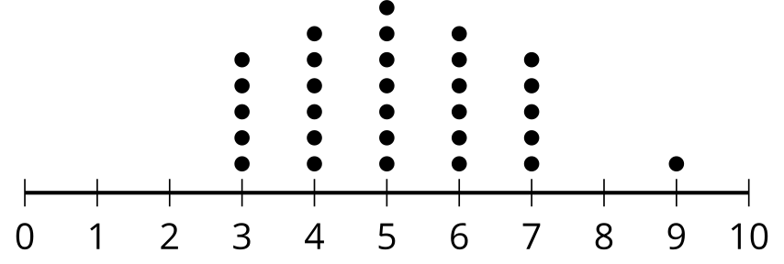
- How does the mean of set A compare to the mean of set B? Explain your reasoning.
- (From Unit 7, Lesson 4.)
- Which distribution is symmetric?
  - 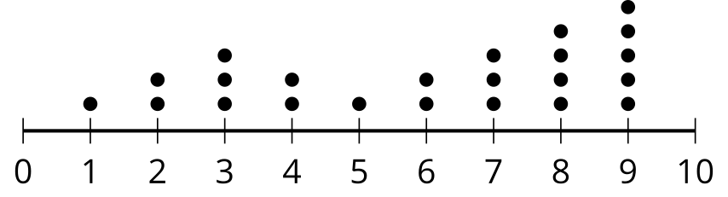
  - 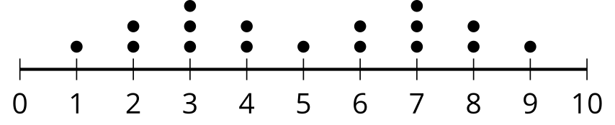
  - 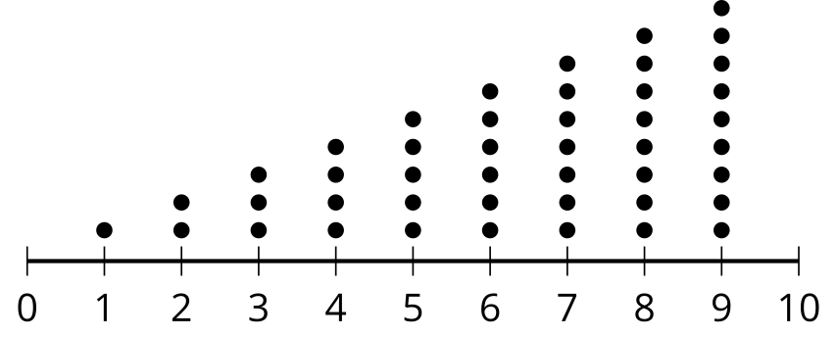
  - 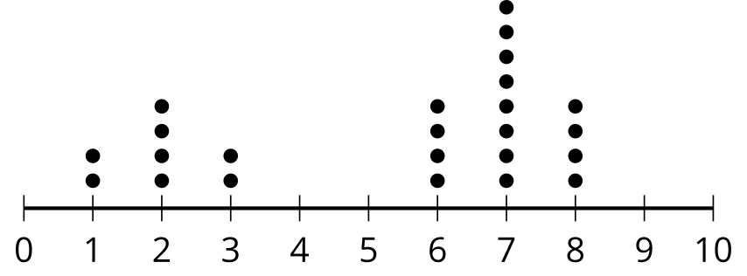
- (From Unit 7, Lesson 4.)
- Clare is designing an experimental study. She says that it is important to randomly assign people to random groups in an experimental study because this helps reduce the likelihood of grouping subjects into groups that may differ on some characteristic that is related to the response of interest. Do you agree with Clare? Explain your reasoning.
- (From Unit 7, Lesson 3.)
© CC BY 2019 by Illustrative Mathematics®

