Lesson 16: Finding and Interpreting Inverse Functions
Let’s find the inverse of linear functions.

16.1: Shopping for Cookbooks
Lin is comparing the cost of buying cookbooks at different online stores.
- Store A sells them at $9 each and offers free shipping.
- Store B sells them at $9 each and charges $5 for shipping.
- Store C sells them at $p$ dollars and charges $5 for shipping.
- Store D sells them at $p$ dollars and charges $f$ dollars for shipping.
- Write an equation to represent the total cost, $T$, in dollars as a function of $n$ cookbooks bought at each store.
- Write an equation to find the number of books, $n$, that Lin could buy if she spent $T$ dollars at each store.

16.2: From Celsius to Fahrenheit
If we know the temperature in degrees Celsius, $C$, we can find the temperature in degrees Fahrenheit, $F$, using the equation:
$F=\frac{9}{5}C+32$
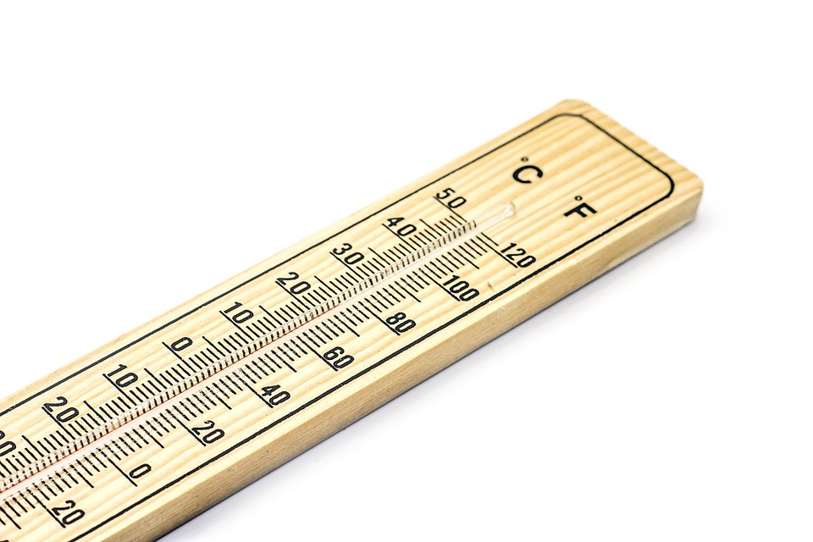
- Complete the table with temperatures in degrees Fahrenheit or degrees Celsius.
- $C$ | - 0 | - 100 | - 25
- $F$ |  |  |  | - 104 | - 50 | - 62.6
- The equation $F=\frac{9}{5}C+32$ represents a function. Write an equation to represent the inverse function. Be prepared to explain your reasoning.
- The equation $R=​\frac{9}{5}​(C+273.15)$ defines the temperature in degrees Rankine as a function of the temperature in degrees Celsius.
- Show that the equation $C=(R−491.67)⋅​\frac{5}{9}$ defines the inverse of that function.

Are you ready for more?
It was cold enough in Alaska one day so that the temperature was the same in degrees Fahrenheit and degrees Celsius. How cold was it? Explain or show how you know.

16.3: Info Gap: Custom Mugs
Your teacher will give you either a problem card or a data card. Do not show or read your card to your partner.
If your teacher gives you the problem card:
- Silently read your card and think about what information you need to answer the question.
- Ask your partner for the specific information that you need.
- Explain to your partner how you are using the information to solve the problem.
- Solve the problem and explain your reasoning to your partner.
If your teacher gives you the data card:
- Silently read the information on your card.
- Ask your partner “What specific information do you need?” and wait for your partner to ask for information. Only give information that is on your card. (Do not figure out anything for your partner!)
- Before telling your partner the information, ask “Why do you need that information?”
- After your partner solves the problem, ask them to explain their reasoning and listen to their explanation.
Pause here so your teacher can review your work. Ask your teacher for a new set of cards and repeat the activity, trading roles with your partner.

16.4: Tables and Seats
At a party, hexagonal tables are placed side by side along one side, as shown here.
- Explain why the equation $S=4n+2$ represents the number of seats, $S$, as a function of the number of tables, $n$.
- What domain and range make sense for this function?
- Write an equation to represent the inverse of the given function. Explain what this inverse function tells us.
- How many tables are needed if the following number of people are attending the party? Be prepared to explain your reasoning.
  - 94 people
  - 95 people
- What domain makes sense for the inverse function? Is it the same set of values as the range of the original function? Explain your reasoning.

Lesson 16 Summary
It is helpful to interpret the inverse of a function in terms of a situation and the quantities it represents.
Suppose a linear function gives the dollar cost, $C$, of renting some equipment for $n$ hours. The function is defined by this equation:
$C=8.25n+30$
If we know the number of hours of rental, $n$, we can substitute it into the expression $8.25n+30$ and evaluate it to find the cost, $C$.
What is the inverse of this function, and what does it tell us about the length and cost of rental?
To find the inverse, let's solve for $n$:
$\begin{matrix}8.25n+30 & =C \\ 8.25n & =C−30 \\ n & =\frac{C−30}{8.25}\end{matrix}$
If we know the cost of rental, $C$, we can substitute it into the expression $\frac{C−30}{8.25}$ and evaluate it to find the hours of rental, $n$.
Notice that the equation defining the inverse function is found by reversing the process that defines the original linear function.
- The original rule, $C=8.25n+30$, tells us to multiply the input, $n$, by 8.25 and add 30 to the result to get the output, $C$.
- The rule of the inverse function, $\frac{C−30}{8.25}$, suggests that we subtract 30 from the input and then divide the result by 8.25 to get the output $n$.
© CC BY 2019 by Illustrative Mathematics®

