Unit 4 Lesson 3: Interpreting & Using Function Notation

1 Observing a Drone (Warm up)

Student Task Statement
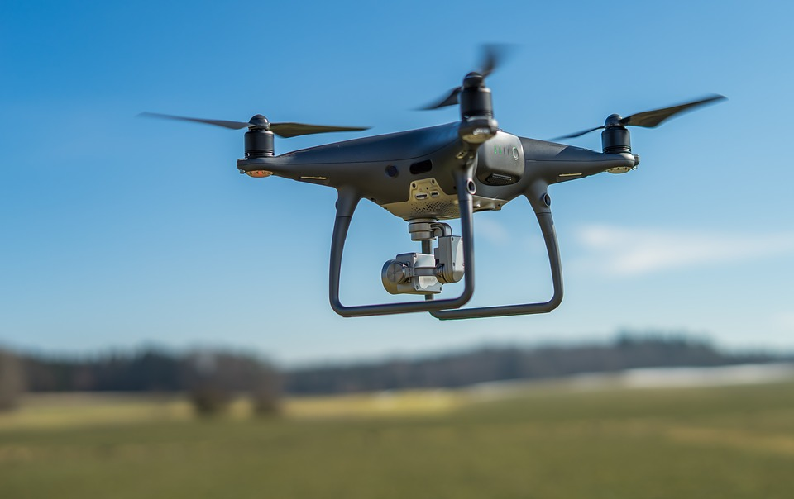
Here is a graph that represents function $f$, which gives the height of a drone, in meters, $t$ seconds after it leaves the ground.
Decide which function value is greater.
- $f(0)$ or $f(4)$
- $f(2)$ or $f(5)$
- $f(3)$ or $f(7)$
- $f(t)$ or $f(t+1)$

2 Smartphones

Student Task Statement
The function $P$ gives the number of people, in millions, who own a smartphone, $t$ years after year 2000.
- What does each equation tell us about smartphone ownership?
  - $P(17)=2,​320$
  - $P(\text{-}10)=0$
- Use function notation to represent each statement.
  - In 2010, the number of people who owned a smartphone was 296,600,000.
  - In 2015, about 1.86 billion people owned a smartphone.
- Mai is curious about the value of $t$ in $P(t)=1,​000$.
  - What would the value of $t$ tell Mai about the situation?
  - Is 4 a possible value of $t$ here?
- Use the information you have so far to sketch a graph of the function.

3 Boiling Water

Student Task Statement
The function $W$ gives the temperature, in degrees Fahrenheit, of a pot of water on a stove, $t$ minutes after the stove is turned on.
- Take turns with your partner to explain the meaning of each statement in this situation. When it’s your partner’s turn, listen carefully to their interpretation. If you disagree, discuss your thinking and work to reach an agreement.
  - $W(0)=72$
  - $W(5)>W(2)$
  - $W(10)=212$
  - $W(12)=W(10)$
  - $W(15)>W(30)$
  - $W(0)<W(30)$
- If all statements in the previous question represent the situation, sketch a possible graph of function $W$.
- Be prepared to show where each statement can be seen on your graph.
© CC BY 2019 by Illustrative Mathematics®

