Lesson 11 Practice Problems
- Technology required. A regular pentagon has side length 7 inches.
  - What is the perimeter of the pentagon?
  - What is the area of the pentagon?
- Technology required. The expression $n⋅sin\left(\frac{360}{2n}\right)$ approximates $π$ by giving the perimeter of a regular polygon inscribed in a circle with radius 1.
  - What does $n$ stand for in the expression?
  - If there are 60 sides, what is the difference between the perimeter and $π$?
- Technology required. A regular hexagon has side length 2 inches.
  - What is the perimeter of the hexagon?
  - What is the area of the hexagon?
- (From Unit 4, Lesson 10.)
- An airplane travels 125 miles horizontally during a decrease of 9 miles vertically.
  - What is the angle of descent?
  - What is the distance of the plane’s path?
- (From Unit 4, Lesson 10.)
- Select all true statements.
- 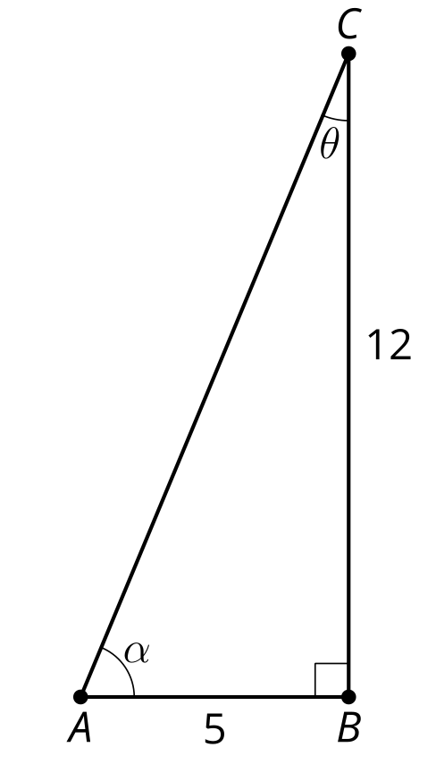
  - $AC$ is $\sqrt{119}$ units
  - $AC$ is 13 units
  - $cos\left(θ\right)=\frac{5}{12}$
  - $sin\left(α\right)=\frac{12}{13}$
  - $θ=arctan\left(\frac{5}{12}\right)$
- (From Unit 4, Lesson 9.)
- Write 2 equations using sine and 2 equations using cosine based on triangle $ABC$.
- 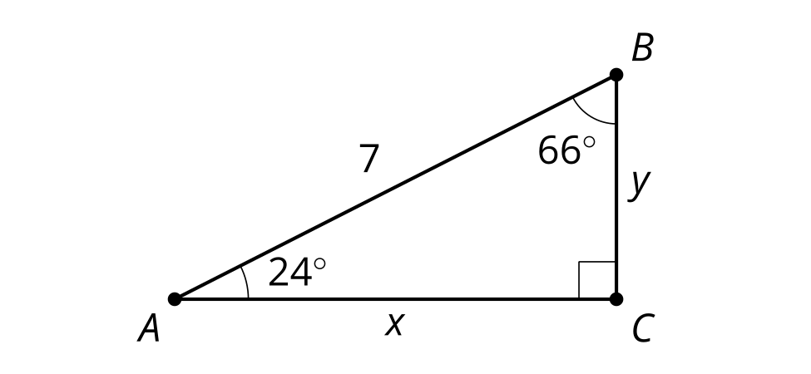
- (From Unit 4, Lesson 8.)
- An equilateral triangle has area of $36\sqrt{3}$ square units. What is the side length?
- (From Unit 4, Lesson 3.)
© CC BY 2019 by Illustrative Mathematics®

