Unit 2 Lesson 26: Using the Sum

1 Some Interesting Sums (Warm up)

Student Task Statement
Recall that for any geometric sequence starting at $a$ with a common ratio $r$, the sum $s$ of the first $n$ terms is given by $s=a\frac{1−r^{n}}{1−r}$. Find the approximate sum of the first 50 terms of each sequence:
- $\frac{1}{2}$, $\frac{1}{4}$, $\frac{1}{8}$, $\frac{1}{16}$, . . .
- 1, $\frac{1}{2}$, $\frac{1}{4}$, $\frac{1}{8}$, $\frac{1}{16}$, . . .

2 That’s a lot of Houses

Student Task Statement
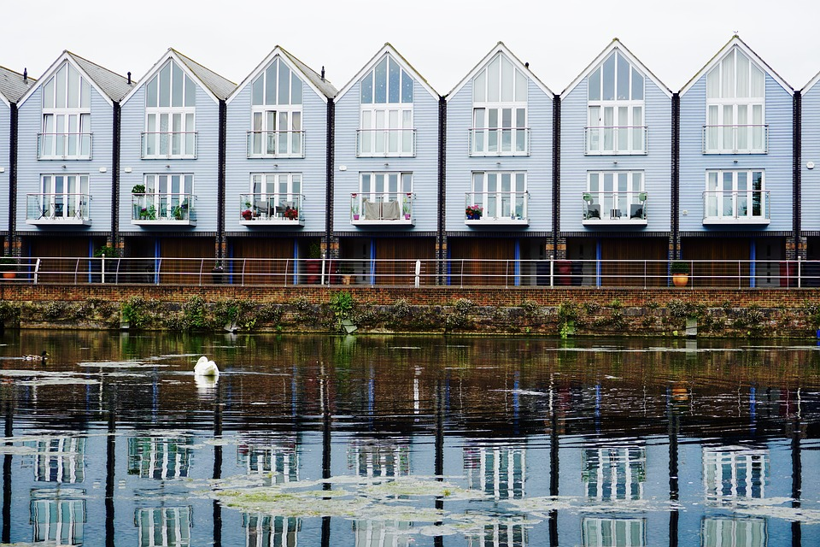
In 2012, about 71 thousand homes were sold in the United Kingdom. For the next 3 years, the number of homes sold increased by about 18% annually. Assuming the sales trend continues,
- How many homes were sold in 2013? In 2014?
- What information does the value of the expression $71\frac{\left(1−{1.18}^{11}\right)}{\left(1−1.18\right)}$ tell us?
- Predict the total number of house sales from 2012 to 2017. Explain your reasoning.
- Do these predictions seem reasonable? Explain your reasoning.

3 Back to Funding the Future

Student Task Statement
Let’s say you open a savings account with an interest rate of 5% per year compounded annually and that you plan on contributing the same amount to it at the start of every year.
- Predict how much you need to put into the account at the start of each year to have over $100,000 in it when you turn 70.
- Calculate how much the account would have after the deposit at the start of the 50th year if the amount invested each year were:
  - $100
  - $500
  - $1,000
  - $2,000
- Say you decide to invest $1,000 into the account at the start of each year at the same interest rate. How many years until the account reaches $100,000? How does the amount you invest into the account compare to the amount of interest earned by the account?
© CC BY 2019 by Illustrative Mathematics®

