Unit 2 Lesson 13: Polynomial Division (Part 2)

1 Notice and Wonder: Different Divisions (Warm up)

Student Task Statement
What do you notice? What do you wonder?
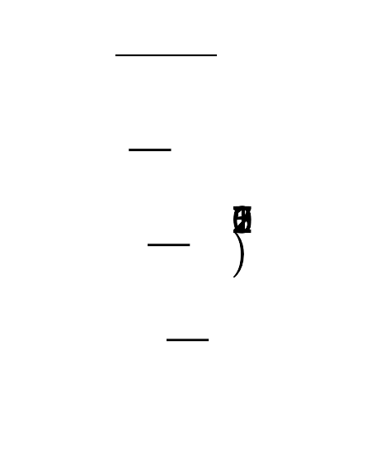
2x2+7x+22x+12x3+7x2+7x+2-2x3−2x2_+7x+225x2+7x+22

2 Polynomial Long Division

Student Task Statement
- Diego used the long division shown here to figure out that $6x^{2}−7x−5=(2x+1)(3x−5)$. Show what it would look like if he had used a diagram.
- 3x−52x+16x2−7x−5-6x2−3x_−55-10x−510x+5_0
- $2x$ | - $6x^{2}$
- 1
- Pause here for a whole-class discussion.
- $(x−2)$ is a factor of $2x^{3}−7x^{2}+x+10$, which means there is some other factor $A$ where $2x^{3}−7x^{2}+x+10=(x−2)(A)$. Finish the division started here to find the value of $A$.
- 2x2+x+100x−22x3−7x2+x+10-2x3+4x2_+x+100
- Jada used the diagram shown here to figure out that $2x^{3}+13x^{2}+16x+5=(2x+1)(x^{2}+6x+5)$. Show what it would look like if she had used long division.
 | - $x^{2}$ | - $6x$ | - 5
- $2x$ | - $2x^{3}$ | - $12x^{2}$ | - $10x$
- 1 | - $x^{2}$ | - $6x$ | - 5
- $\begin{matrix}2x+12x^{3}+13x^{2}+16x+5\end{matrix}$

3 More Long Division

Student Task Statement
Here are some polynomial functions with known factors. Rewrite each polynomial as a product of linear factors using long division.
- $A(x)=x^{3}−7x^{2}−16x+112$, $(x−7)$
x255555555555x−7x3−7x2−16x+112-x3+7x2_.55555555555
- $C(x)=x^{3}−3x^{2}−13x+15$, $(x+3)$

4 Missing Numbers (Optional)

Student Task Statement
Here are pairs of equivalent expressions, one in standard form and the other in factored form. Find the missing numbers.
- $x^{2}+9x+14$ and (x+2)(x+30)
- $x^{2}−9x+20$ and (x−30)(x−30)
- $2x^{2}+2x−24$ and 2(x+30)(x−3)
- 30x3+11x2−17x+6 and $(\text{-}x+3)(2x−1)(x−2)$
- $6x^{3}+2x^{2}−16x+8$ and (x−1)(2x+4)(30x−2)
- $2x^{3}+7x^{2}−7x−12$ and (2x−3)(x+30)(x+30)
- x3+6x2+30x−10 and (x+2)(x−1)(x+30)
© CC BY 2019 by Illustrative Mathematics®

