Unit 1 Lesson 2: Explore Expressions and Sums

WU Choral Count: Count to 41 (Warm up)

Student Task Statement

1 Matching Dot Cards and Expressions

Student Task Statement
Match each pair of dots to an expression. Then, find the total.
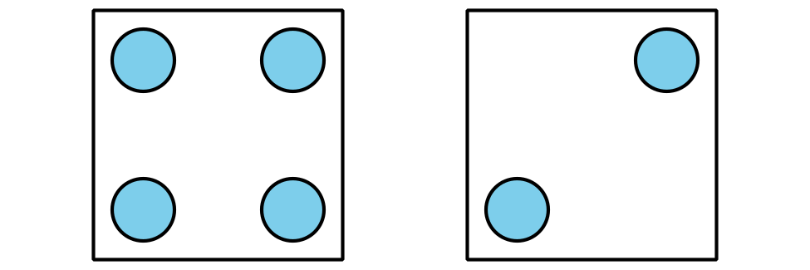
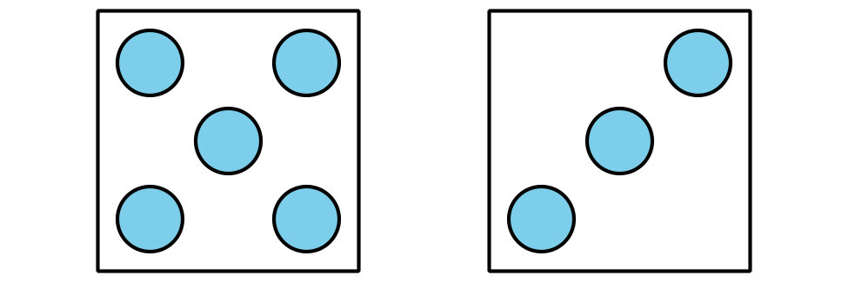
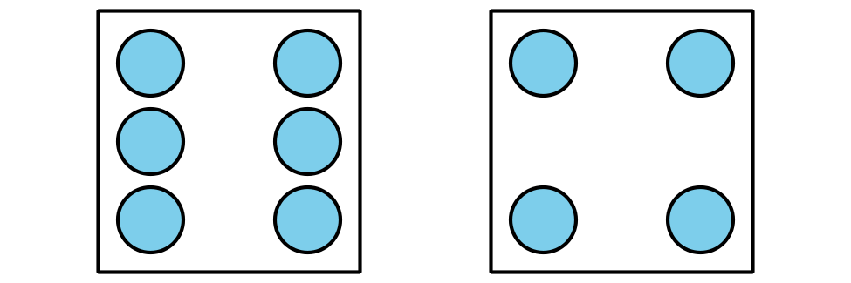
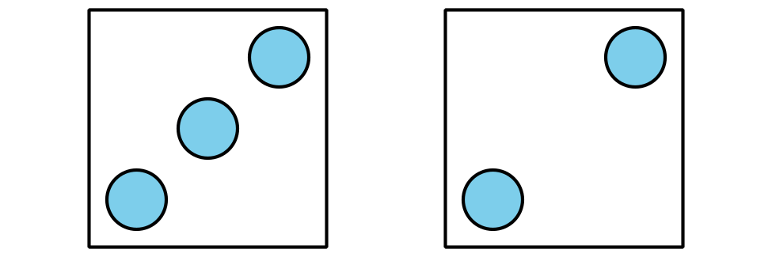
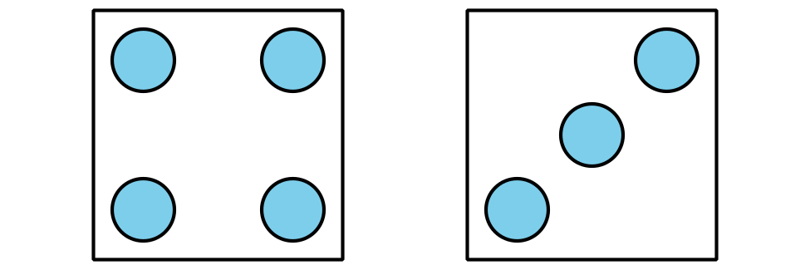
expression | total
$3+2$
$4+2$
$5+3$
$6+4$
$4+3$
Draw the missing dots to match the expression. Then, find the total.
Expression: $4+2$
Total: ____________
​​​​​​Expression: $5+2$
Total: ____________
Expression: $2+6$
Total: ____________
Write the missing expression to match the dots. Then, find the total.
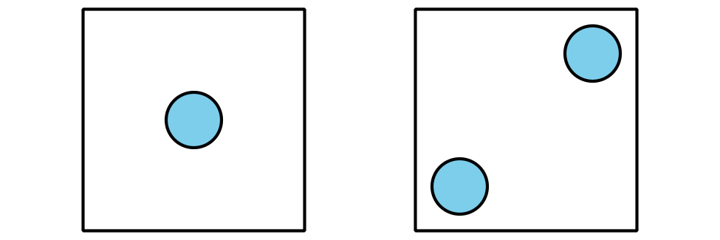
Expression: _____________________
Total: ____________
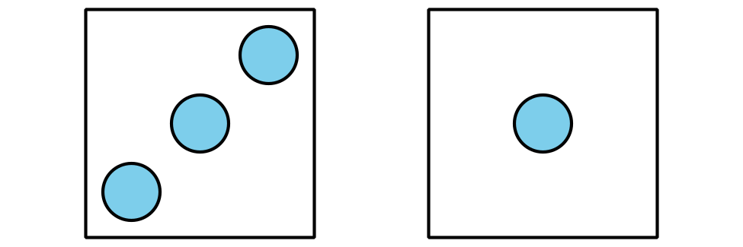
Expression: _____________________
Total: ____________

2 Introduce: Check it Off, Add within 10

Student Task Statement
© CC BY 2021 Illustrative Mathematics®

