Unit 6 Lesson 18: Money Problems

WU How Many Do You See: Groups of Coins (Warm up)

Student Task Statement
How many coins do you see? How do you see them?
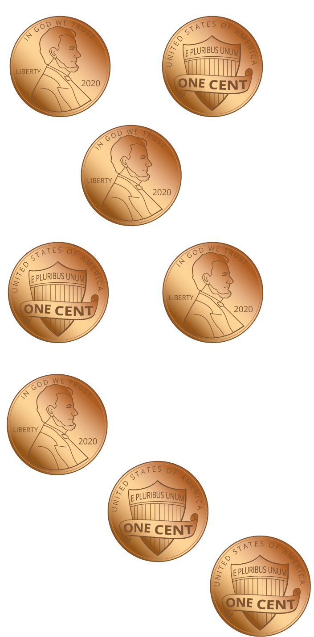
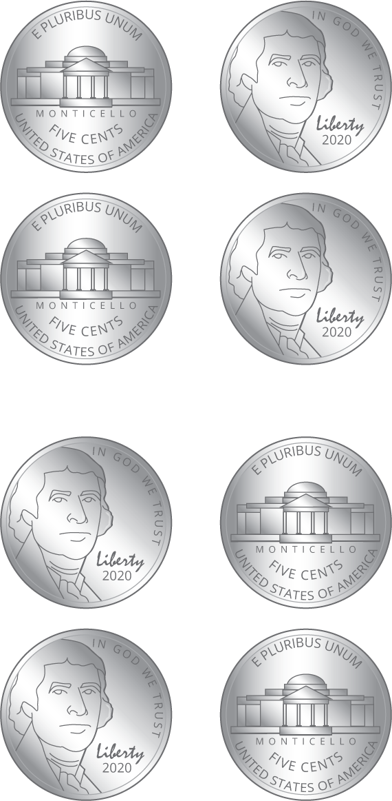
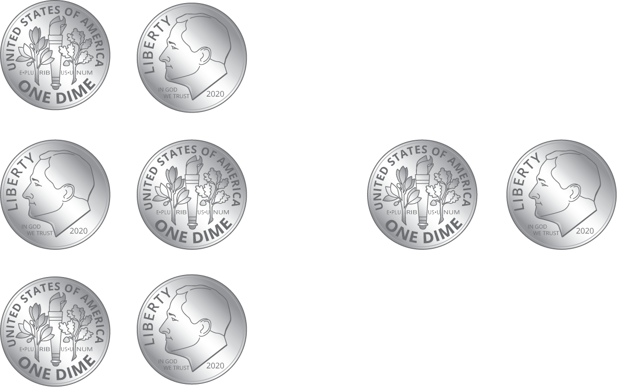

1 Shop for School Supplies

Student Task Statement
items | cost
pack of pencils | 75¢
pencil sharpener | 35¢
eraser | 45¢
pens | 18¢
- Lin has these coins:
- 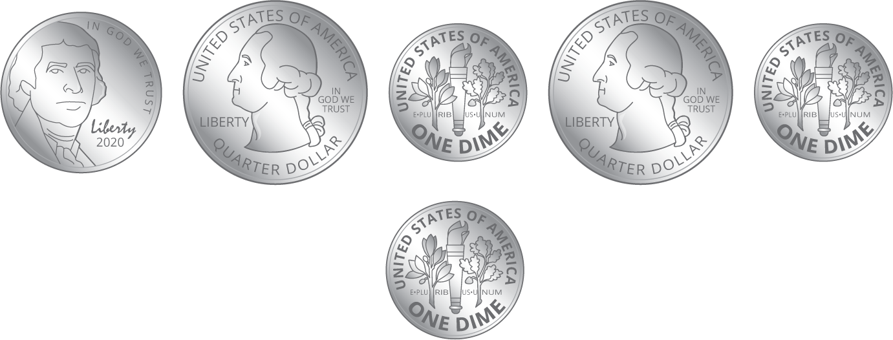
  - How much money does Lin have for supplies?
  - If Lin buys an eraser, how much money will she have left? Show your thinking.
- Diego has these coins:
- 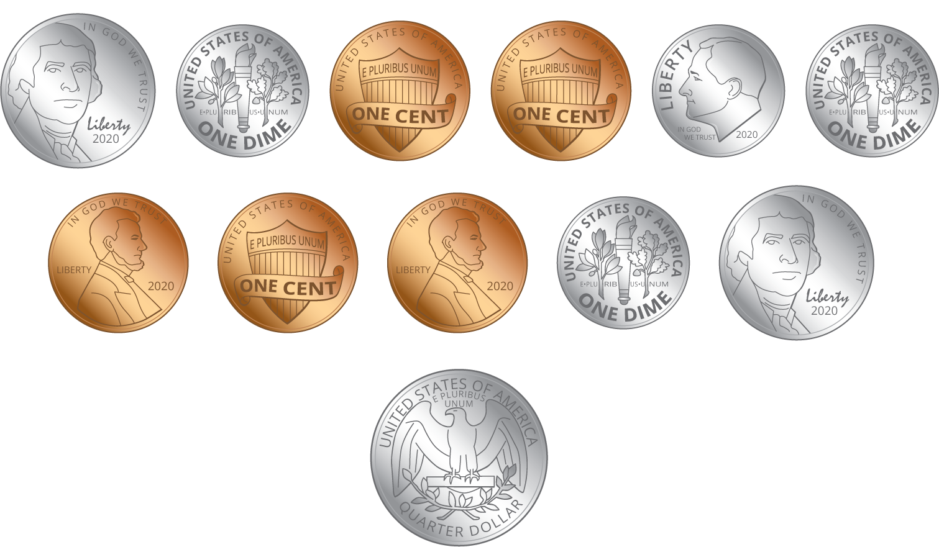
  - How much money does Diego have for supplies?
  - If Diego buys a pack of pencils, how much money will he have left? Show your thinking.

2 Shop with a Dollar

Student Task Statement
Show your thinking for each problem.
supplies | cost
notebooks | 26¢
colored pencils | 18¢
pencil box | 39¢
glue stick | 44¢
- Clare wants to buy a pencil box and colored pencils.
  - How much money will it cost?
  - Clare has $1. How much will she have left?
- Tyler wants to buy a notebook and a pencil box. He has $1. How much will he have left?
- Andre has $1. He wants to buy a glue stick, a pencil box, and colored pencils. Does Andre have enough money?
© CC BY 2021 Illustrative Mathematics®

