Lesson 3: Attributes that Define Shapes
- Let’s play Mystery Quadrilateral.

Warm-up: Number Talk: Multiply Multiples of Ten
Find the value of each expression mentally.
- $4×40$
- $8×40$
- $7×40$
- $9×40$

3.1: Learn How to Play Mystery Quadrilateral
Play a round of Mystery Quadrilateral with your teacher.
- Partner A: Choose a shape from the group of quadrilaterals. Place it in the mystery quadrilateral folder without your partner seeing it.
- Partner B: Ask up to 5 “yes” or “no” questions to identify the quadrilateral. Then guess which quadrilateral is the mystery quadrilateral.
- Partner A: Show your partner the mystery quadrilateral.
- Switch roles and play again.
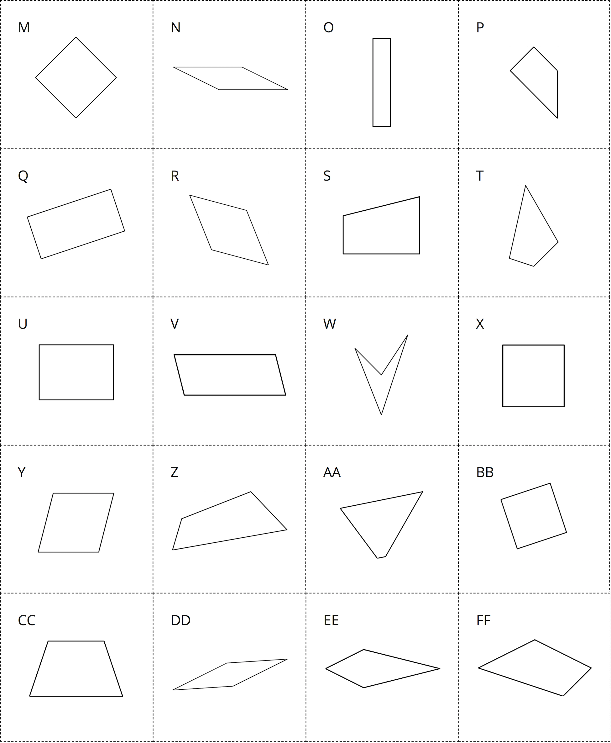

3.2: Play Mystery Quadrilateral
- Partner A: Choose a shape from the group of quadrilaterals. Place it in the mystery quadrilateral folder without your partner seeing it.
- Partner B: Ask up to 5 “yes” or “no” questions to identify the quadrilateral. Then guess which quadrilateral is the mystery quadrilateral.
- Partner A: Show your partner the mystery quadrilateral.
- Switch roles and play again.
© CC BY 2021 Illustrative Mathematics®

