Lesson 11: A Bigger Piece

Standards Alignments
Addressing | 1.G.A, 1.G.A.3, 1.NBT.C.5

Teacher-facing Learning Goals
- Compare the size of halves and fourths of the same shape.
- Understand that for halves and fourths, partitioning a shape into more equal pieces creates smaller pieces.

Student-facing Learning Goals
- Let’s compare the size of halves and fourths.
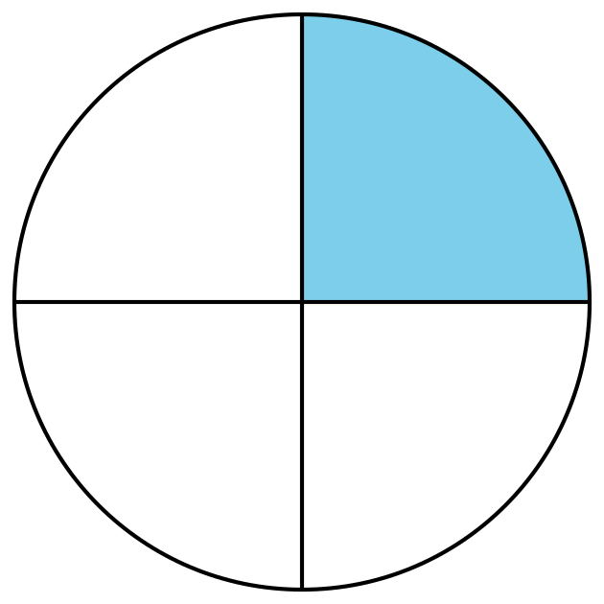

Lesson Purpose
The purpose of this lesson is for students to compare the size of halves and fourths of the same shape and understand that partitioning a shape into more equal pieces creates smaller pieces.
In previous lessons, students partitioned shapes into halves and fourths and identified “a half,” “a fourth,” and “a quarter,” of a shape. In this lesson, students build on this work by comparing the size of halves and fourths of same-size shapes. Students explain that for the same shape, a fourth is smaller than a half. In later grades, students will generalize that for any whole, splitting it into more pieces creates smaller size pieces. At this point, they only need to understand the relative size of halves and fourths of the same shape.
This lesson has a Student Section Summary.

Access for:

Students with Disabilities
- Action and Expression (Activity 1)

English Learners
- MLR7 (Activity 1)

Instructional Routines
Choral Count (Warm-up), MLR8 Discussion Supports (Activity 2)

Materials to Gather
- Bags: Activity 3
- Colored pencils or crayons: Activity 2
- Geoblocks: Activity 3
- Scissors: Activity 1

Required Preparation

Lesson Timeline
Warm-up | 10 min
Activity 1 | 15 min
Activity 2 | 10 min
Activity 3 | 15 min
Lesson Synthesis | 10 min

Teacher Reflection Question
When do your students feel successful in math? How do you know?

Cool-down
(to be completed at the end of the lesson) 0min
Unit 7, Section B Checkpoint

Standards Alignments
Addressing | 1.G.A.3

Student-facing Task Statement
Lesson observations

Student Responses
- Partition a circle or rectangle into halves or fourths.
- Understand that for halves and fourths, partitioning a shape into more equal pieces creates smaller pieces.

