Lesson 16: Guess the Figure
- Let’s draw and identify all kinds of two-dimensional figures.

Warm-up: Notice and Wonder: Two Figures
What do you notice? What do you wonder?
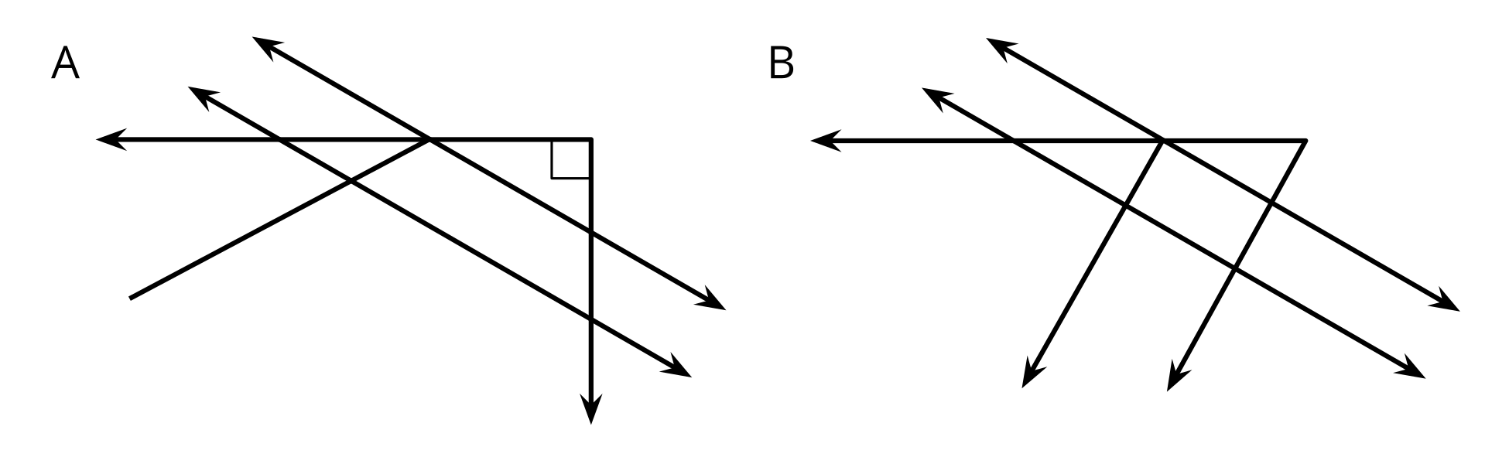

16.1: Make a Change
Your teacher will give you a set of cards. Each partner picks one of the cards.
- Draw the figure you selected, but make at least one change.
- Look at your partner’s card and drawing. What change did your partner make?
If you have time, repeat with another card.

16.2: Guess My Figure
- Create a two-dimensional shape that has at least 3 of the following:
  - ray
  - line segment
  - right angle
  - acute angle
  - obtuse angle
  - perpendicular lines
  - parallel lines
- Without showing your partner, describe the figure so that your partner is able to draw it as best as possible.
- Switch roles, and draw your partner’s shape based on their description.
© CC BY 2021 Illustrative Mathematics®

