Lesson 6: Distinguishing between Two Types of Situations

6.1: Which One Doesn’t Belong: Seeing Structure
Which equation doesn’t belong?
$4(x+3)=9$
$4⋅x+12=9$
$4+3x=9$
$9=12+4x$

6.2: Card Sort: Categories of Equations
Your teacher will give you a set of cards that show equations. Sort the cards into 2 categories of your choosing. Be prepared to explain the meaning of your categories. Then, sort the cards into 2 categories in a different way. Be prepared to explain the meaning of your new categories.

6.3: Even More Situations, Diagrams, and Equations
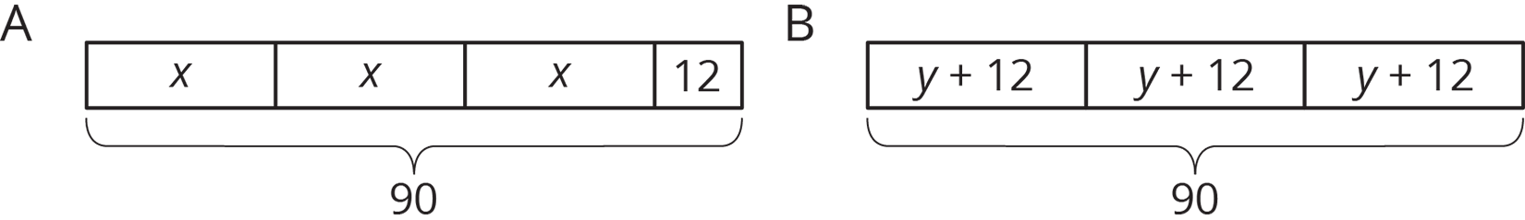
Story 1: Lin had 90 flyers to hang up around the school. She gave 12 flyers to each of three volunteers. Then she took the remaining flyers and divided them up equally between the three volunteers.
Story 2: Lin had 90 flyers to hang up around the school. After giving the same number of flyers to each of three volunteers, she had 12 left to hang up by herself.
- Which diagram goes with which story? Be prepared to explain your reasoning.
- In each diagram, what part of the story does the variable represent?
- Write an equation corresponding to each story. If you get stuck, use the diagram.
- Find the value of the variable in the story.

Are you ready for more?
A tutor is starting a business. In the first year, they start with 5 clients and charge $10 per week for an hour of tutoring with each client. For each year following, they double the number of clients and the number of hours each week. Each new client will be charged 150% of the charges of the clients from the previous year.
- Organize the weekly earnings for each year in a table.
- Assuming a full-time week is 40 hours per week, how many years will it take to reach full time and how many new clients will be taken on that year?
- After reaching full time, what is the tutor’s annual salary if they take 2 weeks of vacation?
- Is there another business model you’d recommend for the tutor? Explain your reasoning.

Lesson 6 Summary
In this unit, we encounter two main types of situations that can be represented with an equation. Here is an example of each type:
- After adding 8 students to each of 6 same-sized teams, there were 72 students altogether.
- After adding an 8-pound box of tennis rackets to a crate with 6 identical boxes of ping pong paddles, the crate weighed 72 pounds.
The first situation has all equal parts, since additions are made to each team. An equation that represents this situation is $6(x+8)=72$, where $x$ represents the original number of students on each team. Eight students were added to each group, there are 6 groups, and there are a total of 72 students.
In the second situation, there are 6 equal parts added to one other part. An equation that represents this situation is $6x+8=72$, where $x$ represents the weight of a box of ping pong paddles, there are 6 boxes of ping pong paddles, there is an additional box that weighs 8 pounds, and the crate weighs 72 pounds altogether.
In the first situation, there were 6 equal groups, and 8 students added to each group. $6(x+8)=72$.
In the second situation, there were 6 equal groups, but 8 more pounds in addition to that. $6x+8=72$.
© CC BY Open Up Resources. Adaptations CC BY IM.

