Lesson 12 Practice Problems
- Diego has $11 and begins saving $5 each week toward buying a new phone. At the same time that Diego begins saving, Lin has $60 and begins spending $2 per week on supplies for her art class. Is there a week when they have the same amount of money? How much do they have at that time?
- Use a graph to find $x$ and $y$ values that make both $y=\frac{\text{-}2}{3}x+3$ and $y=2x−5$ true.
- 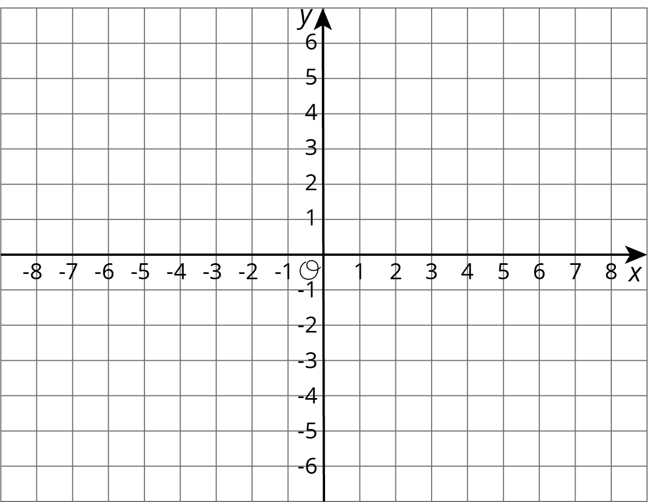
- The point where the graphs of two equations intersect has $y$-coordinate 2. One equation is $y=\text{-}3x+5$. Find the other equation if its graph has a slope of 1.
- A farm has chickens and cows. All the cows have 4 legs and all the chickens have 2 legs. All together, there are 82 cow and chicken legs on the farm. Complete the table to show some possible combinations of chickens and cows to get 82 total legs.
- number of chickens ($x$) | - number of cows ($y$)
- 35
- 7
 | - 10
- 19
 | - 5
- Here is a graph that shows possible combinations of chickens and cows that add up to 30 animals:
- 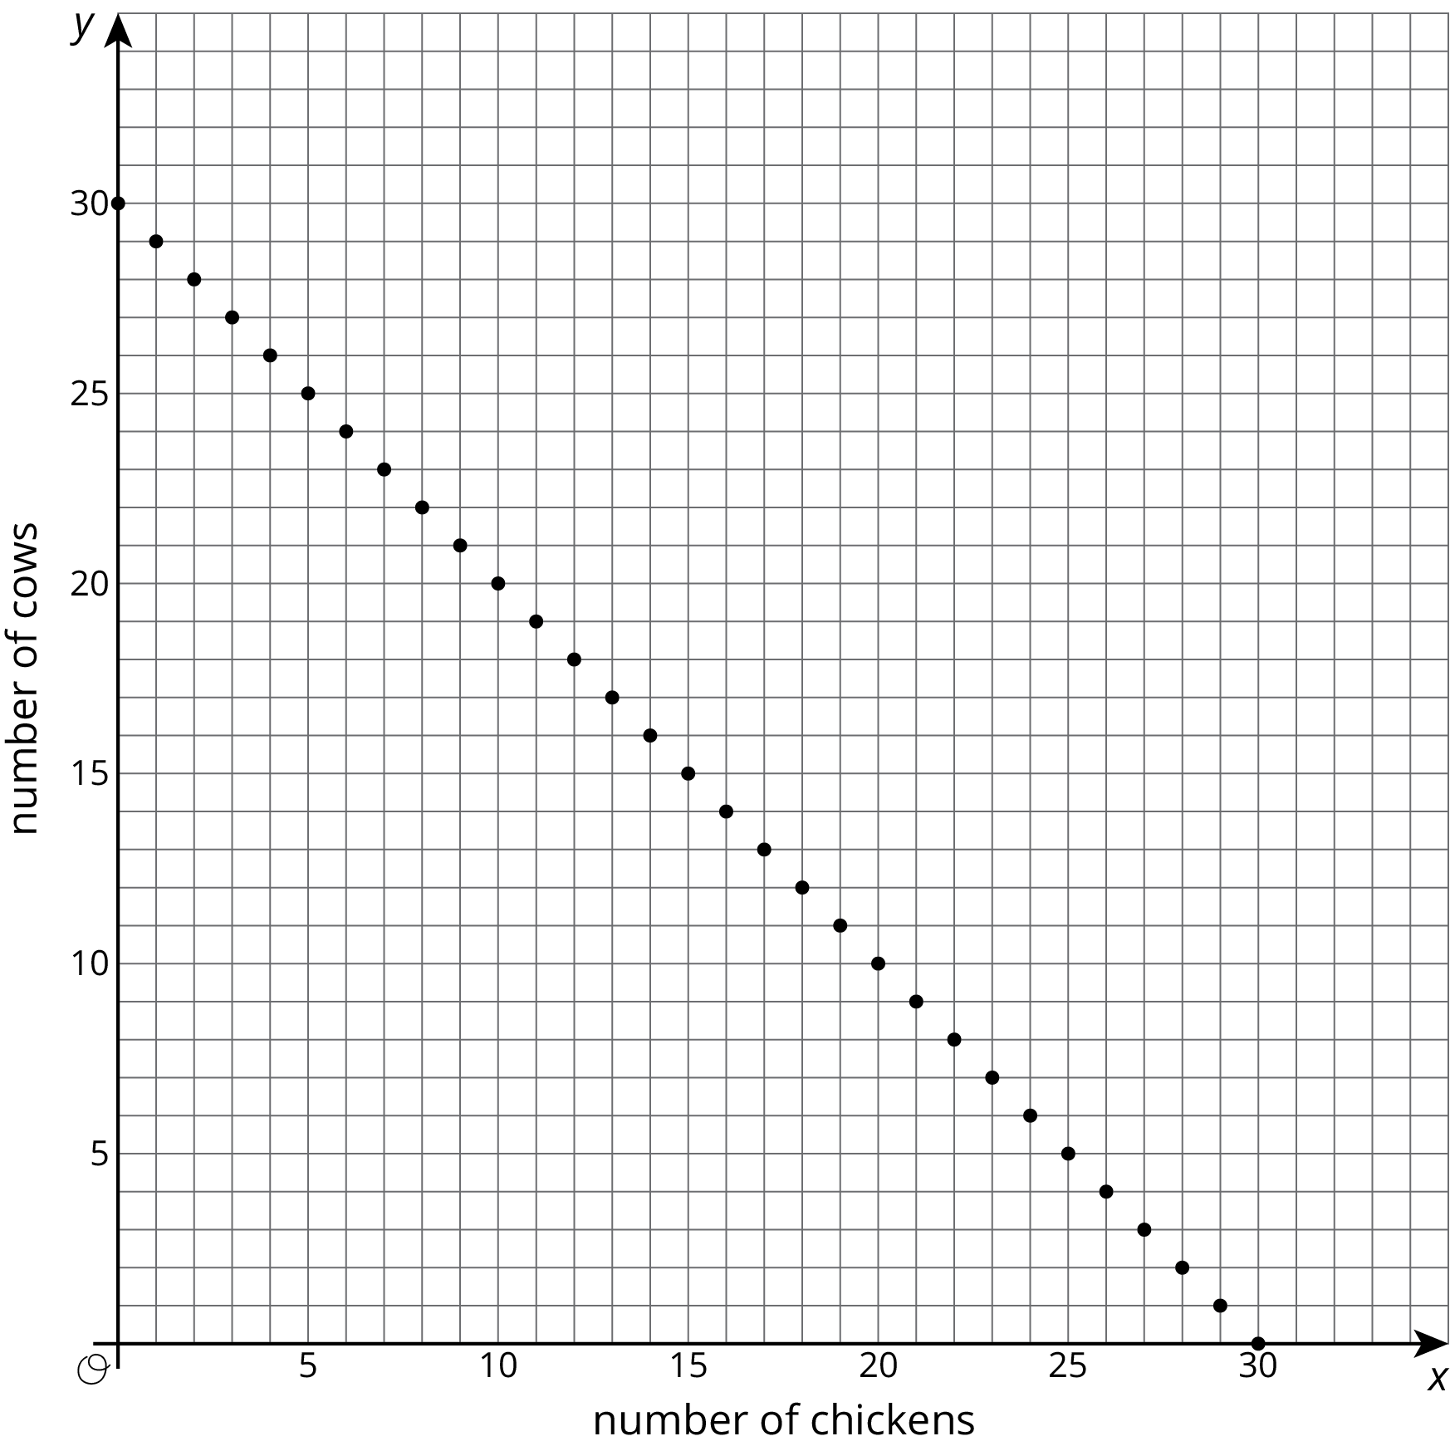
- If the farm has 30 chickens and cows, and there are 82 chicken and cow legs all together, then how many chickens and how many cows could the farm have?

  - Match the lines $m$ and $n$ to the statements they represent:
  - 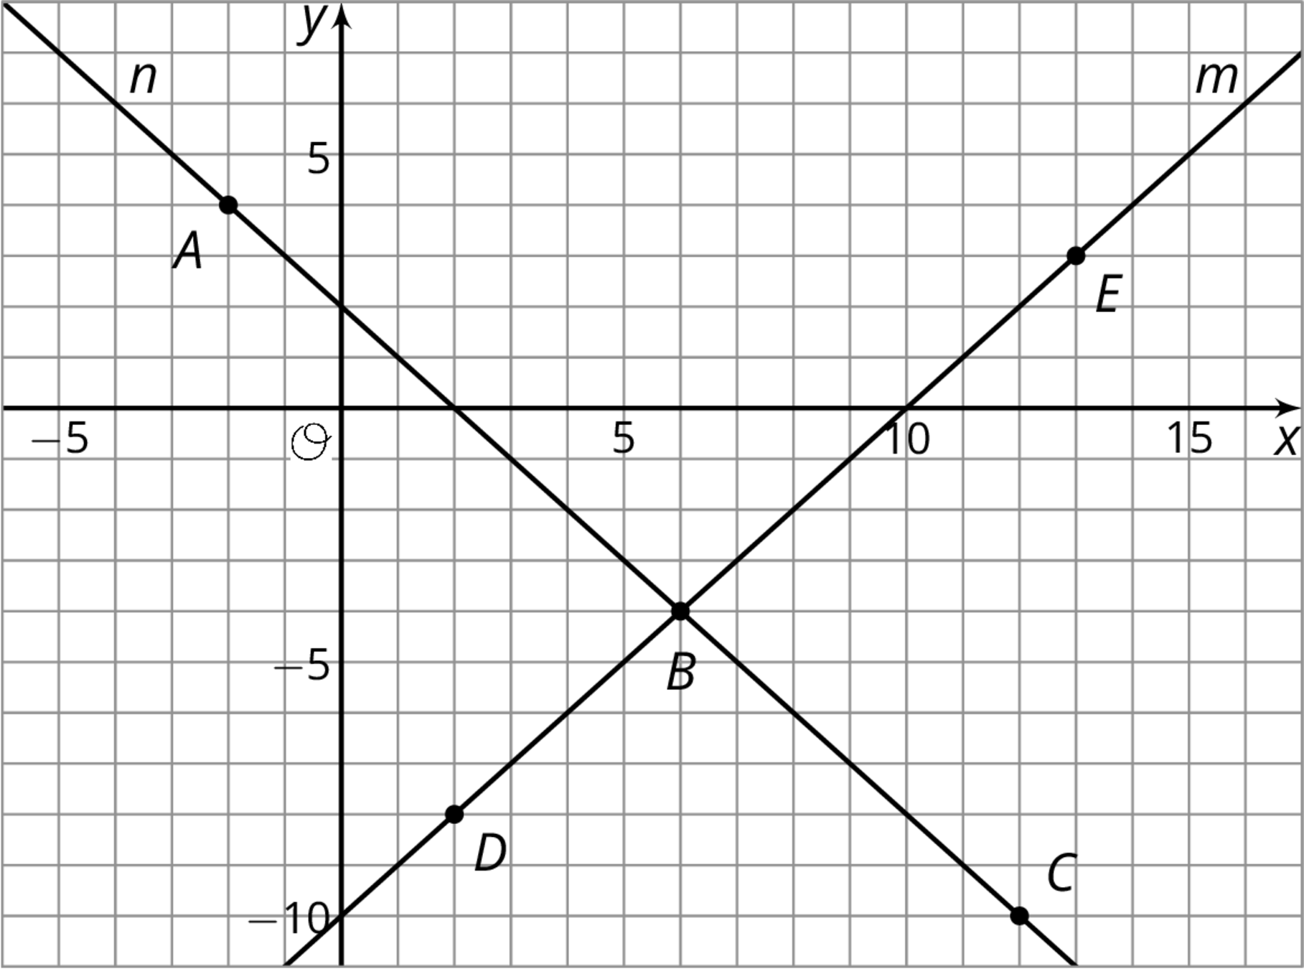
    - A set of points where the coordinates of each point have a sum of 2
    - A set of points where the $y$-coordinate of each point is 10 less than its $x$-coordinate
  - Match the labeled points on the graph to statements about their coordinates:
    - Two numbers with a sum of 2
    - Two numbers where the $y$-coordinate is 10 less than the $x$-coordinate
    - Two numbers with a sum of 2 and where the $y$-coordinate is 10 less than the $x$-coordinate
- Here is an equation: $4x−4=4x+\text{__}$. What could you write in the blank so the equation would be true for:
  - No values of $x$
  - All values of $x$
  - One value of $x$
- (From Unit 4, Lesson 15.)
© CC BY Open Up Resources. Adaptations CC BY IM.

