Lesson 6 Practice Problems
- A normal curve with a mean of 500 and a standard deviation of 100 is shown. Shade the region under the curve within one standard deviation of the mean. How much of the data falls within the shaded region?
- 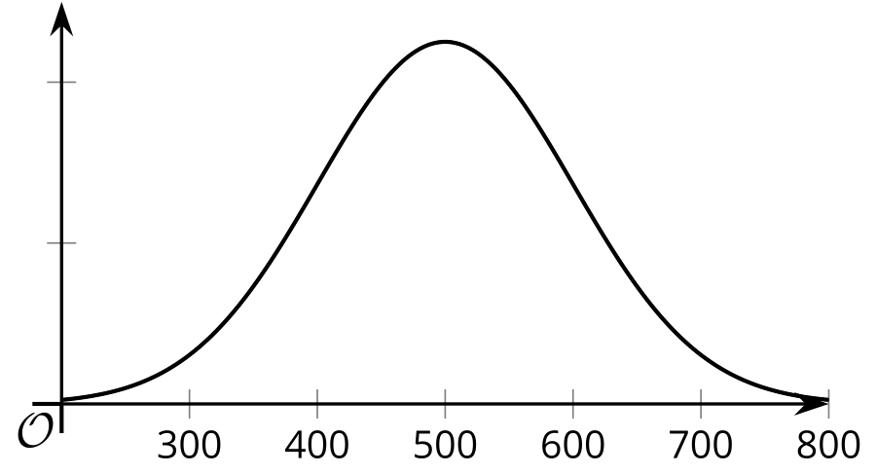
- The stopping distance of a certain car traveling at 60 miles per hour follows an approximately normal distribution with a mean of 130 feet and a standard deviation of 5 feet. Approximately what percent of the time does the car stop at a distance of between 120 feet and 140 feet?
- The distribution of weights for bags of chips is shown to follow an approximately normal distribution as seen in this histogram.
- 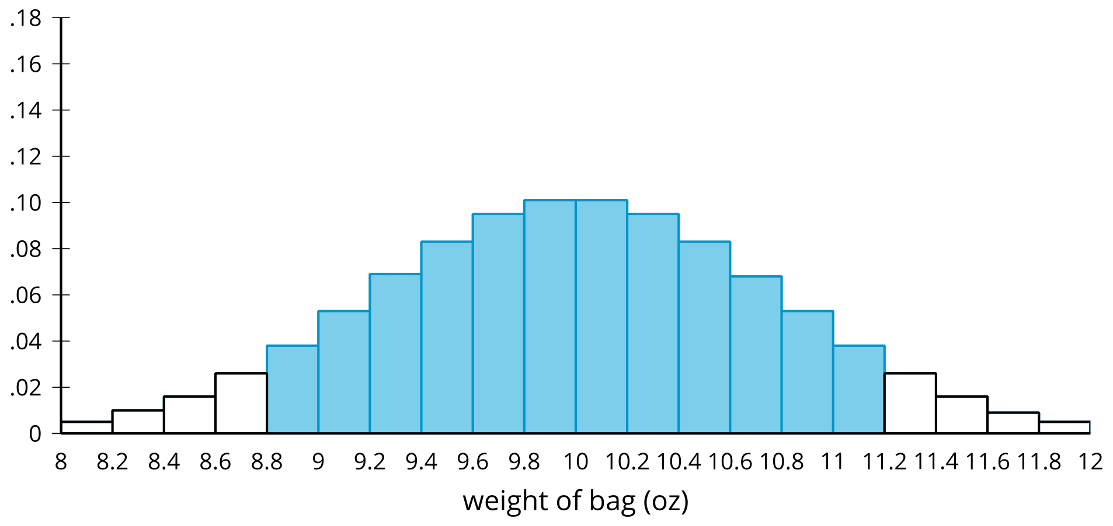
- The weights of approximately 95% of the chip bags fall within the shaded region.
  - What is the approximate mean weight of a chip bag?
  - What is the approximate standard deviation of the weight of a chip bag?
- Here is a histogram of a distribution with 50 data points.
- 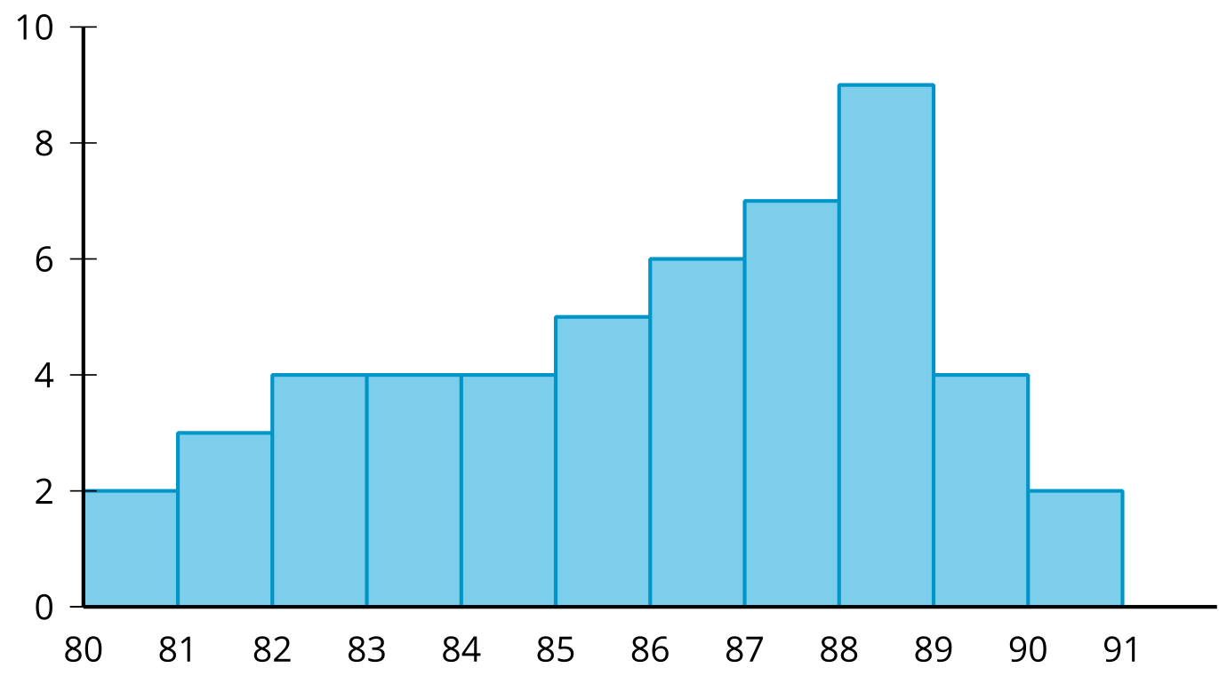
- For each given interval, find the proportion of data points which fall in that interval.
  - 80 to 81
  - 83 to 84
  - 88 to 89
- (From Unit 7, Lesson 5.)
- Two curves representing normal distributions are shown. Does the solid curve or dashed curve have a greater standard deviation? Explain how you know.
- 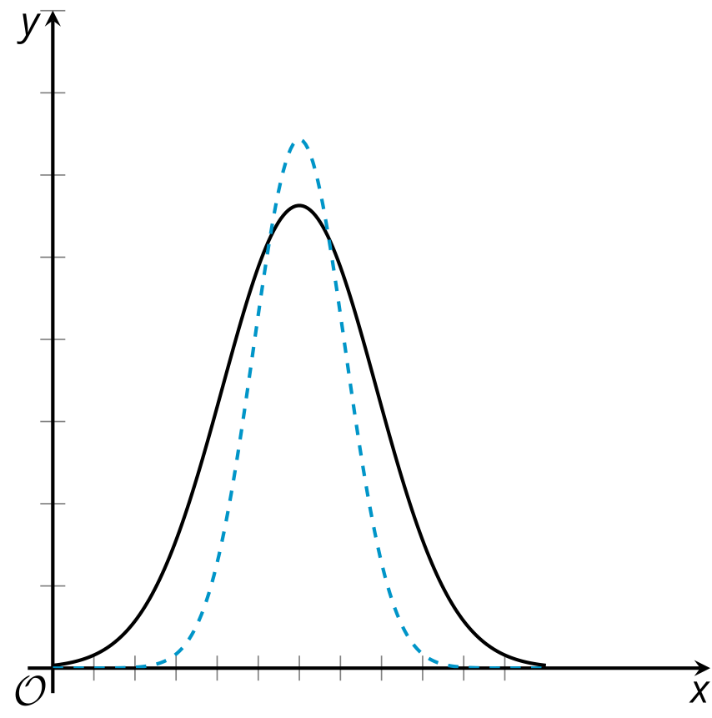
- (From Unit 7, Lesson 5.)
- Why is it important to randomly assign people to random groups in an experimental study?
- (From Unit 7, Lesson 3.)
© CC BY 2019 by Illustrative Mathematics®

